CWC Wood Design

Assignment 1: Introduction to Wood as a Material (Modules 1-4)

# Question 1

a) What is the difference between sapwood and heartwood? Describe each.

b) Wood is an anisotropic material, what are the three principal axes? Describe each.

c) What is engineered wood and what are two advantage of using engineered wood? Name three types of engineered wood used in the industry.

d) A Ponderosa pine piece of lumber measuring 20 m3 has a Specific Gravity (SG) value of 0.40. What is oven-dry weight of the lumber?

# Question 2

a) A stud had dimensions of 38 mm x 89 mm x 2438 mm and a moisture content of 150% when it was prepared. After seasoning, the moisture content was reduced to 7%. If the tangential, radial and longitudinal directions of the grains are on the same order as the dimensions indicated above, what are the dimensions of the seasoned stud if the moisture-shrinkage relation follows Figure 1. Assume the FSP is 28%.



Figure 1. Relation between shrinkage and moisture.

b) In A.5.4.6 of the O86-14 Engineering Design in Wood, a general equation for shrinkage is proposed as follows:

S = D x (Mi – MF) x c

Where S is the dimension change due to shrinkage/swelling (mm), D is the original dimension (mm), Mi is the initial moisture (%) , MF­ is the final moisture content (%) (Mi and MF are less than or equal to the fibre saturation point), and c is the shrinkage coefficient given as 0.002 for perpendicular-to-grain dimensions and 0.00005 for parallel-to-grain dimensions.

Compare the shrinkage values from this equation to those determined in part a). Discuss the results.

c) A.5.4.6 in O86-14 offers a generalized shrinkage formula in lieu of the specific data given in Figure 1 of this assignment

S = D x (Mi – MF) x c

Where S is the dimension change due to shrinkage/swelling (mm), D is the original dimension (mm), Mi is the initial moisture (%) , MF­ is the final moisture content (%) (Mi and MF are less than or equal to the fibre saturation point), and c is the shrinkage coefficient given as 0.002 for perpendicular-to-grain dimensions and 0.00005 for parallel-to-grain dimensions.

Compare the shrinkage values from this equation to those determined in part a). Discuss the results

# Question 3

A 105 mm deep 3-ply CLT floor is supported in bearing by a glulam column. An adjacent 175 mm x 380 mm glulam joist is also supported in bearing by a larger 265 mm x 798 mm glulam beam. During the construction of this assembly, the wood moisture content was observed to be 5%. Later during a rainy period, the moisture content was 60%. Assuming a fibre saturation point of 28% for all members, calculate the remaining clearance between the CLT and the upper column, and the glulam joist and the CLT floor. Assume the columns are detailed to prevent shrinkage/swelling and that the CLT is able to uplift. Do you have any concerns about the swelling of this assembly?

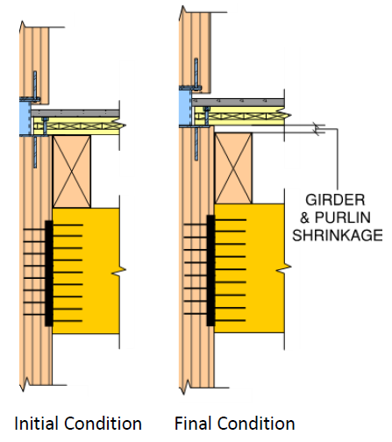

265x798mm Glulam beam

175x380mm Glulam joist

105 mm CLT Floor

25 mm clearance

25 mm clearance

# Question 4

A three-storey timber building consists of glulam columns supporting glulam beams. During construction, shrinkage detailing was missed for all columns on the right side. Assuming the beams and left side columns will not experience a change in moisture content, calculate the induced moment on the top-most beam if the moisture content changes from 28% to 7%. The glulam columns are 4 m in length with a spacing of 9 m, and the beams have a flexural rigidity E*I of 25600 kNm2. The beams are rigidly connected to the columns.

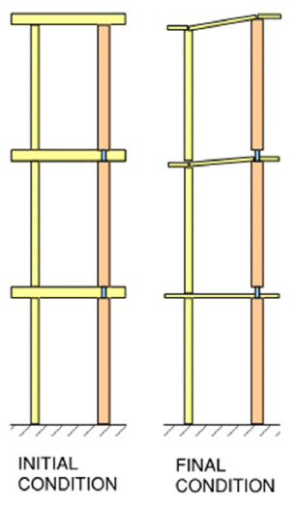

No shrinkage detailing

# Question 5

A timber frame supports a CLT Floor Panel and an unfactored dead load of 32 kPa. The Glulam beams supporting the CLT and dead load are spaced at 2.5 m on centers. The Glulam beams are 215x266 mm D. Fir-L Grade 20f-E with EI = 4180 x 109 Nmm2 and an oven dry specific gravity of 0.49. The CLT flooring is 7-ply Grade E1 with a ply thickness of 35 mm and an oven dry density of 420 kg/m3.

a) For the frame shown in the Figure below, calculate the difference in beam deflection between cases when the Moisture Content (MC) of the Glulam beam and CLT floor is 0% and when the MC of the Glulam beam and CLT floor is 45%. Assume the beam is simply supported and that water is distributed evenly throughout the CLT and glulam. Also assume a Fibre Saturation Point of 28% for both members. Ignore any contribution of the columns and the effects of expansion/shrinkage. The beam can be treated as an interior beam for tributary area calculations.

b) Based on your knowledge of serviceability limit states, express any concern you may have about this system.

7-Ply CLT Grade E1

ρOvenDry = 420 kg/m3

215x266 mm D. Fir-L. Glulam Beam Grade 20f-E

EI = 4180 x 109 Nmm2

γOvenDry = 0.49

5 m clear span

Dead load = 32 kPa