CWC Wood Engineering

Assignment 2 Solutions

# Question 1

**Part A)** The governing load case will maximize the axial force in member CE. As there only dead and live specified loads, load cases 1 and 2 stand out for comparison. It’s important to note that each load case will have a different load duration factor, KD, per **O86-14 5.3.2**. Therefore, a larger factored load value may not govern a member’s design if a lower PF has KD < 1.0.

Load Case 1: 1.4D

PF = 1.4(12 kN) = 16.8 kN

KD = 0.65 (only dead load is applied)

Load Case 2: 1.25D + 1.5 L

PF = 1.25(12 kN) + 1.5(5 kN) = 22.5 kN

KD = 1.0 – 0.5 log (PL / PS) ≥ 0.65

KD = 1.0 – 0.5 log (12 kN/5 kN) ≥ 0.65

KD = 0.81

When the specific dead (permanent) load exceeds the specified (unfactored) standard term loads (snow and live in the combinations shown in **5.3.2.3**), KD is calculated as follows. Note that only the loads considered in the relevant load case you are using need to be included.

As mentioned, for different KD values, the governing load case may not be obvious since KD reduces the capacity of a member. One solution for this is to estimate the “apparent” factored load by dividing PF/KD which allows for a comparison between load cases with different KD values (this will not work for members in axial compression since KD is non-linearly related to the factored resistance). Therefore,

Load Case 1: PF/KD = 16.8 kN/0.65 = 25.8 kN

Load Case 2: PF/KD = 22.5 kN/0.81 = **27.8 kN (governs)**

**Part B)** First the tension in member CE must be determined. Since the system is symmetric, the forces in CE and DE will be the same. Examining equilibrium at Node E:

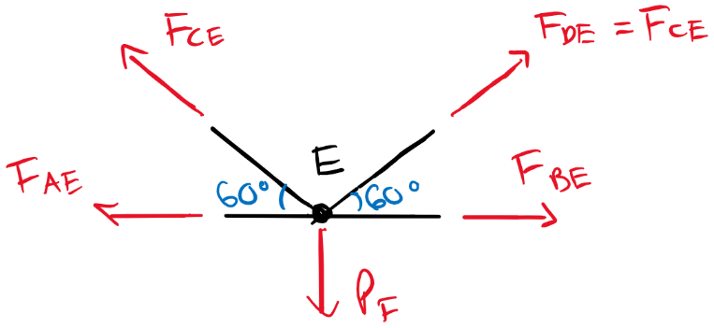

ΣFY = 0 = -PF + FCE sin60 + FDE sin60

FCE = PF/(2sin60)

FCE = 22.5 kN / (2sin60)

FCE = 13.0 kN (tension)

Now we can use the selection tables to select a 38 mm Nothern No. 1 member for the factored load in CE. Similarly to above, its important to note that the Wood Design Manual selection tables offer resistance values for standard conditions only (typically meaning standard load durations, dry service conditions, no treatments, basic loading configurations, and etc.). Therefore, any strength reducing/increasing factors must be accounted for manually.

For the purposes of selecting a member from the tables, we can adjust the force calculated for member CE by the load duration factor for our governing case as well as the assumed reduction in gross area of 15% for connections (both factors reduce the capacity of a member and will increase the “apparent” load).

For use in the member selection tables:

TR, selection ≥ FCE/KD(AN/AG) = (13.0 kN)/ [(0.81)(0.85)]

TR, selection ≥ 18.9 kN

From the selection tables for 38 mm Nothern No. 1 Sawn Timber Tension members, the minimum suitable size appears to be 38x140 with TR = 24.9 kN.

Design Check for 38 x 140 mm:

Per **Table 6.3.1.A**, member is “Structural Joist + Plank”.

Member Properties (**Table 6.4.5**):

ft = 4.0 MPa (tensile strength)

Calculating Sawn Lumber Tensile Resistance Parallel to Grain (**6.5.9**)

TR = φFtAnKzt ≥ FCE

Ft = ft (KDKHKstKT)

Ft = (4.0 MPa)(0.81)(1)(1)(1)

Ft = 3.24 MPa

Kzt = 1.3 (**Table 6.4.5**)

TR = (0.9)(3.24 MPa)(0.85 x 38 x 140 mm2)(1.3) ≥ 13.0 kN

TR = 17.1 kN ≥ 13.0 kN (**Passes**)

This section passes the tensile design check, but is it the smallest possible member per the original question? Check one size lower: 38 x 89 mm

Design Check for 38 x 89 mm:

Kzt = 1.5 (**Table 6.4.5**)

TR = (0.9)(3.24 MPa)(0.85 x 38 x 89 mm2)(1.5) ≥ 13.0 kN

TR = 12.6 kN ≥ 13.0 kN (**FAILS**)

The new section fails the tension design check. Therefore, 38 x 140 mm is the smallest suitable member of this grade and species.

# Question 2

Here, we are to select a column depth for a 16c-E D. Fir-L member with the bracing and loading shown and in wet conditions. This will prove more challenging than question 1 as we cannot easily compensate for varying KD values for axial compression members.

Considering the following load combinations, we get:

Load Case 1:

Pf1 = 1.4D = 1.4(300 kN) = 420 kN

KD = 0.65

Load Case 2:

Pf2 = 1.25D + 1.5L + 1.0S = 1.25(300 kN) + 1.5(100 kN) + 1.0(150kN) = 675 kN

The greatest standard term load Ps is calculated per **5.3.2.3**.

PS = S + 0.5L = 200 kN

KD = 1.0 – 0.5log(PL/PS) = 1.0 – 0.5log(300/200)

KD = 0.91

Load Case 3:

Pf3 = 1.25D + 1.5S + 1.0S = 1.25(300 kN) + 1.5(150 kN) + 1.0(100 kN) = 700 kN

For the same standard and long-term loads as Case 2, KD will be the same.

KD = 0.91

For the same KD, we can distinguish that Load Case 3 will govern over Load Case 2. We must proceed with full design calculations to determine which will govern between Case 1 and 3.

Design Check:

The column is in wet service conditions which yields the following reduction factors from **Table 7.4.2.**

KSC = 0.75; KSE = 0.9

Based on these reduction factors, the compression resistance will be reduced by at least 0.75 compared to the tabulated values. We can take an educated guess and conservatively choose a trial member from the selection tables. Try 215x304 mm 16c-E D. Fir-L (Table Pr = 902 to 1320 kN for L = 2.0 to 4.0 m)

Member Properties (**Table 7.3**):

fC = 30.2 MPa

E = 12.4 GPa

For glulam columns (not sawn lumber), the compression design is governed by the greatest axial slenderness ratio calculated in **7.5.8**. Only the most slender axis need be considered.

**Strong Axis:**

CCX = LX Ke /d

Note that the product LKe is the effective column length and relies on the shortest unbraced length of the column. Here, there is intermediate support in both axes, and Ke = 1.0 for pin-pin supports (**A.6.5.6.1**).

CCX = (4.0 m)(1.0)/(0.304 m) = 13.3 ≤ 50

**Weak Axis:**

CCY = LY Ke / b

CCY = (3.0 m)(1.0) / (0.215 m) = 14.0 ≤ 50 (Weak axis governs design)

For axial compression resistance parallel to grain:

PR = φFCAKzcgKC

Kzcg = 0.68(beam volume)-0.13 ≤ 1.0

Kzcg = 0.68(8000 x 304 x 215 mm3)-0.13 ≤ 1.0

Kzcg = 0.74 ≤ 1.0

Now for FC and KC the calculations will diverge depending on our potentially governing load cases:

Load Case 1:

FC = fc KDKHKSCKT = (30.2 MPa)(0.65)(1.0)(0.75)(1.0) = 14.7 MPa

KC =[1.0 + FCKzcgCC3 / 35E05KseKT ]-1

E05 = 0.87E = 0.87(12.4 GPa)

KC = [1.0 + (14.7 MPa)(0.74)(14.0)3/35(10788 MPa)(0.90)(1.0)]-1

KC = 0.92

Now:

Pr1 = (0.80)(14.7 MPa)(215 x 304 mm2)(0.74)(0.92) ≥ Pf1

Pr1 = 523 kN ≥ 420 kN (**Passes**)

This member is suitable for Load Case 1.

Load Case 3:

FC = (30.2 MPa)(0.91)(1.0)(0.75)(1.0) = 20.6 MPa

KC = [1.0 + (20.6 MPa)(0.74)(14.0)3 / 35(10788 MPa)(0.90)(1.0)]-1

KC = 0.89

Now:

Pr3 = (0.80)(20.6 MPa)(215 x 304 mm2)(0.74)(0.89) ≥ Pf3

Pr3 = 709 kN ≥ 700 kN (**Passes**)

This member is suitable for Load Case 3.

This section passes the compression design check for both load cases. It is interesting to observe the ~200 kN difference in compressive strength resulting from varying KD factors. This column is reasonably efficient with a utilization of 700/709 = 0.99.

# Question 3

**Key Assumptions:**

-Wet service conditions

-All joist loads are the same

-Only joist bearing may govern (shear and flexure assumed adequate). The joists rest on half of the girder’s width

-Only girder bearing, shear, moment, or deflection may govern (connections and columns are adequate)

-PL = 0.5PD

Therefore, the bearing capacity of the joists and the moment, shear, deflection, and bearing capacity of the girder must be calculated to determine the critical Pf.

For dead and live loads only, the following load cases may govern. Since axial compression is not considered, we can determine the governing load case based on KD.

Load Case 1:

Pf = 1.4D = 1.4PD

KD = 0.65

Pf/KD = 2.15PD

Load Case 2:

Pf = 1.25D + 1.5L = 1.25PD + 1.5(0.5PD) = 2PD

KD = 1.0 – 0.5log(PD/0.5PD) = 0.85

Pf/KD = 2.35PD (**governs over load case 1**)

Therefore, Load Case 2 will govern.

Girder Properties: 215x950 SPF 20f-E

fb = 25.6 MPa; fv = 1.75 MPa; fcp = 5.8 MPa; ftb =5.8 MPa; E = 10300 MPa

KSV = 0.87; KSE = 0.90; KSb =0.80; KScp = 0.67

Joist Properties: 191x343 D. Fir-L Select Structural

fcp = 7.0 MPa

KScp = 0.67

Shear/Moment Diagram:

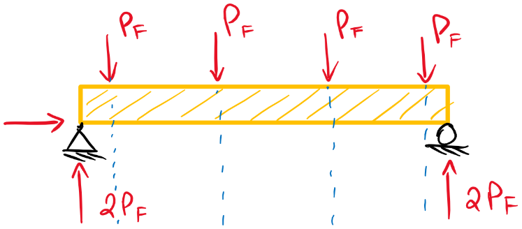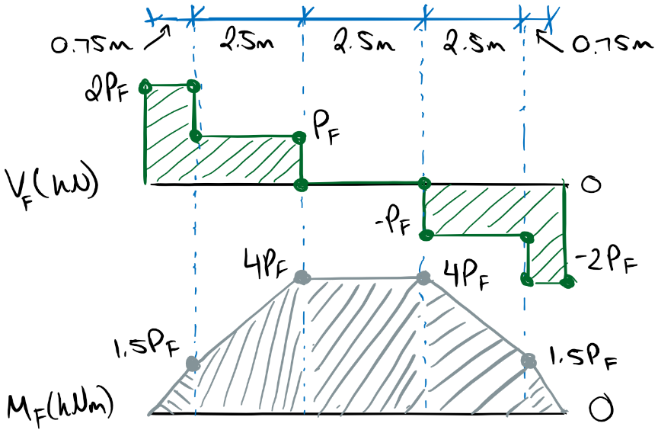

Mf, max = 4Pf

Vf, max = Pf for a distance d away from the support per **7.5.7.1.1**

Girder Shear Resistance (**7.5.7.2**):

The beam volume must be checked to determine the appropriate shear calculation per **7.5.7.2**

Z = bdl = 0.215 x 0.950 x 9 m3 = 1.84 m3 < 2.0 m3

The volume is less than 2.0 m3 so we can use the simplified shear calculation in **7.5.7.2.b**

Vr = φFVAG2/3

Fv =fvKDKHKsvKT = (1.75 MPa)(0.85)(1.0)(0.87)(1.0) = 1.29 MPa

Vr = (0.90)(1.29 MPa)(215 x 950 mm2)2/3 ≥ Vf = Pf

Vr = 158 kN ≥ Pf

Girder Moment Resistance (**7.5.6.5**):

This beam only has one point of inflection in the factored applied moment. Therefore, no special considerations are needed per the note in **7.5.6.5**.

Two moment resistance calculations are offered in O86-14, Mr1, which checks the moment resistance in pure flexure with a failure mode in extreme fibre failure, and Mr2, which checks the moment resistance for failure in lateral torsional buckling. This is why Mr2 utilizes the lateral stability factor KL.

Mr1 = φFbSKxKzbg

Mr2 = φFbSKxKL

Fb = fbKDKHKsbKT = (25.6 MPa)(0.85)(1.0)(0.80)(1.0) = 17.4 MPa

S =bd2/6 = (215 mm)(950 mm)2/6 = 32.34 x 106 mm3

The size factor for glulam in bending applies the width of the widest laminate (taken as b/2 = 107.5 mm in this example).

Kzbg = [130/b x 610/d x 9100/L]1/10 ≤ 1.3

Kzbg = [ 130/(107.5 mm) x 610/(950 mm) x 9100/(9000 mm)]1/10 ≤ 1.3

Kzbg = 0.98 ≤ 1.3

For the lateral stability factor we can assume the joist loads stabilize the member which makes the joist spacing the maximum unsupported beam length (**7.5.6.4.3**). Therefore,

a = 2.5 m

We can calculate the effective beam length Le from **Table 7.5.6.4.3**. The loading condition in this example doesn’t fit into a category for evenly spaced point loads (maybe it falls between 1/3 to 1/5 points – judgement call) so we will be conservative and use the calculation for “any loading”.

Le = 1.92a = 1.92(2.5 m) = 4.8 m

The slenderness ratio is:

CB = [Led/b2]1/2 = [ (4.8 m)(0.95 m)/(0.215 m)2]1/2 = 9.93 ≤ 50

Now from **7.5.6.4.4** for CB < 10:

KL = 1.0 (our conservative Le calculation likely would not have change much).

Now we can calculate the Mr.

Mr1 = (0.90)(17.4 MPa)(32.34x106 mm3)(1.0)(0.98)

Mr1 = 496 kNm (**governs Mr**)

Mr2 = (0.90)(17.4 MPa)(32.34x106 mm3)(1.0)(1.0)

Mr2 = 506 kNm

Therefore,

Mr = 496 kNm ≥ Mf = 4Pf

Girder Bearing (**7.5.9**):

The bearing on the girder must be considered in two capacities. The first, governed by **7.5.9.2** is the bearing at the applied loads from the joists away from the support. The second, governed by **7.5.9.3** is the bearing within a distance d from the center of the support (also called critical bearing). In this region, the beam is “squeezed” between the applied load and the support which causes a different bearing mechanism than the first case.

Bearing at the Joist Load (away from the support – **7.5.9.2**):

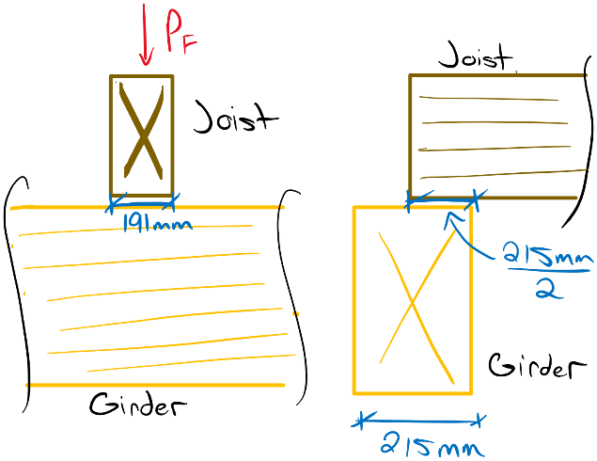

Qr = φFcpAbKBKzcp

Fcp = fcpKDKscpKT = (5.8 MPa)(0.85)(0.67)(1.0) = 3.3 MPa

AB = 191 mm x 215 mm/2 =20532.5 mm2

The size factor for bearing is determined in **6.5.7.4** using the laminate thickness as the depth.

For b/d = (215 mm)/(38 mm) = 5.7 ≥ 2.0,

Kzcp = 1.15

The length of bearing factor KB is determined by **6.5.7.5**. Since the middle two joists are in the region of highest bending stress, the benefit of locally stressing fibres to resist bearing should be ignored.

KB = 1.0

Qr, load = (0.80)(3.3 MPa)(20532.5 mm2)(1.0)(1.15) ≥ Qf

Qr, load = 62 kN ≥ Qf = Pf

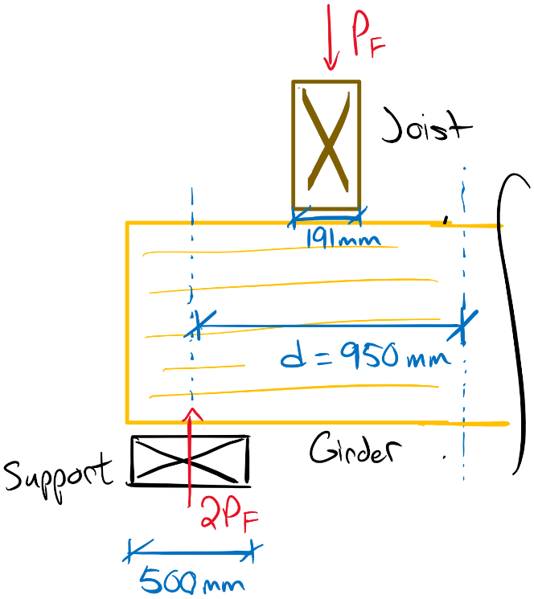Bearing at the Support Reaction (**7.5.9.2**):

Ab = 500 mm x 215 mm = 107500 mm2

Since the bearing length falls within 75 mm from the end of the member, no strength bonus from the length of bearing is permitted.

KB = 1.0

Qr, support = (0.80)(3.3 MPa)(107500 mm2)(1.0)(1.15) ≥ Qf

Qr, support = 326 kN≥ Qf = 2Pf

Critical Bearing at the Joist Load (near support – **7.5.9.3**):

Qr’ = 2/3 φFcpAb’KBKzcp

Since the bearing area is away from the member end and not in a region of high bending stress, we can get KB from **Table 6.5.7.5**. However, for a bearing length greater than 150 mm (191 mm), no increase is permitted.

KB = 1.0

The average bearing area between the support and the load near the support is needed (**6.5.7.3.2**):

Ab’ = b (Lb1 + Lb2)/2 ≤ 1.5bLb1

b = (215 mm + 107.5 mm)/2 = 161.25 mm

Ab’ = (161.25 mm) [(191 mm)(500 mm)]/2 ≤ 1.5(161.25 mm)(191 mm)

Ab’ = 55712 mm2 ≤ 46198 mm2

Ab’ = 46198 mm2

Qr’ = 2/3 (0.80)(3.3 MPa)(46198 mm2)(1.0)(1.15) ≥ Qf

Qr’ = 93.5 kN ≥ Qf = Pf

Girder Deflection:

The deflection limit of L/360 may also govern the factored load Pf. Per **5.4.1**, the modulus of elasticity needs to be modified by KSE for deflection calculations. For the deflections of a beam in the loading conditions shown, we can rely on the Beam Diagrams in the reference information section of the CWC Wood Design Manual. While there is no diagram for the loading specific in this example, for elastic deflections we can use the superposition of two states to calculate the total deflection.

Es = EKSEKT = (10300 MPa)(0.90)(1.0) = 9270 MPa

EsI = (9270 MPa)(215 mm)(950 mm)3/12 = 142400 kNm2

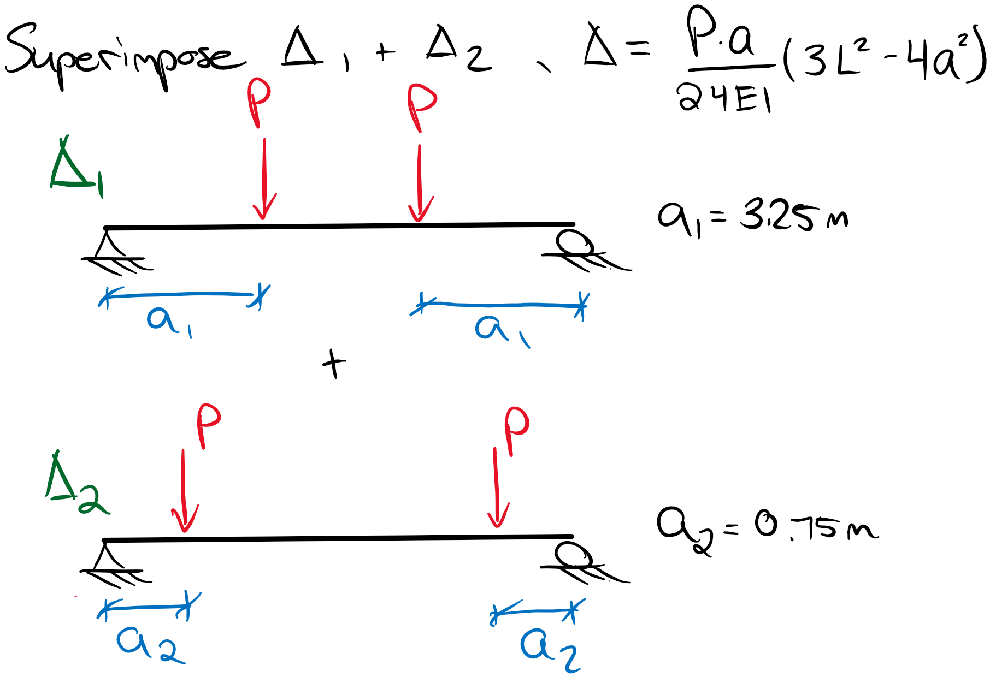

Δtotal = Δ1 + Δ2 ≤ L/360

Δtotal = Pa1 (3L2-4a12)/24EI + Pa2 (3L2-4a22)/24EI

P ≤ 24EsIL/360 x [a1 (3L2-4a12)+ a2 (3L2-4a22)]-1

P ≤ 24(142400 kNm2)(9 m)/360 x [ (3.25 m)(3(9 m)2 – 4(3.25 m)2) + (0.75 m)(3(9 m)2 – 4(0.75 m)2) ]-1

P ≤ 102 kN

Now we must finally check the bearing of the joist member.

Joist Bearing (**6.5.7**):

Since there are no bearing loads applied within a distance d from the support (the joist supports a distributed load), the only bearing check needed is for the support. Therefore, 6.5.7.2 applies. The length of bearing and size factor must be calculated for this scenario.

Qr, joist = φFcpAbKBKzcp

For b/d = 191/343 < 1.0,

Kzcp = 1.0

Per **6.5.7.5**, since the bearing area occurs at the end of the member, no strength benefit can be claimed.

KB = 1.0

Fcp = fcpKDKspKT = (7.0 MPa)(0.85)(0.67)(1.0) = 4.0 MPa

Qr, joist = (0.80)(4.0 MPa)(107.5x191 mm2)(1.0)(1.0) ≥ Qf

Qr, joist = 65.5 kN ≥ Qf = Pf

**Summary of Governing Loads:**

Based on the various resistances and limits calculated, we can determine the governing PD, PL using the relationships determined earlier Pf = 2PD, PL = 0.5PL, and P = 1.5PD.

Girder Shear:

Vr = 158 kN ≥ Pf

Pf ≤ 158 kN

PD = 79 kN, PL = 39.5 kN

Girder Moment:

Mr = 496 kNm ≥ 4Pf

Pf ≤ 124 kN

PD = 62 kN, PL = 31 kN

Girder Deflection:

Δtotal ≤ L/360

P ≤ 102 kN = 1.5PD

PD = 68 kN , PL = 34 kN

Girder Bearing @ Joist Load away from support:

Qr, load = 62 kN ≥ Pf

Pf ≤ 62 kN

PD = 31 kN , PL = 15.5 kN (**Governs**)

Girder Bearing @ Support Reaction:

Qr, support = 326 kN≥ 2Pf

Pf ≤ 163 kN

PD = 81.5 kN, PL = 40.8 kN

Girder Critical Bearing Near Support:

Qr’ = 93.5 kN ≥ Pf

Pf ≤ 93.5 kN

PD = 46.8 kN, PL = 23.4 kN

Therefore, based on this system, the bearing at a joist load away from the support is the governing case and limits PD to 31 kN and PL to 15.5 kN.

# Question 4

This configuration introduces bearing at an angle to the grain direction of the 241x241 member. Therefore, **6.5.8** applies which requires a combination of both bearing (perpendicular to grain) and compression (parallel to grain) resistances for the member with some basic modifications.

fc = 8.7 MPa

fcp = 5.3 MPa

Kzcp­ = 1.0 (assumed in question)

For bearing at an angle to the grain:

Nr = PrQr/(Prsin2θ + Qrcos2 θ)

where Pr is calculated assuming KC = 1.0

Resistance Parallel to grain (**6.5.6.2.3**):

Fc = fcKDKHKscKT = (8.7 MPa)(1.0)(1.0)(1.0)(1.0) = 8.7 MPa

Pr = φFcAKzcKC = (0.80)(8.7 MPa)(241x241 mm2)(1.0)(1.0)

**Pr = 404 kN**

Resistance Perpendicular to grain (**6.5.7.2**):

Fcp = fcpKDKscpKT = (5.3 MPa)(1.0)(1.0)(1.0) = 5.3 MPa

Qr = φFcpAbKBKzcp

The bearing length parallel to grain is:

Lb = 191 mm/sin30° = 382 mm > 150 mm

KB = 1.0

For b/d = 241/241 ≤ 1.0,

Kzcp = 1.0

Qr = (0.80)(5.3 MPa)(382x141 mm2)(1.0)(1.0)

**Qr = 228 kN**

Total bearing resistance at an angle to grain:

Nr = (404 kN)(228 kN)/[ (404 kN)sin2(30) + (228 kN)cos2(30) ]

Nr = 339 kN

Therefore the bearing resistance of the beam for this configuration is 339 kN.

# Question 5

In this example, we are to determine the minimum number of plies needed for the built-up sawn cantilever column assuming the nail requirements are met per **6.5.6.4.2**. We can use two properties of built-up columns to solve for the number of plies: 1) **6.5.6.4.6** allows the strong axis to see no reduction in compressive strength and 2) **6.5.6.4.2** allows 60% of the gross section compressive strength for the weak axis to be taken. Therefore, we can solve for the governing weak axis member depth using these relationships.

Member Properties: 38x184 D.Fir-L No. 2

fc = 14.0 MPa; E05 = 7000 MPa

KTE = 0.95; KT = 0.85 (Table 6.4.3)

Ksc = 0.69; K­SE = 0.94 (Table 6.4.2)

KD = 1.0

Strong Axis Compression:

The strong axis compressive resistance is taken as the full resistance of the gross section. For a cantilever column, the Ke can be found in **A.6.5.6.1**.

C­cx = KeL/d = (2.0)(3.5 m)/(0.184 mm) = 38.0 ≤ 50

Kzc = 6.3(dL)-0.13 ≤ 1.3

Kzc = 6.3(184 mm x 3500 mm)-0.13 ≤ 1.3

Kzc = 1.1 ≤ 1.3

Fc = fcKDKHKscKT = (14.0 MPa)(1.0)(1.0)(0.69)(0.85) = 8.21 MPa

Kc = [1.0 + FCKzcgCC3 / 35E05KseKT ]-1­

Kc = [1.0 + (8.21 MPa)(1.1)(38.0)3 / 35(7000 MPa)(0.94)(0.85)]1

Kc = 0.283

Prx = φFcAKzcKc x n ≥ Pf = 20 kN

n ≥ (20000 N)/(0.8)(8.21 MPa)(38x184 mm2)(1.1)(0.283)

n ≥ 1.4 plies

**n = 2 plies for sufficient strong axis Pr**

Weak Axis:

Weak axis Pr is taken as 60% of the built-up gross section.

Ccy = KeL/nb = (2.0)(3.5 m)/n(0.038 m) ≤ 50

n ≥ (2.0)(3.5 m)/50(0.038 m)

n ≥ 3.68 plies

**n = 4 plies to meet slenderness requirements**

Proceed resistance check for 4 plies:

Ccy = (2.0)(3.5 m)/(4)(0.038 m) = 46 ≤ 50

Kc = [1.0 + (8.21 MPa)(1.1)(46.0)3 / 35(7000 MPa)(0.94)(0.85)]1

Kc = 0.182

Pry = 0.60 x φFcAKzcKc x n ≥ Pf = 20 kN

Pry = 0.60 x (0.80)(8.21 MPa)(38x184 mm2)(1.1)(0.182) x 4 plies ≥ Pf = 20 kN

Pry = 22 kN ≥ Pf = 20 kN

Therefore, 4 plies is the minimum number to resist Pf for a fixed member size of 38x184.

# Question 6

This question involves determining the governing beam resistance in both cases when deflections and bearing are not considered. Therefore, the possible governing cases are:

- Beam Flexure (same resistance in both cases)

- Beam Shear (same resistance in both cases)

- Tension Notch Shear (Case A)

- Compression Notch Shear (Case B)

Beam Properties: 365x798 D.Fir-L 24f-E

Laminates are b/2 x 38 mm

fb = 30.6 MPa; fv = 2.0 MPa; E = 12800 MPa

No treatment, dry service conditions

KD = 1.15

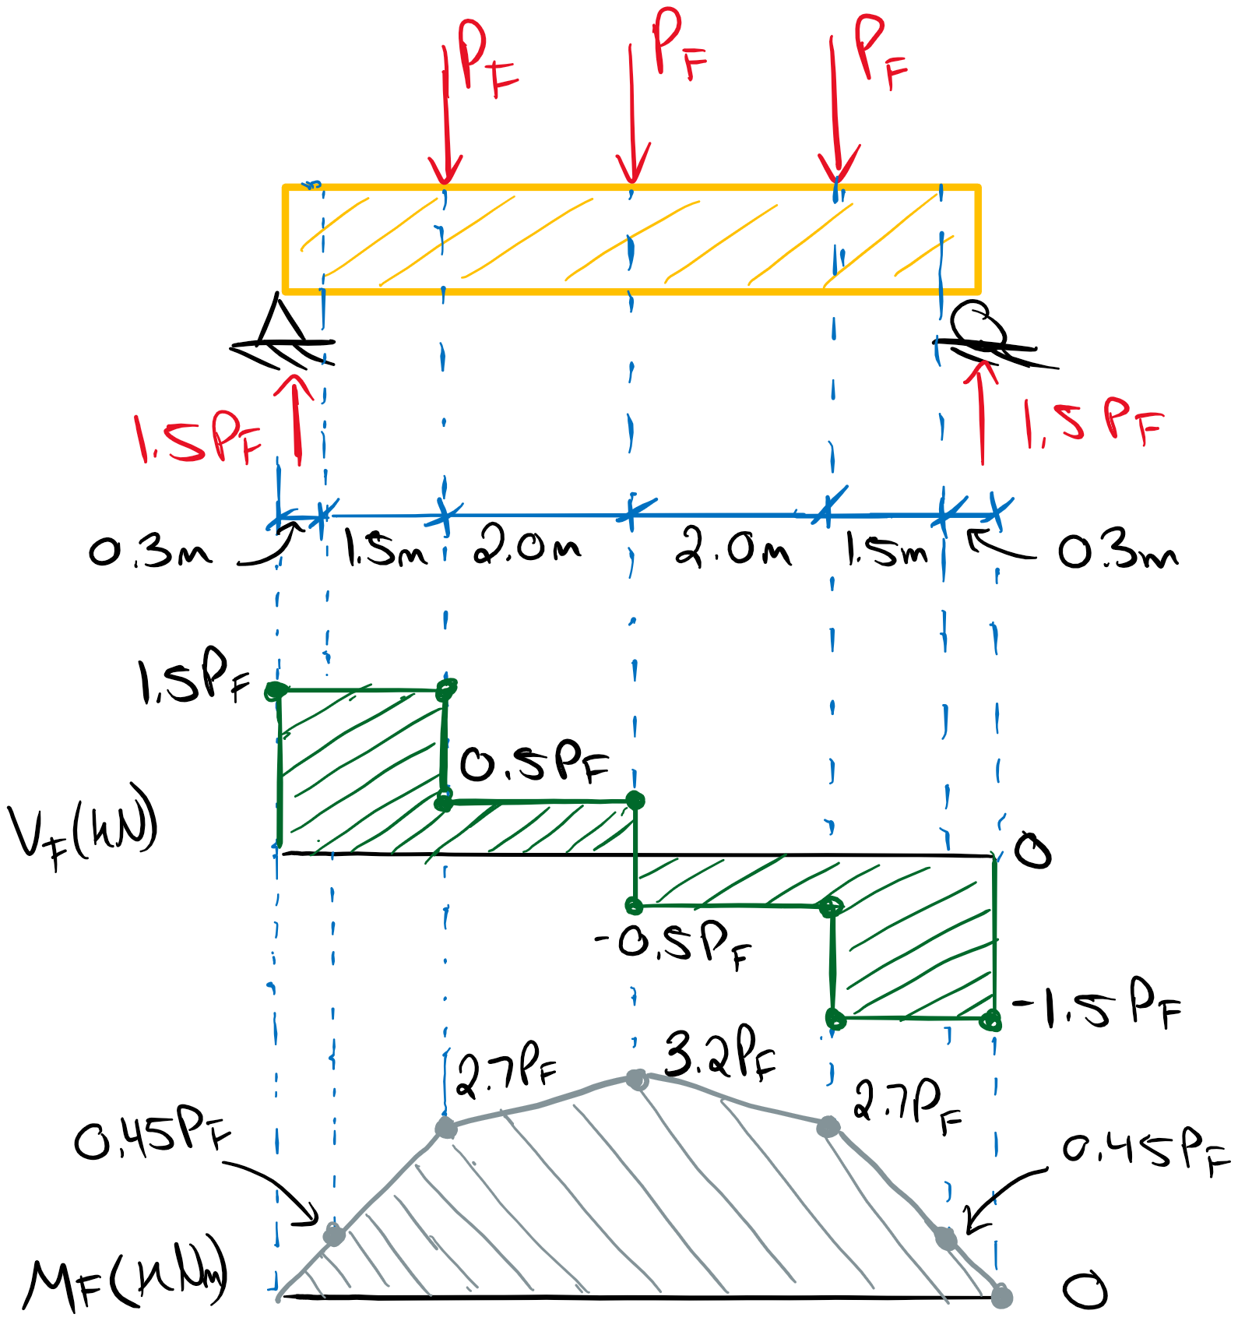

Moment Resistance:

The moment resistance will be checked for both the midspan and the reduced cross-section as a precaution.

Full Depth:

S = bd2/6 = 38.73 x 106 mm3

Fb = fbKDKHKsbKT = (30.6 MPa(1.15)(1.0)(1.0)(1.0) = 35.2 MPa

Kzbg = [130/b x 610/d x 9100/L]1/10 ≤ 1.3

Kzbg = [ 130/(182.5 mm) x 610/(798 mm) x 9100/(7600mm)]1/10 ≤ 1.3

Kzbg = 0.96 ≤ 1.3

Assuming the purlins provide lateral stability, the maximum purlin spacing is 2.0 m. Due to irregular load spacing we will conservatively apply the “any loading” condition in **Table 7.5.6.4.3**.

a = 2.0 m

Le = 1.92a = 3.84 m

CB = [Led/b2]1/2 = [ (3.84 m)(0.798 m)/(0.365 m)2 ]1/2 = 4.8 ≤ 50

For CB ≤ 10 in **7.5.6.4.4**

KL = 1.0

Mr1 = φFbSKzbgKx

Mr1 = (0.9)(35.2 MPa)(38.73 x 106 mm3)(0.96)(1.0)

**Mr1 = 1179 kNm ≥ Mf = 3.2Pf (governs Mr)**

Mr2 = φFbSKLKx

Mr2 = (0.9)(35.2 MPa)(38.73 x 106 mm3)(1.0)(1.0)

Mr2 = 1227 kNm ≥ Mf = 3.2Pf

After Notch:

As an exercise, the moment resistance at the notched section can be compared to the factored moment in the same location. Calculating the moment resistance after the notch requires some discretion since the relevant Mr calculations consider lateral torsional buckling and extreme fibre failures. For a small segment of the beam, it may not be appropriate to recalculate KL and Kzbg in the sense that the risk of lateral torsional buckling over a small section near a support may not be increased sufficiently to warrant determining a new CB for the reduced section, nor a new size factor. As an estimate, we can adjust the governing Mr for the full beam depth through adjusting the section modulus for the reduced beam depth.

Sreduced = (365 mm)(684 mm)2/6 = 28.46 x 106 mm3

Mr1, notch = (0.9)(35.2 MPa)(28.46 x 106 mm3)(0.96)(1.0)

Mr1, notch = 866 kN ≥ Mf = 0.45Pf

Therefore, the notching resulted in 66/1179 = 0.73 of the moment resistance but is compensated by 0.45Pf/3.2Pf = 0.14 of the factored moment. Therefore, the drop in factored moment at the notch is more significant than the loss of moment resistance from the notch.

Longitudinal Shear Resistance (**7.5.7**):

The longitudinal shear resistance will be the same for both configurations. The volume of the beam must be checked to determine if the simplified shear procedure is valid.

Z = Lbd = (7.8 m)(0.365 m)(0.798 m) = 2.3 m3 ≥ 2.0 m3

The beam volume is greater than 2.0 m3 therefore the longitudinal shear resistance is governed by **7.5.7.2a**.

Wr = φFv0.48AgCvZ-0.18 ≥ Wf

Where Wf is all factored loads acting perpendicular to the member, not just the maximum Vf as done previously for the simplified shear procedure.

Fv = fvKDKHKsvKT = (2.0 MPa)(1.15)(1.0)(1.0)(1.0) = 2.3 MPa

The shear load coefficient Cv is determined in **7.5.7.5**. Since the loading in this example is not exactly specified by **Table 7.5.7.5A**, the procedure in **7.5.7.5a-d** must be followed.

a) See Vf diagram above

b) There are a total of 4 segments each representing a constant value of Vf such that there is no abrupt change in the factored shear.

c) Calculate the factor G for each segment

Segment 1:

VA = 1.5Pf ; VB = 1.5Pf ; VC = 1.5Pf ; la = 1.8 m

G1 = la[VA5 + VB5 + 4VC5] = 82Pf5 mkN5

Segment 2:

VA = VB = VC = 0.5Pf ; la = 2.0 m

G2 = la[VA5 + VB5 + 4VC5] = 0.375Pf5

Segment 3:

Same as segment 2

G3 = 82Pf5

Segment 4:

Same as segment 1

G4 = 0.375Pf5

d) Calculate Cv. Pay attention to the units to assure yourself the final Cv value is unitless. The variable load Pf cancels out of the equation.

Cv = 1.825Wf (L/ΣG)1/5

Wf = 3Pf (sum of all normal loads)

Cv = 1.825(3Pf)[ (7.6 m)/(82Pf5 + 0.375Pf5 + 0.375Pf5 + 82Pf5)mkN5 ]1/5

Cv = 2.96

As an exercise, let’s assume the loading in this example is symmetrically placed such that we can determine Cv with **Table 7.5.7.5A**. Here we must calculate the ratio of concentrated loads to uniform loads, r*.

r* = 3Pf / 0

As there are no uniform loads, the ratio is undefined and becomes infinity which falls under the “10.0 and over” category. Then, for three concentrated loads.

Cv = 2.84

Therefore we achieve a slight increase in Cv (and therefore shear resistance) based on this specific non-standard loading condition.

Wr = (0.90)(2.3 MPa)0.48(365 x 798 mm2)(2.96)(2.3 m3)-0.18 ≥ Wf = 3Pf

**Wr = 737 kN ≥ 3Pf**

Now the notch shear resistance in both cases must be calculated to assess the critical factored load.

Case a) Tension Side Notch Shear:

For tension-side notches, the notch shear resistance is governed by **7.5.7.4**. Per **7.5.7.4.1**, notches with depths less than a quarter of the beam’s depth are permitted within a distance equal to the beam’s depth with no reduction in the longitudinal shear resistance calculated in **7.5.7.2**. **Figure 6.5.5.3.2** provides some help in determining tension notch parameters.

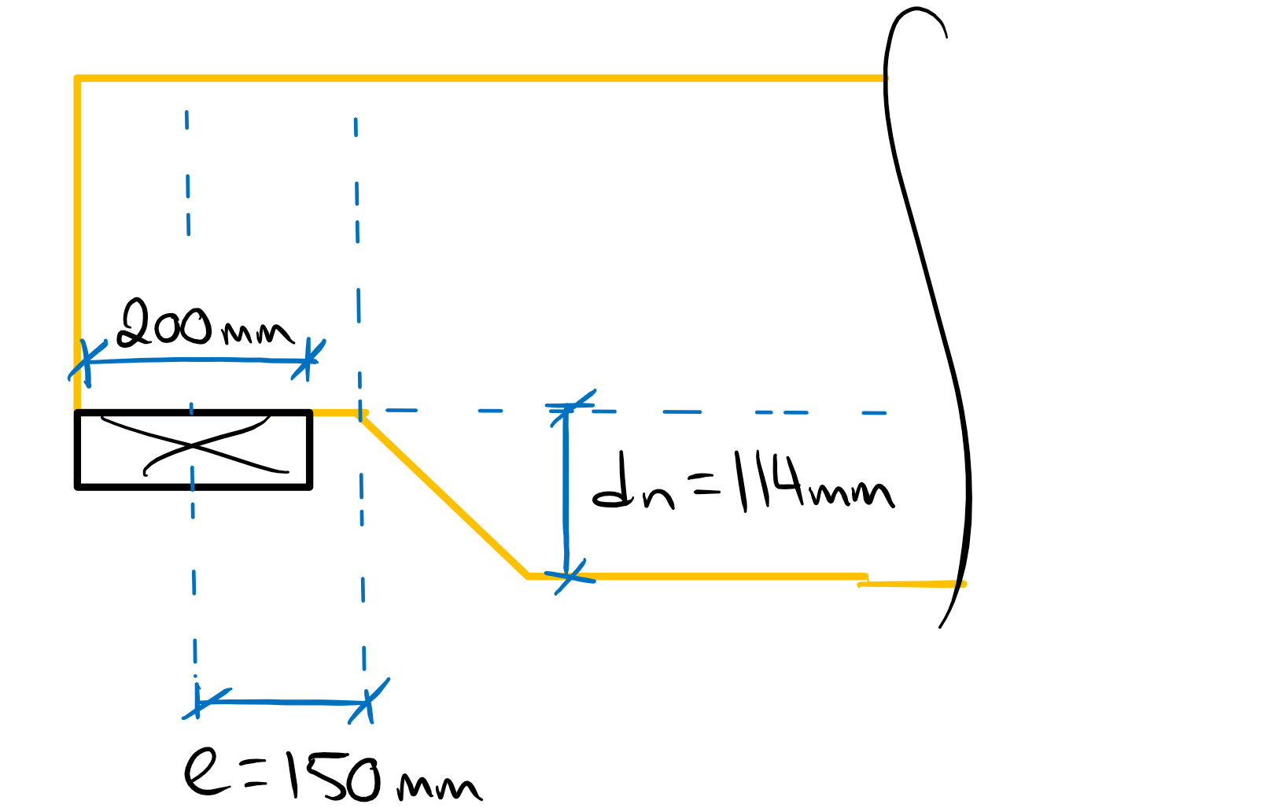

The fracture shear resistance at a tension-side notch is calculated as follows:

Fr = φFfAgKN

Ff = ffKDKHKsfKT

ff = max(2.5beff-0.2 or 0.9 MPa)

beff is taken as the width of the widest lamination (in this case b/2 = 182.5 mm)

fr = max( 2.5(182.5 mm)-0.2 , 0.9 MPa) = max (0.88 MPa , 0.9 MPa) = 0.9 MPa

Ff = (0.9 MPa)(1.15)(1.0)(1.0)(1.0) = 1.035 MPa

The Notch Factor, KN, can be determined through the equation given in **7.5.7.4.2** (the same as **6.5.5.3.2**) or alternatively through interpolation in **Table 6.5.5.3.2** with the notch dimensional parameters.

KN = [ 0.006d ( 1.6 (1/α – 1) + η2 (1/ α3 – 1))]-1/2

α = 1 – dn/d = 1 – (114 mm)/(798 mm) = 0.857

η = e/d = (150 mm)/(798 mm) = 0.188

dn = 114 mm ; e = 150 mm (see **Figure 6.5.5.3.2**)

KN = [ 0.006(798 mm) ( 1.6 (1/(0.857) – 1) + (0.188)2 (1/ (0.857)3 – 1))]-1/2

KN = 0.85

As an exercise, we can determine KN through **Table 6.5.5.3.2** with interpolation. Both methods are valid however the interpolation method may prove faster if the specific values of α and η are close to the reported values. Otherwise single or double interpolation may be required. In this example, double interpolation is required for a KN corresponding to α = 0.857, η = 0.188.

Interpolating for KN­­d1/2(α = 0.857, η = 0.15) = 24.6

Interpolating for KN­­d1/2(α = 0.857, η = 0.20) = 24.1

Now, Interpolating between these values for KN­­d1/2(α = 0.857, η = 0.188) = 24.2

Therefore,

KNd1/2 = 24.2

KN = 24.2/(798 mm)1/2 = 0.86

This value can be compared to that determine with the equation in **7.5.7.4.2**. Note the values are very similar and either method can be used to determine KN.

Fr = (0.90)(1.035 MPa)(365 x 798 mm2)(0.85)

**Fr = 231 kN ≥ 1.5Pf**

Case b) Compression Side Notch Shear:

Notch shear resistance for compression-side notches is determined by **7.5.7.3**. For compression notches, note the value of ec is different than the value of e for tension-side notches, as ec is measured from the edge of the support face to the end of the notch and e is taken from the center of the support to the beginning of the notch.

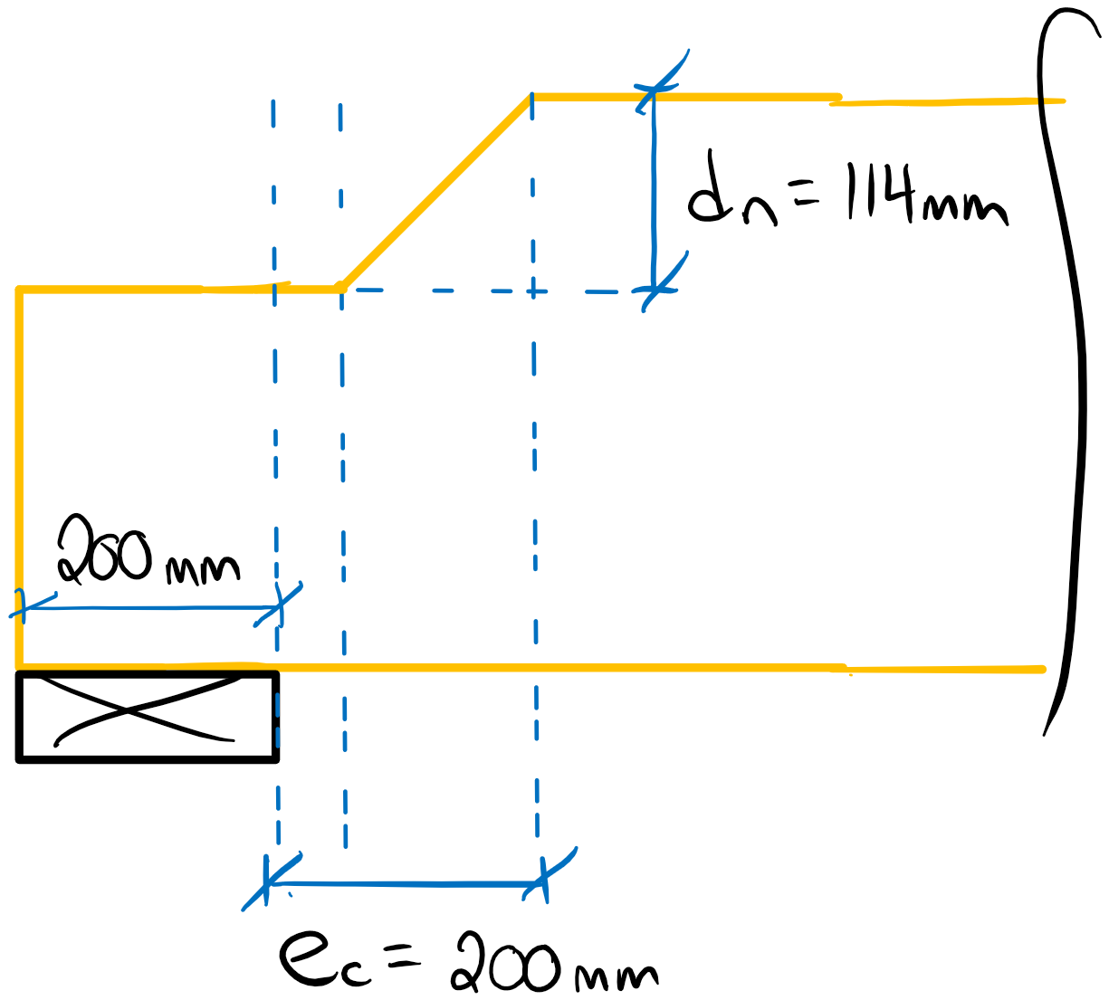

ec = 200 mm; dn = 114 mm

For ec = 200 < d = 798 mm:

Vr = φFv2/3Ag [1 – dnec/d(d - d­n)]

Vr = (0.90)(2.3 MPa)2/3(365x798 mm2)[1 – (114 mm)(200 mm)/ ( (798 mm)(798 mm – 114 mm) ) ]

**Vr = 385 kN ≥ 1.5Pf**

Now we can compare the various resistances to determine the governing factored load.

**Summary:**

Moment Resistance:

Mr = 1179 kNm ≥ 3.2Pf

Pf ≤ 368 kN

Longitudinal Shear Resistance:

Wr = 737 kN ≥ 3Pf

**Pf ≤ 246 kN (Governs Case b)**

Case a) Tension Notch Shear:

Fr = 231 kN ≥ 1.5Pf

**Pf ≤ 151 kN (governs Case a)**

Case b) Compression Notch Shear:

Vr = 385 kN ≥ 1.5Pf

Pf ≤ 257 kN

Therefore the governing configuration is Case a) due to tension-side notch shear and the limiting Pf is 151 kN. For Case b), the maximum Pf that can be achieved is 246 kN.

# Question 7

The design of this multi-span cantilever beam will first require an analysis of the load combinations to maximize critical effects. Since bearing and deflection can be ignored, the relevant resistances to consider are shear and flexure.

Determining Maximum Factored Loads:

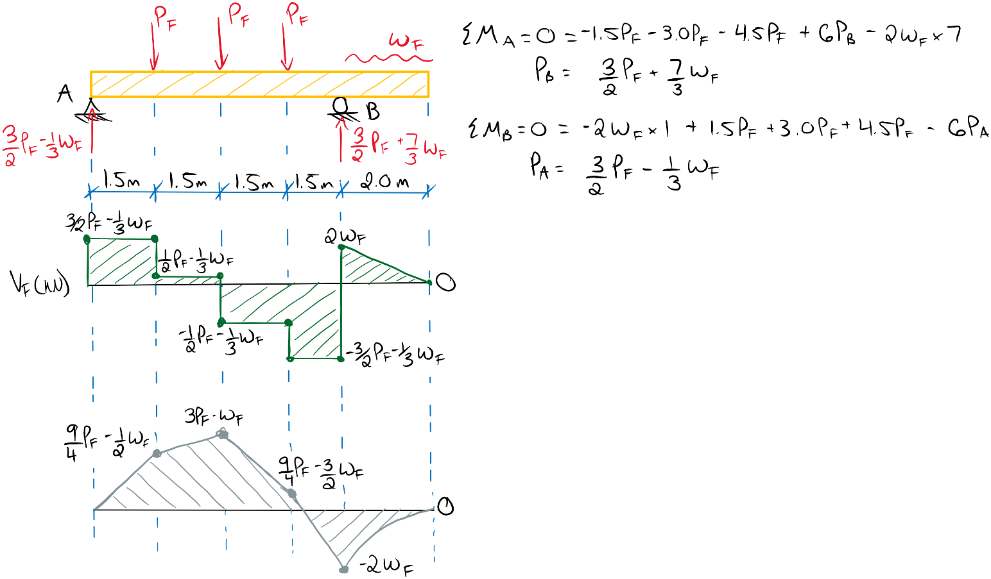A generalized shear and moment diagram based on variables Pf and wf can be created to allow easier calculation of factored loads for each combination.

Vf, max = -1/3wf – 1.5Pf

Mf+, max = -wf + 3Pf

Mf-, max = -2wf

Remember that the load duration factor KD will need to be considered for each load case.

Potential Load Cases for Maximum Factored Positive Moment:

Maximizing Pf and minimizing wf will produce the maximum positive moment.

1) 1.4D

Pf = 1.4(20 kN) = 28 kN , wf = 1.4(10 kN/m) = 14 kN/m , KD = 0.65

Vf, max/KD = 46.7 kN/0.65 = 72 kN

Mf+, max/KD = 70 kNm/0.65 = 108 kNm

Mf-, max/KD = 28 kNm/0.65 = 28 kNm

2) 1.25D + 1.5L

Note that the snow companion load is omitted on the cantilever to minimize wf. The snow load will also be omitted from the calculation of KD since it is not applied.

Pf = 62.5 kN , wf =12.5 kN/m, KD = 1.0 – 0.5log(80/75) = 0.99

**Vf, max/KD = 97.9 kN/0.99 = 99 kN (governs Vf)**

**Mf+, max/KD =175 kNm/0.99 = 178 kNm (governs Mf+)**

Mf-, max/KD = 25 kNm/0.99 = 25.2 kNm

Potential Load Cases for Maximum Factored Negative Moment:

3) 0.9D + 1.5S + (1.0L)

Maximizing wf and minimizing Pf will produce the maximum negative moment. Note the companion live load is omitted on the main span to minimize Pf. The snow load is now considered in KD but the live load is not.

Pf = 18 kN , wf =31.5 kN/m, KD = 1.0 – 0.5log(80/30) = 0.79

Vf, max/KD = -37.5 kN/0.79 = 47.5 kN

Mf+, max/KD = 22.5 kNm/0.79 = 28.5 kNm

**Mf-, max/KD = 63 kNm/0.79 = 79.7 kNm (governs Mf-)**

Potential Load Cases for Maximum Factored Shear:

Maximizing all loads normal to the beam will maximize the shear.

2) 1.25D + 1.5L + (1.0S)

Now the companion snow load is considered on the cantilever span to maximize wf. Note that since the specified dead load is now longer greater than the specific long term loads (since both snow and live load are considered), KD is taken as the duration factor of the shortest term load per **5.3.2.4**.

Pf = 62.5 kN , wf = 27.5 kN/m, KD = 1.15

Vf, max/KD = 103 kN/1.15 = 89.5 kN

Mf+, max/KD = 160 kNm/1.15 = 139 kNm

Mf-, max/KD = 55 kNm/1.15 = 47.8 kNm

Summary of Governing Factored Loads:

**Vf = 97.9 kN and KD = 0.99**

**Mf+ = 175 kNm and KD = 0.99**

**Mf-­ = 63 kNm and KD = 0.79**

Note that, despite a larger factored shear load in Load Case 2) with the companion snow load, the increased KD factor (KD = 1.15) will increase the member’s shear resistance such that the same load case without the companion snow load will instead govern the design due to its KD of 0.99. This dilemma reinforces the importance of the note in 5.3.2.2 which indicates designer judgment should be applied in determination of the duration factor. This example will proceed with the governing case indicated above.

Beam Properties (20f-E SPF glulam):

fb+ = 25.6 MPa ; fb- = 19.2 MPa ; fv = 1.75 MPa ; E = 10300 MPa

Ksb = 0.80 ; K­sf = 0.85 ; Ksv = 0.87 ; KSE = 0.90

To select an approximate section size from the selection tables, we must account for the strength reduction of the Ks and KD factors. This will be a rough guess since the beam in this configuration does not have standard loading nor a simple span.

Vf, max/KDKsv = 97.9 kN/(0.99)(0.87) = 114 kN

Mf+, max/KDKsb = 175 kNm/(0.99)(0.80) = 221 kNm

Mf-, max/KDKsb = 63 kNm/(0.79)(0.80) = 100 kNm

Assuming the shear resistance may govern the design, try 215x532 20f-E SPF glulam:

Mr, table = 234 kNm

Vr, table = 120 kN

**Design Check:**

Longitudinal Shear:

Z = 0.215 x 0.532 x 8 m3 = 0.92 m3 < 2.0 m3

Therefore, **7.5.7.2b** can be applied.

Vr = φFvAg2/3 ≥ Vf

Fv = fvKDKsvKHKT = (1.75 MPa)(0.99)(0.87)(1.0)(1.0) = 1.51 MPa

Vr = (0.90)(1.51 MPa)(215x532 mm2)2/3 ≥ Vf = 97.9

**Vr = 104 kN ≥ 97.9**

The longitudinal shear resistance is sufficient for this section.

Moment Resistance:

Per **7.5.6.5.1**, for a beam with multiple points of inflection in the factored moment distribution, the bending size factor must be considered for each segment. In this example, the point of inflection occurs on the roller support. Note that if the load case for the maximum negative moment shifted the point of inflection, the moment resistance calculations would need to be performed separately. However in this case, since the inflections are the same between critical cases, the only accommodation needed to calculate the negative moment resistance is the use of Fb- instead of Fb+.

Mr1 = φFbSKzbgKx

Mr2 = φFbSKLKx

Fb+ = fb+KDKHKsbKT = (25.6 MPa)(0.99)(1.0)(0.80)(1.0) = 20.3 MPa

Fb- = fb-KDKHKsbKT = (19.2 MPa)(0.79)(1.0)(0.80)(1.0) = 12.1 MPa

S = bd2/6 = (215 mm)(532 mm)2/6 = 10.14 x 106 mm3

The lateral stability factor KL determined in **7.5.6.4** will be the same for all segments. The maximum unsupported length in this example is the 2 m cantilever span. However, since the calculation of Le varies based on loading condition, let’s convince ourselves the cantilever unsupported length will govern over the joist spacing.

Joist Spacing at 1/4 Points: a = 1.5 m , Le = 1.54a = 2.31 m

Cantilever Length: lu = 2 m ,Le =1.23lu = 2.46 m **(governs)**

CB = [Led/b2]1/2 = [ (2.46 m)(0.532 m)/(0.215 m)2 ]1/2 = 5.32 < 10

KL = 1.0

Beam Segment 1:

Kzbg = [ 130/b x 610/d x 9100/L1 ]1/10 < 1.3

Kzbg­ =[ 130/(107.5 mm) x 610/(532 mm) x 9100/(6000 mm) ]1/10 < 1.3

Kzbg­ = 1.08 < 1.3

KL < Kzbg therefore Mr2 will govern this segment.

Mr2+ = (0.90)(20.3 MPa)(10.14 x 106 mm3)(1.0)(1.0) ≥ Mf+ = 175 kNm

**Mr2+ = 185 kNm ≥ 175 kNm**

Mr2- = (0.90)(12.1 MPa)(10.14 x 106 mm3)(1.0)(1.0) ≥ Mf- = 63 kNm

**Mr2- = 110 kNm ≥ 63 kNm**

Beam Segment 2:

Kzbg­ =[ 130/(107.5 mm) x 610/(532 mm) x 9100/(2000 mm) ]1/10 < 1.3

Kzbg­ = 1.20 < 1.3

KL < Kzbg therefore Mr2 will govern this segment. Mr2 will be the same as the first beam segment.

**Mr2+ = 185 kNm ≥ 0 kNm**

**Mr2- = 110 kNm ≥ 63 kNm**

Therefore, the 215x532 section is suitable in flexure and passes all required design checks.