CWC Wood Engineering

Assignment 3 Solutions

# Question 1

This question requires the analysis of the specified glulam column under the given factored loads using only the tabulated resistance values in O86-14. As there are no compression perpendicular to grain requirements, the values we must seek from the selection tables are the shear resistance, moment resistance, and axial compression resistance. The shear and moment resistances should be taken from the beam selection tables for a 215x266 mm SPF 20f-EX member and the axial compression resistance should be taken from the combined-loading column selection tables for the same member. Note that, while the beam selection tables do not specify the 20f-EX grade, the main difference between 20f-E and 20f-EX is the negative bending stress which is significant in this problem, so the tabulated values apply. Also note that all relevant modification factors are equal to 1.

One parameter that must be checked is the lateral stability factor as the tables assume KL is taken as 1.0. To confirm this assumption in our problem, we can refer to clause **6.5.4.2.1** which indicates KL = 1.0 for bending members with depth-to-width ratios of 4:1 or less and with no intermediate support, which our member falls under (1.24:1).

Therefore, from the selection tables:

Pr = 585 kN

Mr = 58.4 kNm (both positive and negative)

Vr = 60.0 kN

The factored loads can be determined considering the d/2 eccentricity from the girder reactions which will induce shear and moment.

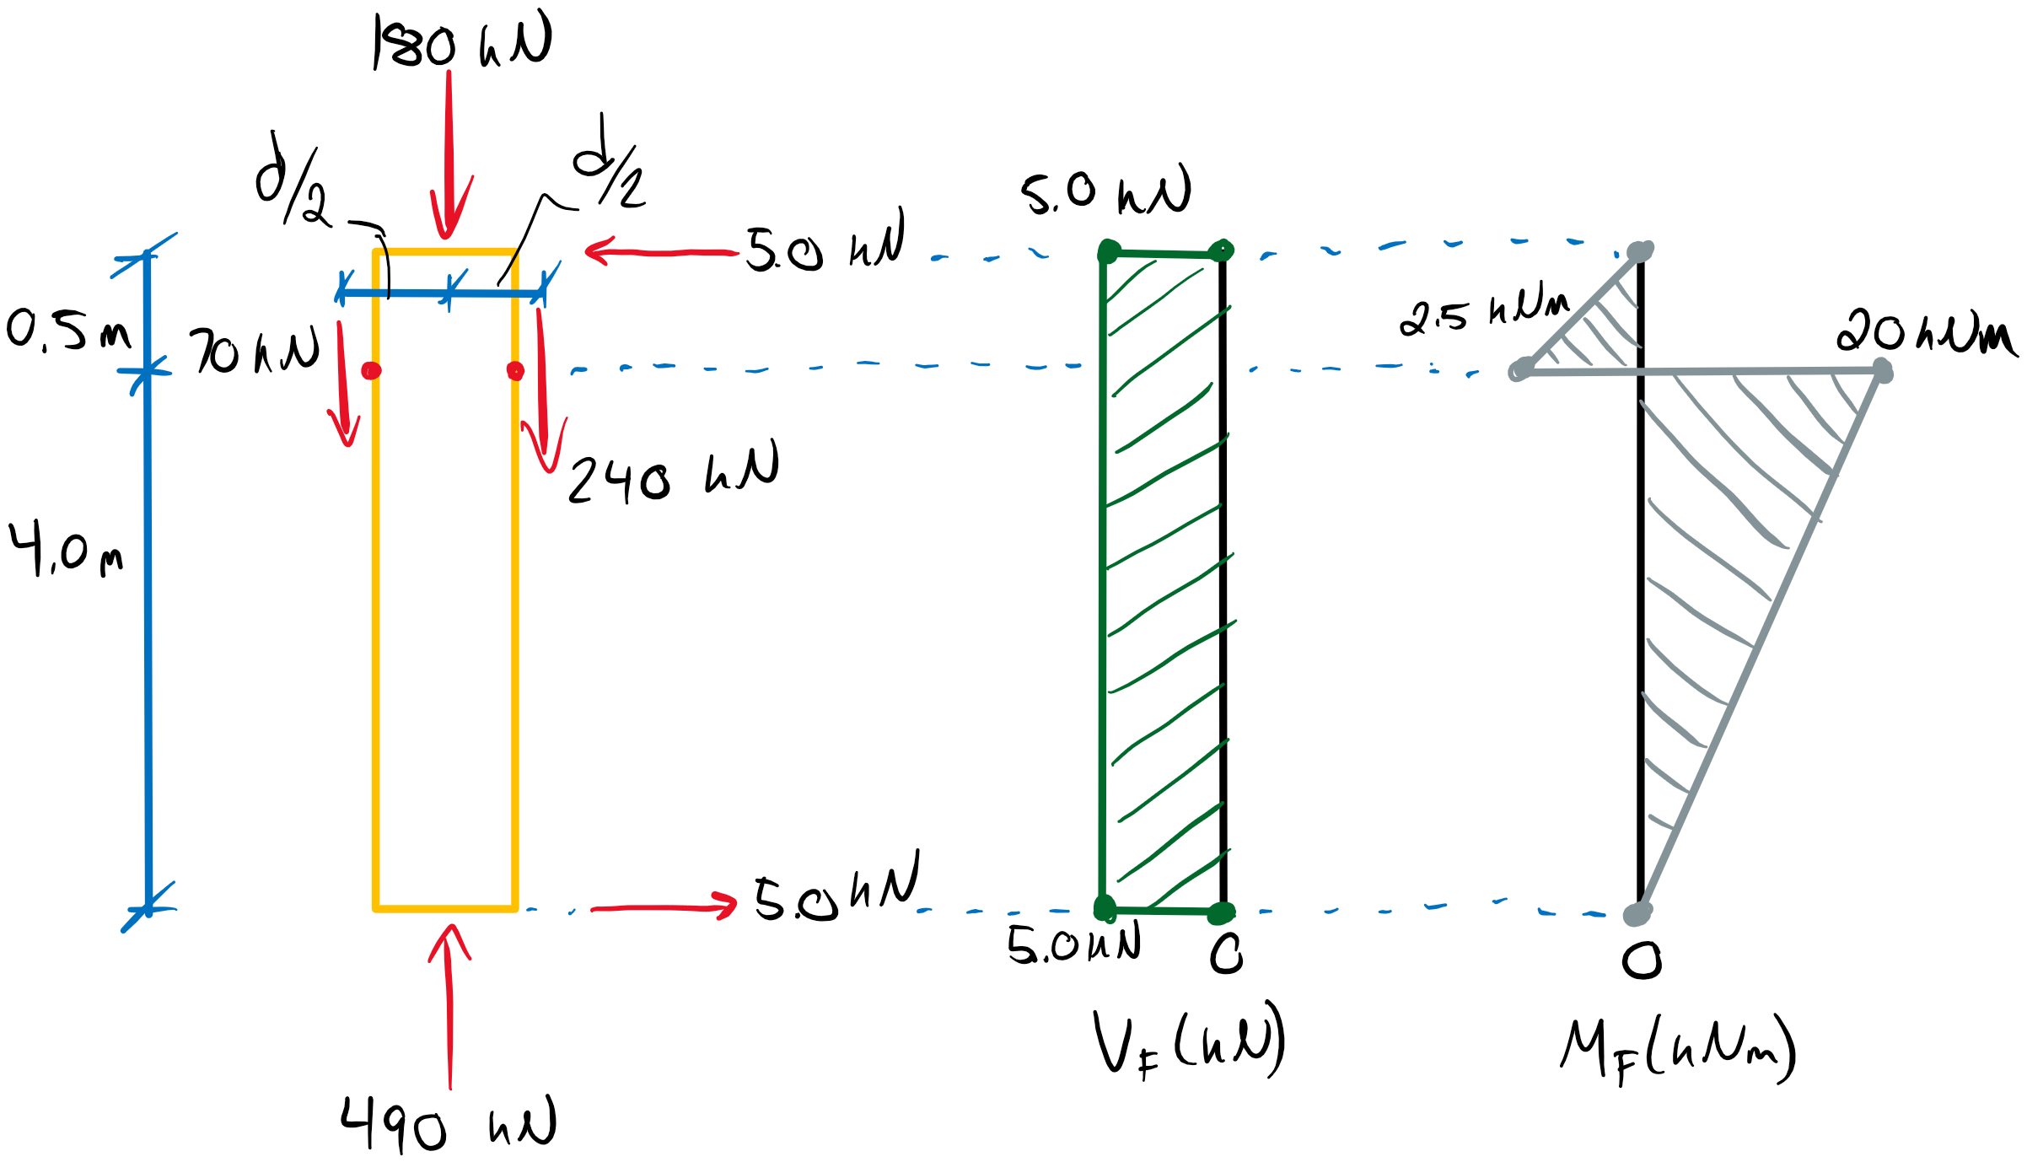

Pf = 490 kN < Pr = 585 kN **(Section Passes Axial Comp.)**

Mf = 20 kNm < Mr = 58.4 kNm **(Section Passes Flexure)**

Vf = 5 kN < Vr = 60.0 kN **(Section Passes Shear)**

The section passes the compression, flexure, and shear requirements but it must also meet the requirements of clause **7.5.12** for the interaction axial loads and flexure. The following interaction equation must be satisfied.

1.0 ≥ (Pf/Pr)2 + Mf/Mr (1 – Pf/PE)-1

where PE is the Euler buckling load:

PE = π2E05KSEKTI/Le2

E05 = 0.87E = 0.87(10300 MPa) = 8961 MPa

I = bd3/12 = (215)(266)3/12 mm4 = 337 x 106 mm4

PE = π2(8961 MPa)(1.0)(1.0)(337x106 mm4)/(1.0 x 4500 mm)2

PE = 1472 kN

1.0 ≥ (490/585)2 + (20/58.4) (1 – 490/1472)-1

1.0 ≥ 0.702 + 0.513

1.0 ≥ 1.21 **(Section Fails Interaction)**

Therefore, we must recommend a larger member to meet the interaction requirements. Lets try 215x304 mm SPF 20f-EX. Remember that increasing the member depth will also increase the applied moment due to the eccentricity. Revising Mf gives:

Mf = 25.7 kNm

Shear resistance was already adequate, so we only need to check moment and axial. From the tables:

Mr = 76.3 kNm > Mf = 25.7 kNm

Pr = 662 kN > Pf = 490 kN

PE = π2(8961 MPa)(1.0)(1.0)(503x106 mm4)/(1.0 x 4500 mm)2 = 2198 kN

1.0 ≥ (490/662)2 + (25.7/76.3) (1 – 490/2198)-1

1.0 ≥ 0.98 **(Section Passes Interaction)**

Therefore, the original section was inadequate but 215x304 mm SPF 20f-EX is suitable.

# Question 2

Here, we are to conduct a full column design based on multiple specified load types and combined axial and bending loads. The design requires a utilization ratio of 85% or higher, grade 20f-EX, SPF glulam, and a deflection limit of L/180. From Table 7.3:

fb+ = fb- = 25.6 MPa

fv = 1.75 MPa

fc = 25.2 MPa

fcb = 25.2 MPa

fcp =5.8 MPa

E = 10300 MPa

E05 = 8961 MPa

I = bd3/12

To simplify the factoring of loads, we can construct a beam diagram in terms of the loads as variables:

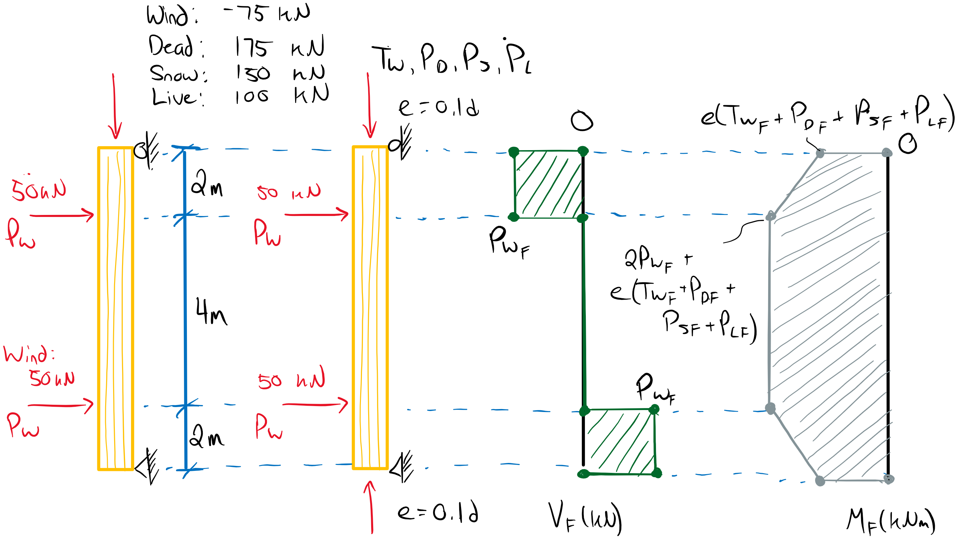

Therefore,

**Mf = 2Pw, f + e(Tw, f + PD, f + Ps, f + PL, f)**

**Vf = Pw, f**

(Note the eccentricities are in the same direction at both columns ends so there is no additional shear generated)

We can also estimate the deflection using the superposition of the lateral point load deflection (Δ1) and the point moment deflections (Δ2) acting at the eccentric axial loads:

Δ = Δ1 + Δ2

Δ = Pw a (3L2 – 4a2)/24EI + ML2/8EI

where

a = 2 m , L = 8 m

M = e(Tw + PD + Ps + PL)

To approximate a member size, let’s assume an eccentricity of 100 mm. This will be a conservative assumption up to a member depth of 1000 mm. Per clause **5.2.4.2** we only need to consider the worst case combination for serviceability requirements. As the lateral wind load contribution is significant, and the wind load uplift is a small portion of the axial load, primarily maximizing Pw should produce the most critical effect, with secondary focus on maximizing the axial force. Therefore, we will proceed with Load Case 4 for the deflection calculation.

Case 4: 1.0D +1.0W + 0.5S

M = (0.1 m)(-75 + 175 + 0.5(150) ) kN = 17.5 kNm

Pw = 50 kN

Now we can estimate a bending stiffness requirement based on the deflection limit of L/180:

Δ = L/180 ≥ Pw a (3L2 – 4a2)/24EI + ML2/8EI

EI ≥ [Pw a (3L2 – 4a2)/24 + ML2/8] x 180/L

EI ≥ [ Pw(2 m) ( 3(8m)2 – 4(2m)2 )/24 + M(8 m)2/8 ] x 180/(8 m)

EI ≥ 330Pw + 180M *(Note: here the priority to maximize Pw over M is evident)*

EI ≥ 330(50 kN) + 180(17.5 kNm)

**EI ≥ 19650 kNm2 (minimum required stiffness for deflection requirements)**

This required stiffness in conjunction with our factored loads can be used to estimate an initial member size.

Factored Loading:

Considering the following load combinations and applying the above equations for Mf , Vf , Pf, we get:

Load Case 1: 1.4 D, KD = 0.65

PD, f = 1.4D = 1.4(175 kN) = 245 kN

Mf = (0.1 m)(245 kN) = 24.5 kNm

Vf = 0

Pf = 245 kNm

Load Case 2a: 1.25D + 1.5L + 1.0S, KD = 1.0

PD, f = 219 kN

PL, f = 150 kN

Ps, f = 150 kN

Mf = 51.9 kNm

Vf = 0

Pf = 519 kN

Load Case 2b: 1.25D + 1.5L + 0.4W, KD = 1.15

PD, f = 219 kN

PL, f = 150 kN

Pw, f = 20 kN

Tw, f = -30 kN

Mf = 73.9 kNm

Vf = 20 kN

Pf = 339 kN

Load Case 3a: 1.25D + 1.5S + 1.0L, KD = 1.0

PD, f = 219 kN

PL, f = 100 kN

Ps, f = 225 kN

Mf = 54.4 kNm

Vf = 0 kN

Pf = 544 kN

Load Case 3b: 1.25D + 1.5S + 0.4W, KD = 1.15

PD, f = 219 kN

Ps, f = 225 kN

Pw, f = 20 kN

Tw, f = -30 kN

Mf = 81.4 kNm

Vf = 20 kN

Pf = 414 kN

Load Case 4: 1.25D + 1.4W + 0.5S, KD = 1.15

PD, f = 219 kN

Ps, f = 75 kN

Pw, f = 70 kN

Tw, f = -105 kN

**Mf = 159 kNm (Governs flexure)**

**Vf = 70 kN (Governs shear)**

Pf = 189 kN

Recall that, for each different load duration factor, compression resistances must be calculated individually. This will also extend to axial and moment interaction calculations. The governing factored load conditions are summarized below:

Summary:

EImin = 19650 kNm2

Vf = 70 kN w/ KD = 1.15

Mf = 159 kNm w/ KD = 1.15

Interaction Cases:

Pf = 245 kN, Mf = 24.5 kNm w/ KD = 0.65 (Case 1)

Pf = 519 kN, Mf = 51.9 kNm w/ KD = 1.0 (Case 2a)

Pf = 339 kN, Mf = 73.9 kNm w/ KD = 1.15 (Case 2b)

Pf = 544 kN, Mf = 54.4 kNm w/ KD = 1.0 (Case 3a)

Pf = 414 kN, Mf = 81.4 kNm w/ KD = 1.15 (Case 3b)

Pf = 189 kN, Mf = 159 kNm w/ KD = 1.15 (Case 4)

Initial Member Sizing:

Although there is a slew of KD factors to consider, we can use the member selection tables to get a rough estimate of the required member dimensions. The moment and axial interaction will require some reserve strength in both resistances and should always govern over moment/axial individually. We will not worry about load optimization at this stage.

Try 365x418 mm SPF 20f-EX:

Mr = 245 kNm

Vr = 160 kN

Pr = 1310 kN

EI = 22900 kNm2

Check axial-moment interaction without considering KD for rough idea of utilization:

PE = π2E05KSEKTI/Le2

PE = π2(0.87 x 10300 MPa)(1.0)(1.0)(365x4183/12 mm4)/(1.0 x 8000 mm)2

PE = 3070 kN

1.0 ≥ (Pf/Pr)2 + Mf/Mr (1 – Pf/PE)-1

1.0 ≥ (414/1310)2 + (81.4/245) (1 – (414/3070) )-1

1.0 ≥ 0.10 + 0.384

1.0 ≥ 0.48 **(Section Passes but is underutilized)**

Based on our test input, it seems this section may not reach our target utilization of 85% or greater. A 315x418 mm member is very close to the required EI value, let’s proceed with a full design calculation for this size.

Full Design Check – 315 x 418 mm SPF 20f-EX:

Mr = 211 kNm

Vr = 138 kN

Pr = 949 kN

EI = 19700 kNm2

The full design check must consider the respective load duration factors. Keep in mind, compressive resistance parallel to grain will not scale linearly with the load duration factor but the other tabulated values should. Despite this, the question requires full design calculations at this stage but you may use the scaled tabulated values as a sanity check.

Our original assumption assumed an eccentricity of 100 mm. We can update this value to 41.8 mm now that we have a specific member size. This will change the applied factored moment and the deflection requirements.

Deflection:

Δ = L/180 ≥ Pw a (3L2 – 4a2)/24EI + ML2/8EI

Case 4: 1.0D +1.0W + 0.5S (**5.2.4.2**)

M = (0.0418 m)(-75 + 175 + 0.5(150) ) kN = 7.32 kNm

Pw = 50 kN

(8 m)/180 ≥ (50 kN)(2m) ( 3(8 m)2 – 4 (2 m)2)/24(19700 kNm2) + (7.32 kNm)(8 m)2/8(19700 kNm2)

0.044 m ≥ (50 kN)(2m) ( 3(8 m)2 – 4 (2 m)2)/24(19700 kNm2) + (7.32 kNm)(8 m)2/8(19700 kNm2)

0.044 m ≥ 0.0372 m + 0.0029 m

0.044 m ≥ 0.040 m **(Section Passes Deflection Requirements)**

Shear (**7.5.7**):

Z = 8 m x 0.315 m x 0.418 m = 1.05 m3 < 2.0 m3

We can proceed with the simplified shear calculation for beam volumes less than 2.0 m3 (**7.5.7.2**):

Vr = φFvAg 2/3

Fv = fvKDKHKsvKT = (1.75 MPa)(1.15)(1)(1)(1) = 2.01 MPa

Vr = (0.90)(2.01 MPa)(315x418 mm2)2/3

Vr = 159 kN ≥ Vf = 70 kN **(Section Passes Shear Requirements)**

Flexure (**7.5.6.5**):

We require a moment resistance value for each of the KD values we must check in combined axial and bending. The factors KL and Kzbg will determine the governing moment resistance per **7.5.6.5.1**:

Kzbg = (130/157.5 x 610/418 x 9100/8000)0.1 ≤ 1.3

Kzbg = 1.03

KL = 1.0 (for members width depth : width ratios less than 4:1 per **6.5.4.2.1**)

Therefore, Mr2 will govern the moment resistance as KL < Kzbg.

Mr2 =φFbSKxKL

Fb = fbKDKHKsbKT = (25.6 MPa)KD(1)(1)(1) = 25.6KD MPa

S = bd2/6 = 9.17x106 mm3

Mr2 = (0.9)(25.6KD MPa)(9.17x106 mm3)(1)(1)

Mr2 = 211.3KD kNm

Comparing to the updated factored moments based on the new eccentricity of 0.1d = 41.8 mm:

Mr = 137 kNm > Mf = 10.2 kNm w/ KD = 0.65

Mr = 243 kNm > Mf = 148 kNm w/ KD = 1.15 **(Governs)**

Mr = 211 kNm > Mf = 22.7 kNm w/ KD = 1.0

**(Section Passes Flexural Requirements)**

Axial Compression (**7.5.8**):

Similarly, we must calculate an axial compression resistance for each relevant KD.

CC = 8 m/0.315 m = 25.4 ≤ 50

Pr = φFcAKzcgKC

Fc = fcKDKHKscKT = (25.2 MPa)KD(1)(1)(1) = 25.2KD MPa

Kzcg = 0.68(Z)-0.13 = 0.68(1.05 m3)-0.13­ = 0.68 ≤ 1.0

KD = 0.65:

Fc = 16.4 MPa

KC =[1.0 + FCKzcgCC3 / 35E05KseKT ]-1 = [1.0 + (16.4 MPa)(0.68)(25.4)3/35(8961 MPa)(1)(1)]-1

KC =0.63

Pr = (0.8)(16.4 MPa)(315x418 mm2)(0.68)(0.63)

Pr = 740 > Pf = 245 kN

KD = 1.15:

Fc =29.0 MPa

KC = 0.49

Pr = 1018 kN > Pf = 544 kN

KD = 1.0:

Fc =25.2 MPa

KC = 0.53

Pr = 957 kN > Pf = 414 kN

**(Section Passes Axial Compression Requirements)**

Combined Axial and Bending (**7.5.12**):

The interaction equation must be checked for each load case, not just per value of KD. This is because it may not be obvious which combination of axial and bending loads is most critical.

PE = π2E05KSEKTI/Le2

PE = π2(8961 MPa)(1.0)(1.0)(315x4183/12 mm4)/(1.0 x 8000 mm)2

PE = 2649 kN

Case 1: Pr = 740 kN, Mr = 137 kNm, Pf = 245 kN, Mf = 10.2 kNm w/ KD = 0.65

1.0 ≥ (Pf/Pr)2 + Mf/Mr (1 – Pf/PE)-1

1.0 ≥ (245/740)2 + (10.2/137) (1 – (245/2649) )-1

1.0 ≥ 0.110 + 0.082

1.0 ≥ 0.19 **(Section Passes)**

Case 2a: Pr = 957 kN, Mr = 211 kNm, Pf = 519 kN, Mf = 21.7 kNm w/ KD = 1.0

1.0 ≥ 0.42 **(Section Passes)**

Case 2b: Pr = 1018 kN, Mr = 243 kNm, Pf = 339 kN, Mf = 54.2 kNm w/ KD = 1.15

1.0 ≥ 0.37 **(Section Passes)**

Case 3a: Pr = 957 kN, Mr = 211 kNm, Pf = 544 kN, Mf = 22.7 kNm w/ KD = 1.0

1.0 ≥ 0.46 **(Section Passes)**

Case 3b: Pr = 1018 kN, Mr = 243 kNm, Pf = 414 kN, Mf = 57.3 kNm w/ KD = 1.15

1.0 ≥ 0.44 **(Section Passes)**

Case 4: Pr = 1018 kN, Mr = 243 kNm, Pf = 189 kN, Mf = 148 kNm w/ KD = 1.50

1.0 ≥ 0.84 **(Section Passes - GOVERNS)**

Summary/Utilization:

Deflection:

Δ = 0.040 m < 0.044 m 0.040/0.044 x 100 = 91% **(Governs Utilization)**

Shear:

Vr = 159 kN ≥ Vf = 70 kN 70/159 x 100 = 44%

Moment:

Mr = 243 kNm > Mf = 148 kNm 148/243 x 100 = 61%

Axial Comp.:

Pr = 1018 kN > Pf = 544 kN 544/1018 x 100 = 53%

Axial and Moment Interaction:

1.0 ≥ 0.82 84%

Therefore, the utilization of the 315x418 mm SPF 20f-EX glulam member is 91%, governed by the deflection requirements. This member is suitable for the given specified loads.

# Question 3

This question requires the determination of the maximum lateral wind load based on the specified axial loads. The stud wall consists of 38x140 mm SPF No. 2 members at 500 mm spacing with 10 mm plywood sheathing and 2 inch common nails spaced at 150 mm.

Member Properties (38x140 mm SPF No. 2)

Structural Joist and Plank (**Table 6.2.2.1, Table 6.3.1A**):

fb = 11.8 MPa

fv = 1.5 MPa

fc = 11.5 MPa

E = 9500 MPa

E05 = 6500 MPa

Based on the requirements of clause **6.4.4.2** and **Table 6.4.5** the following modification factors are relevant:

Kzb = 1.4

Kzv = 1.4

KHb = 1.4

KHc = 1.10

KHv = 1.10

The question also indicates to only consider load cases duration factors equal to 1.15. There are no treatment or service conditions to consider.

The maximum factored loads can be determined in terms of the unknown factored wind load ww, f. With no eccentricity in the axial load, the following beam diagram can be created:

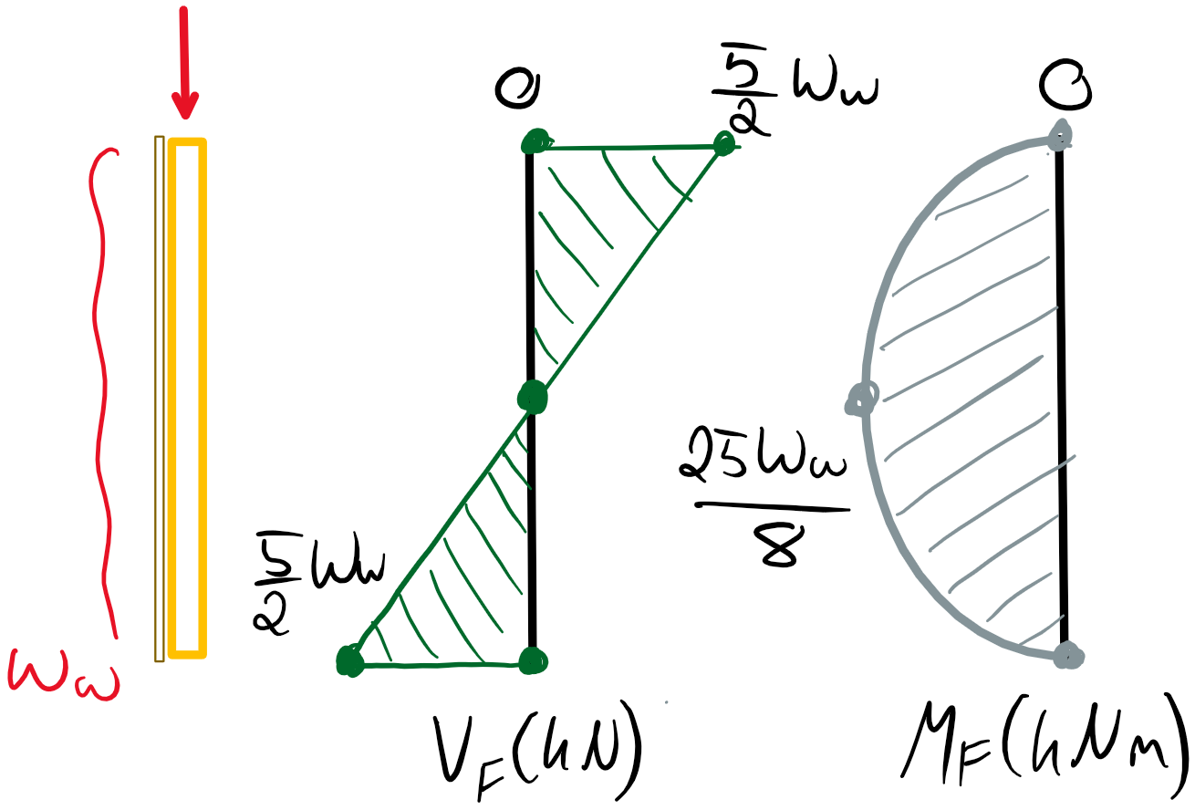

Mf = 25 ww, f /8

Vf = 5 ww, f /2

The factored axial load is dependent on the load case. The following load cases that yield KD = 1.15 must be considered. This implies load cases including wind as a primary or companion load need consideration.

Load Case 2: 1.25D + 1.5L + 0.4W KD = 1.15

Pf = 1.25(6 kN/m) + 1.5(10 kN/m) = 22.5 kN/m **(Governs Critical ww, f)**

Load Case 4a: 1.25D + 1.4W + 0.5L KD = 1.15

Pf = 1.25(6 kN/m) + 0.5(10 kN/m) = 6.25 kN/m

We are interested in the most critical value of ww, f which will occur for the largest axial (thus requiring a smaller lateral load to reach the critical moment-axial interaction). It is for this reason that Case 4 with no companion load is not considered.

Shear Resistance (**6.5.5.2**)

Vr = φFvAnKzv2/3

Fv = fvKDKHvKsvKT = (1.5 MPa)(1.15)(1.4)(1)(1) = 2.4 MPa

Vr = (0.9)(2.4 MPa)(38x140 mm2)(1.4) x 2/3

**Vr = 10.7 kN** **≥ Vf = 5 ww, f /2**

Moment Resistance (**6.5.4**)

Mr = φFbSKzbKL

Fb = fbKDKHbKsbKT = (11.8 MPa)(1.15)(1.40)(1) = 19.0 MPa

S = bd2/6 = (38)(140)2/6 mm3 = 0.124 x 106 mm3

­For b/d = 3.7 (**6.5.4.2.1**),

KL = 1.0

Mr = (0.9)(19.0 MPa)(0.124 x 106 mm3)(1.4)(1.0)

**Mr = 3.0 kNm ≥ Mf = 25 ww, f /8**

Axial Compression (**6.5.6.2.3)**

Based on clause **6.5.6.5**, the depth of the stud members can be used to calculate the slenderness ratio since it is sheathed. Pin-pin support is assumed.

CCx = CCy = Le/d = (5.0 m)/(0.14 m) = 35.7 < 50

Pr = φFcAKzcKc

Fc = fcKDKHcK­scKT = (11.5 MPa)(1.15)(1.10)(1)(1) = 14.5 MPa

Kzc =6.3(dL)-0.13 = 6.3[ (140)(5000) ]-0.13 = 1.10 < 1.3

Kc =[1.0 + FCKzcCC3 / 35E05KseKT ]-1 = [1.0 + (14.5 MPa)(1.10)(35.7)3/35(6500 MPa)(1)(1)]-1

Kc = 0.24

Pr = (0.80)(14.5 MPa)(38x140 mm)(1.10)(0.24)

**Pr = 16.3 kN ≥ Pf = 11.25 kN**

Combined Axial and Moment (**6.5.10**)

PE = π2E05KSEKTI/Le2

PE = π2(6500 MPa)(1.0)(1.0)(38x1403/12 mm4)/(5000 mm)2

PE = 22.3 kN

The interaction equation must be solved for Mf to determine the limit on the lateral load.

1.0 ≥ (Pf/Pr)2 + Mf/Mr (1 – Pf/PE)-1

Mf ≤ [1 – (Pf/Pr)2] x [1 – Pf/PE] x Mr

Mf ≤ [1 – (11.25/16.3)2] x [1 – (11.25)/(22.3)] x (3.0 kNm)

**Mf ≤ 0.78 kNm**

Summary

Shear:

Vr = 10.7 kN ≥ Vf = 5 ww, f /2

**ww, f ≤ 4.3 kN/m**

Moment:

Mr = 3.0 kNm ≥ Mf = 25 ww, f /8

**ww, f ≤ 0.96 kN/m**

Axial + Moment:

Mf ≤ 0.78 kNm = 25 ww, f /8

**ww, f ≤ 0.25 kN/m** (**Governs**)

This governing value of ww, f should be compared to the value in the stud wall selection tables (SPF No. 2 38x140 mm studs with a length of 5 m and no eccentricity). We can interpolate based on the factored axial load to determine the maximum lateral wind load.

Interpolating with Pf = 11.25 kN/m

(ww, f – 0.239) / (0.344 – 0.239) = (11.25 – 11.3) / (9.71 – 11.3)

**ww, f = 0.24 kN/m**

This tabulated value is very close to the calculated limit on ww, f. For this problem, as soon as Pf was known ww, f could have been determined.

# Question 4

**Part A:**

This first part of this question requires the manual calculation of the effective bending stiffnesses and shear rigidities for the CLT panels in question. This is done through clause **8.4.3.2**. Although the calculations should be done by hand, the final answers can be compared to **Table 2.12** in Volume 1 of the CWC Wood Design Manual.

CLT Properties (5-ply Grade E2 – **Table 8.2.4** in **O86-14**)

t = 35 mm

bx = 2.4 m

by = 10 m

Longitudinal Layers (layers 1, 3, 5):

fb = 23.9 MPa

fs = 0.63 MPa

Ex = 10300 MPa

Ex, ⟂ = Ex/30 = 343 MPa

Gx = Ex/16 = 644 MPa

Gx, ⟂ = Gx /10 = 64.4 MPa

Transverse Layers (layers 2, 4):

fb = 4.6 MPa

fs = 0.63 MPa

Ey = 10000 MPa

Ey, ⟂ = Ey/30 = 333 MPa

Gy = Ey/16 = 625 MPa

Gy, ⟂ = Gy /10 = 62.5 MPa

For the effective bending stiffness in the longitudinal strength direction:

EIeff, x = ΣEbt3/12 + ΣEbtz2

Note that this summation will include terms two terms for layers 1 and 5, one term for layer 3, and two terms for layers 2 and 4. The transverse layers contribute to the bending stiffness. The z variable refers to the distance to the centroid of each layer from the centroid of the full panel cross section. Therefore layers 2 and 4, as well as 1 and 5, will have the same value for z. Layer 3 has z =0.

EIeff, x = [Ex bxt3/12]Layer 3 + 2 [Ey, ⟂ bxt3/12 + Ey, ⟂ bxt z22]Layers 2, 4 + 2[Ex bxt3/12 + Ex bxt z52]Layers 1, 5

EIeff, x = [88.32 kNm2] + [74.24 kNm2] + [8655.61 kNm2]

**EIeff, x = 8818 kNm2**

From **Table 2.12 in Vol. 1**:

EIeff, x = 3670 x109 Nmm2 /m x 2.4 m

**EIeff, x = 8808 kNm2**

For the effective bending stiffness in the transverse direction:

EIeff, y = ΣEbt3/12 + ΣEbtz2

The transverse bending stiffness does not utilize the extreme layers (Layers 1 and 5) and therefore will only have two terms for layers 2 and 4, and one term for layer 3.

EIeff, y = [Ex, ⟂ byt3/12]Layer 3 + 2 [Ey byt3/12 + Ey byt z22]Layers 2, 4

EIeff, y = 12.26 kNm2 + 9289.58 kNm2

**EIeff, y = 9302 kNm2**

From **Table 2.12 in Vol. 1**:

EIeff, y = 930 x109 Nmm2 /m x 10.0 m

**EIeff, y = 9300 kNm2**

For the longitudinal in-plane shear rigidity:

GAeff, x = (h – t1/2 – t5/2)2 / [ t1/2G1bx + Σ ti/Gibx + t5/2G5bx ]

GAeff, x = (h – t1/2 – t5/2)2 / [ t1/2Gxbx (Layer 1) + 2(t2/G y, ⟂ bx) (Layers 2, 4) + t3/Gxbx (Layer 3) + t5/2Gxbx (Layer 5) ]

GAeff, x = (140 mm)2 / [5.120 x 10-4 MPa-1]

**GAeff, x = 38281 kN**

From **Table 2.12 in Vol. 1**:

GAeff, x = 16.0 x106 N/m x 2.4 m

**GAeff, x = 38400 kN**

For the tranvserse in-plane shear rigidity all layers are considered:

GAeff, y = (h – t1/2 – t5/2)2 / [ t1/2G1by + Σ ti/Giby + t5/2G5by ]

GAeff, y = (h – t1/2 – t5/2)2 / [ t1/2Gx, ⟂by (Layer 1) + 2(t2/G yby) (Layers 2, 4) + t3/Gx, ⟂by (Layer 3) + t5/2Gx, ⟂by (Layer 5)

GAeff, y = (140 mm)2 / [1.199 x 10-4 MPa-1]

**GAeff, y = 163470 kN**

From **Table 2.12 in Vol. 1**:

GAeff, x = 16.3 x106 N/m x 10.0 m

**GAeff, x = 163000 kN**

All calculated stiffness and rigidity values match well with the tabulated values.

**Part B:**

Now we must perform ULS design checks for the CLT panel based on the specified loading. We must consider the following load cases for dead and live loads:

Load Case 2a: 1.25D + 1.5L KD = 1.0

wf = 1.25(1.5 kPa x 2.4 m) + 1.5(4.8 kPa x 2.4 m) = 21.8 kN/m

We will consider this loading case over the full span of the panels.

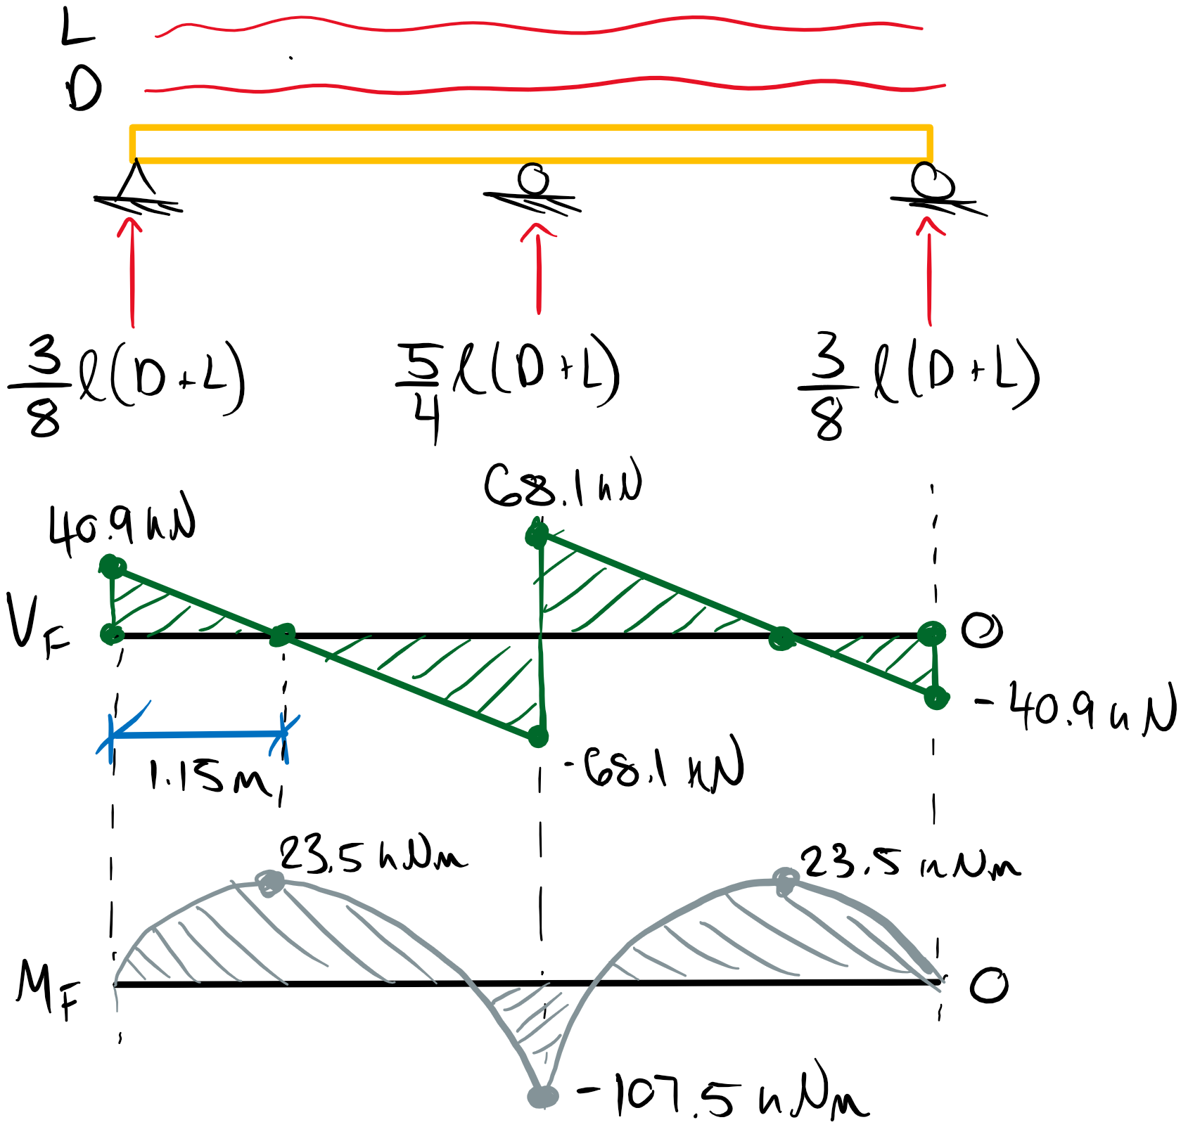

Mf+ = 23.5 kNm

**Mf- = 107.5 kNm (Governs)**

**Vf = 68.1 kN (Governs)**

Load Case 2b: 0.9D + 1.5L KD = 1.0

wf = 0.9(1.5 kPa x 2.4 m) + 1.5(4.8 kPa x 2.4 m) = 3.2 kN/m + 17.3 kN/m

To maximize the factored positive moment, we will omit live load from half of the CLT span and apply the 0.9 factor to the dead load.

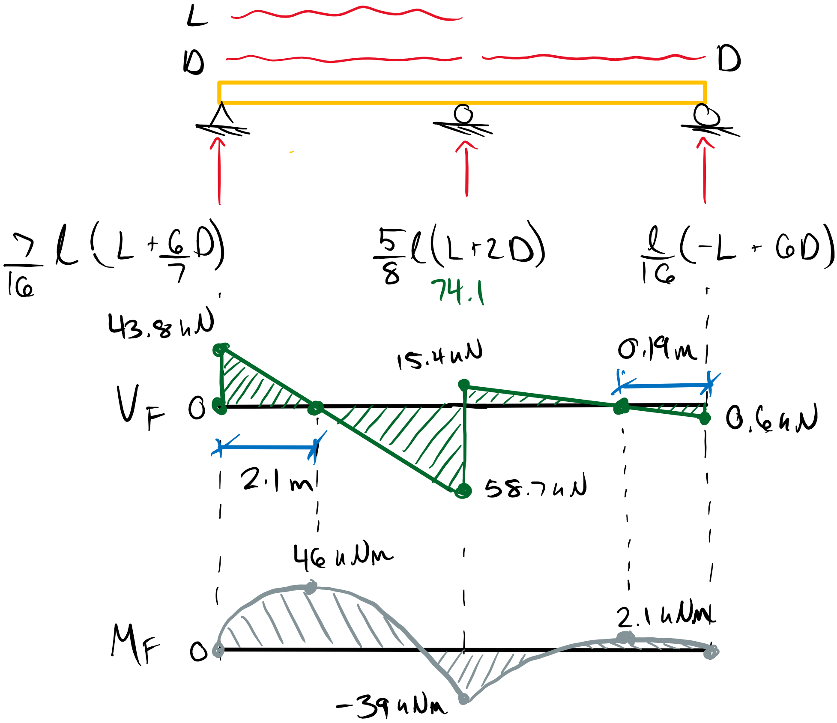

**Mf+ = 46 kNm (Governs)**

Mf- = 39 kNm

Vf = 58.7 kN

Factored Loads:

Mf+ = 46 kNm

Mf- = 107.5 kNm

Vf = 68.1 kN

Vf(d) = 65.7 kN (at a distance d from support)

Moment Resistance (**8.4.3**)

For the longitudinal major strength direction:

Mr = φFbSeff, xKrb, x

Krb, x = 0.85 Calibration factor for the major strength direction

Fb = fb,x KDKHKsbKT

Fb = (23.9 MPa)(1)(1)(1)(1) = 23.9 MPa

Seff,x = EIeff, x/Ex x 2/h

Seff,x = (8808 x 109 Nmm2)/(10300 MPa) x 2/(175 mm)

Seff,x = 9.085 x 106 mm3

Mr = (0.9)(23.9 MPa)(9.085 x 106 mm3)(0.85)

**Mr =166 kNm > Mf = 107.5 kNm** (**Section Passes Flexural Check**).

Shear Resistance (**8.4.4**)

For the major strength direction:

Vr = φFsAg, zx 2/3

Fs = fsKDKHKsvKT = (0.63 MPa)(1)(1)(1)(1) = 0.63 MPa

Vr = (0.90)(0.63 MPa)(2400x175 mm2)2/3

**Vr = 159 kN > Vf = 65.7 kN (Section Passes Shear Check)**

Therefore, the CLT panel passes all required ULS checks.

**Part C:**

Annex **A.8.5.2** and **A.8.5.3** provide calculations for the SLS (deflection and vibration) assessment of CLT members.

For a deflection limit of L/180 and a single span CLT panel exposed to a distributed load:

Δ = Δst + ΔLTKcreep

where the long term load effects of dead load are multiplied by a creep factor.

Δ = [5/384 wLL4/EIeff, x + 1/8 wLL2κ/GAeff, x]Live Load + Kcreep[5/384 wDL4/EIeff, x + 1/8 wDL2κ/GAeff, x]Dead Load

κ = 1.2 Shear deformation form factor for rectangular cross-sections.

Δ = [ 5/384 (11.52)(5000)4/(8188 x 109) + 1/8 (11.52)(5000)2(1.2)/(0.16 x 109) ]Live Load +

(2.0) [ 5/384 (3.6)(5000)4/(8188 x 109) + 1/8 (3.6)(5000)2(1.2)/(0.16 x 109) ]Dead Load

Δ = 14.15 mm + 3.64 mm

**Δ = 17.8 mm < L/180 = 5000/180 mm = 27.8 mm** (**Section Passes Deflection Check**)

For the limiting span based on vibration requirements

Lmax = 0.11 (EIeff, x /106)0.29 / m0.12

m = 420 kg/m3 x 1.0 m x 0.175 m = 73.5 kg/m Linear mass of CLT for a 1 m wide panel

Lmax = 0.11 (8188 x 109 / 106)0.29 / (73.5)0.12

**Lmax = 6.6 m < L = 5 m (Section O.K for Vibration)**

Therefore based on Annex **A.8**, this section meets the SLS deflection and vibration requirements.

# Question 5

This question requires the design a CLT bearing wall subjected to axial and lateral loads. The panel width is 3 m and a CLT grade of E1 is required. The applied loads are factored so load cases need not be considered. The load duration factor is assumed to be 1.0.

We can use loading diagrams to determine the maximum factored loads. The axial load eccentricity will vary depending on the final design which will affect the maximum moment and shear values. The eccentricity is only applied to the top axial loads.

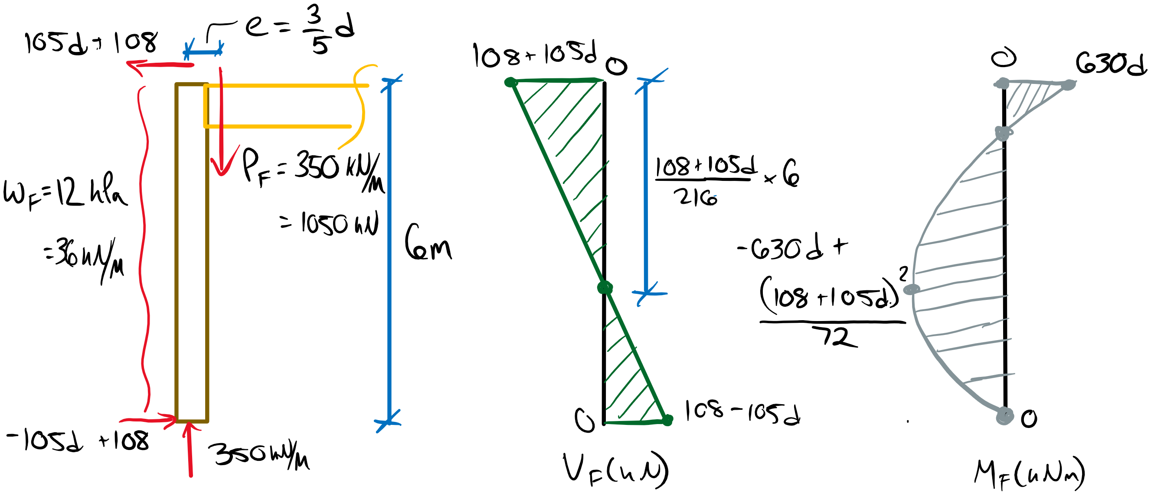

Mf + = -630d + (108 + 105d)2/72

Mf - = -630d

Vf =108 + 105d

Pf = 1050 kN

Since KD = 1.0 and e > d/2, the tabulated CLT resistances will not be conservative. With this knowledge, we can see that likely a 7-ply or 9-ply CLT panel will be required and a 5-ply will be insufficient. Let’s first try a 7-ply since we are after the smallest number of plies.

CLT Grade E1 – 7 ply:

fc = 19.3 MPa

fs = 0.50 MPa

fb = 28.2 MPa

d = 245 mm

E = 11700 MPa

E05 =0.87E = 9594 MPa

EIeff, x = 30900 kNm2

EIeff, y = 9660 kNm2

GAeff, x = 65700 kN

GAeff, y = 81600 kN

The factored loads will be:

Mf+ = 94 kNm

Mf- = 154 kNm

Vf =134 kN

Pf = 1050 kN

Shear Resistance (**8.4.4**)

For the major strength direction:

Vr = φFsAg, zx 2/3

Fs = fsKDKHKsvKT = (0.50 MPa)(1)(1)(1)(1) = 0.50 MPa

Vr = (0.90)(0.50 MPa)(3000 x 245 mm2)2/3

**Vr = 220 kN > Vf = 134 kN (Section Passes Shear Check)**

Moment Resistance (**8.4.3**)

For the longitudinal major strength direction:

Mr = φFbSeff, xKrb, x

Krb, x = 0.85 Calibration factor for the major strength direction

Fb = fb,x KDKHKsbKT

Fb = (28.2 MPa)(1)(1)(1)(1) = 28.2 MPa

Seff,x = EIeff, x/Ex x 2/h

Seff,x = (30900 x 109 Nmm2)/(11700 MPa) x 2/(245 mm)

Seff,x = 21.56 x 106 mm3

Mr = (0.9)(28.2 MPa)(21.56x 106 mm3)(0.85)

**Mr =465 kNm > Mf = 154 kNm** (**Section Passes Flexural Check**).

Axial Compression Resistance (**8.4.5.4.2**)

In axial compression, the transverse CLT layers are not considered and the effective moment of inertia must be calculated independently from the tabulated values. For the longitudinal major strength direction

Pr = φFCAeffKzcKC

Fc = fcKDKHKscKT = (19.3 MPa)(1)(1)(1)(1) = 19.3 MPa

Kzc = 6.3(120.5 reffL)-0.13 ≤ 1.3

CC = Le/120.5 reff

reff = (Ieff/Aeff)0.5

Aeff = 4 x (35 mm x 3000 mm) = 420000 mm2

Ieff = Σ (bt3/12 + btz2) This is the parallel axis theorem from Mechanics class!

Ieff = 4 x (bt3/12) + bt(z12 + z32 + z52 + z72)

Ieff = 4 x (3000)(35)3/12 mm4 + (3000)(35)[ (3 x 35)2 + (35)2 + (35)2 + (3 x 35)2 ] mm4

Ieff = 42.875 x 106 mm4 + 2572.5 x 106 mm4

Ieff = 2615 x 106 mm4

reff = [ (2615 x 106 mm4/(420000 mm2) ]0.5 = 78.8 mm

CC = (6000 mm)/120.5(78.8 mm) = 22.0 < 43.0 **(slenderness ratio O.K)**

Kzc = 6.3(120.5 (78.8)(6000) )-0.13 = 0.98 ≤ 1.3

KC =[1.0 + FCKzcCC3 / 35E05KseKT ]-1 = [1.0 + (19.3 MPa)(0.98)(22.0)3/35(9594 MPa)(1)(1)]-1

KC =0.625

Pr = (0.80)(19.3 MPa)(420000 mm2)(0.98)(0.625)

**Pr =3972 > Pf = 1050 kN (Section Passes Axial Comp. Check)**

Combined Axial and Moment (**8.4.6**)

Pf/Pr + Mf/Mr (1 – Pf/PE, v)-1 ≤ 1.0

PE, v = PE/(1 + κPE/GAeff, x) (Euler buckling considering shear deformations)

PE = π2E05KSEKTIeff/Le2 = π2(9594 MPa)(1)(1)(2605 x 106 mm4)/(6000 mm)2 = 6852 kN

PE, v = (6852 kN)/(1 + (1.2)(6852 kN)/(65700 kN) = 6090 kN

1.0 ≥ (1050)/(3972) + (154)/(465)(1 – 1050/6090)-1

1.0 ≥ 0.264 + 0.400

**1.0 ≥ 0.66** **(Section Passes Moment + Axial Interaction)**

Therefore, 7-ply grade E1 CLY is the smallest number of plies for this application. Need not check 5 plies since the tabulated values are insufficient and unconservative for e > d/2 and KD = 1.0.