CWC Wood Engineering

Assignment 4 Solutions

# Question 1

This problem requires two stages: 1) determination of the maximum connection capacity and 2) design of the beam depth such that the shear resistance allows for the connection capacity to be reached.

Connection Capacity (Nailed Connection – **12.9**):

Since the nails are penetrating the SPF beam, the appropriate column of **Table 12.9.2.1** is used to determine the fastener spacing requirements. The nail diameter must be known first however and can be found in **Table A.12.5.9.2**. For 3” common nails:

df = 3.66 mm

Spacing requirements:

Spacing para. to grain: amin = 16df = 58.6 mm < 60 mm **(Spacing OK)**

End distance para. to grain bmin = 12df = 43.9 mm < 45 mm **(Spacing OK)**

Spacing perp. to grain cmin = 8df = 29.3 mm < 35 mm **(Spacing OK)**

Edge distance perp. to grain dmin = 4df = 14.6 mm < 20 mm **(Spacing OK)**

The connection detail passes all nail spacing requirements. Per clause **12.9.2.2**, for a steel side plate, the nails must penetrate a minimum of 5 nail diameters into the wood:

Penetration = (3 in x 25.4 mm/in) – 6 mm = 70.2 mm > 5df = 18.3 mm **(Penetration OK)**

The connection is loaded laterally relative to the fasteners, so only clause **12.9.4** need be considered.

Nail Lateral Resistance (**12.9.4)**:

Nr = φNunfnsJf

Nail lateral resistance is calculated per fastener then multiplied by number of fasteners, nf, and the number of shear planes the fastener is loaded over, ns. The number of shear planes can be visualized based on the number of members the nail intersects minus one. For the two -member connection herein, the number of shear planes is one since there is only one interface between the steel plate and the timber beam. If the fastener passed completely through the beam and another steel plate, the number of shear planes would be two (one per interface: steel-wood then wood-steel).

Nu = nuKDKsfKT

nu is calculated per clause **12.9.4.2** for a number of fastener failure modes considering fastener and material yielding. For the two-member connection in this problem only **12.9.4.2 a, b, d, e, f, g** are considered based on the following parameters in **12.9.4.2**.

For the steel side member (member 1):

f1 = Ksp fu φsteel/φwood = (3.0)(450 MPa)(0.80)/(0.80) = **1350 MPa**

t1 = 6 mm

For the wood main member (member 2):

t2 = 70.2 mm (nail penetration length into wood)

f2 = 50G(1-0.01df)Jx= 50(0.44)(1-0.01(3.66))(1.0) = **21.2 MPa**

G = 0.44 **(Table A.12.1 for SPF glulam)**

f3 = 110G1.8(1-0.01df)Jx = 110(0.44)1.8(1-0.01(3.66))(1) = **24.2 MPa**

fy =50(16-df) = **617 MPa**

**12.9.4.2 a)** nu = 29.6 kN

**b)** nu = 5.4 kN

**d)** nu = 6.6 kN

**e)** Won’t govern over d) b/c t1 < t2

**f)** nu = 7.0 kN

**g)** nu = 1.32 kN **(governs)**

Nu = (1.32 kN)(1)(1)(1) = 1.32 kN

Nr = (0.80)(1.32 kN)(22 nails)(1 shear plane)(1)

Nr = 23 kN **(Connection lateral resistance)**

Now we can determine the shear design demand based on all six connections reaching their max capacity. For a single point load on the beam (ie two connections – one on each side):

Pf = 1.25 x (2 x 23 kN) = 57.5 kN

Constructing a beam diagram gives:

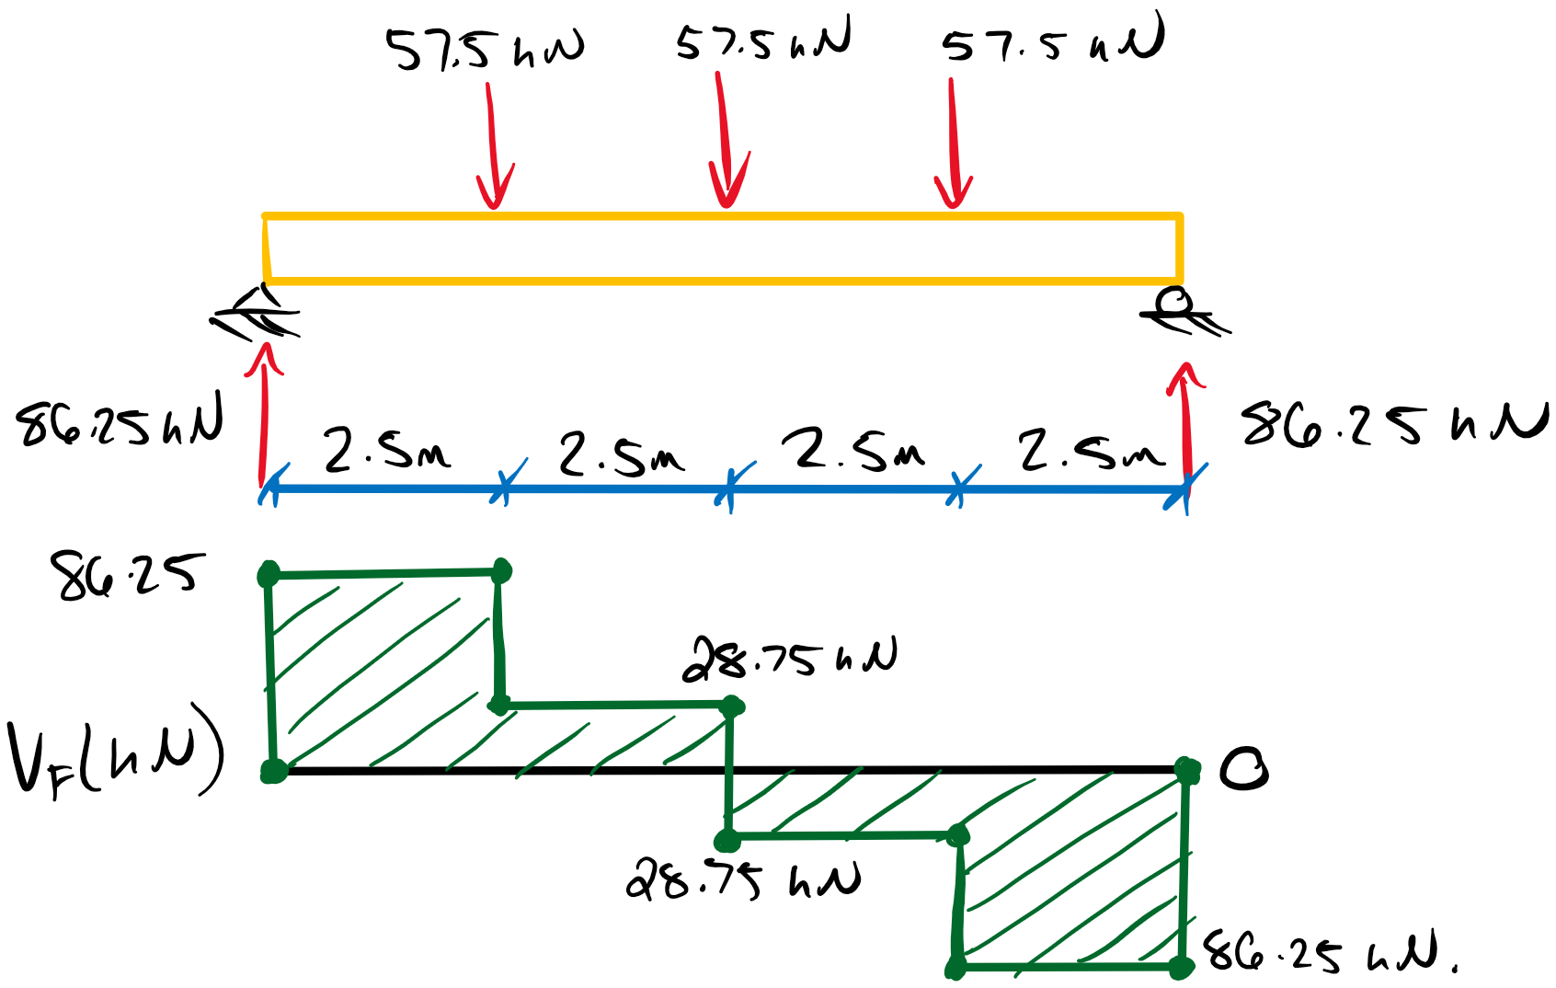

Vf = 86.25 kN

Therefore, the beam depth must be designed such that Vr > 86.25 kN.

Beam Shear Resistance (**7.5.7.2**):

Per Clause **12.2.1.5**, the shear resistance of the beam must be reduced to account for the connections. This method changes the effective depth for shear resistance to the distance from the loaded edge of the member to the extremity of the fastener group. For the downward force on this connection, the loaded beam edge becomes the bottom (tensile) face. Therefore, the effective depth for shear, de, is:

de = d – 20 mm

Assuming beam volume is less than 2.0 m3:

Vr = φFv(b x de)2/3

Fv = (1.75 MPa)(1)(1)(1)(1) = 1.75 MPa

Vr = (0.90)(1.75 MPa)(215 mm x de)2/3 > Vf = 86.25 kN

de >382 mm

d > 402 mm **(member depth requirement for shear)**

Based on the standard depths for glulam members, the smallest suitable depth is therefore **418 mm.**

Confirm beam volume < 2.0 m3:

Z = b x d x l = 0.215 x 0.418 x 10 m3 = 0.86 m3 **(assumption OK)**

Therefore, 215 x 418 mm is the smallest beam depth to allow for a shear resistance greater than 25% the load induced from the maximum connection capacity.

# Question 2

This question requires the determination of the shear resistance of a light-frame timber shear wall which is governed by **11.5.1.2 a** and **b** for the two main failure modes of sheathing connection and panel buckling. Clauses **11.1, 11.2, 11.3, 11.4, and 11.5** all contain relevant info towards the resistance calculations, however.

Per **11.3.3.3**, shear walls with openings are analyzed as the sum of the segments, not including those above or below an opening. Therefore, the shear wall must be analyzed as the following two segments:

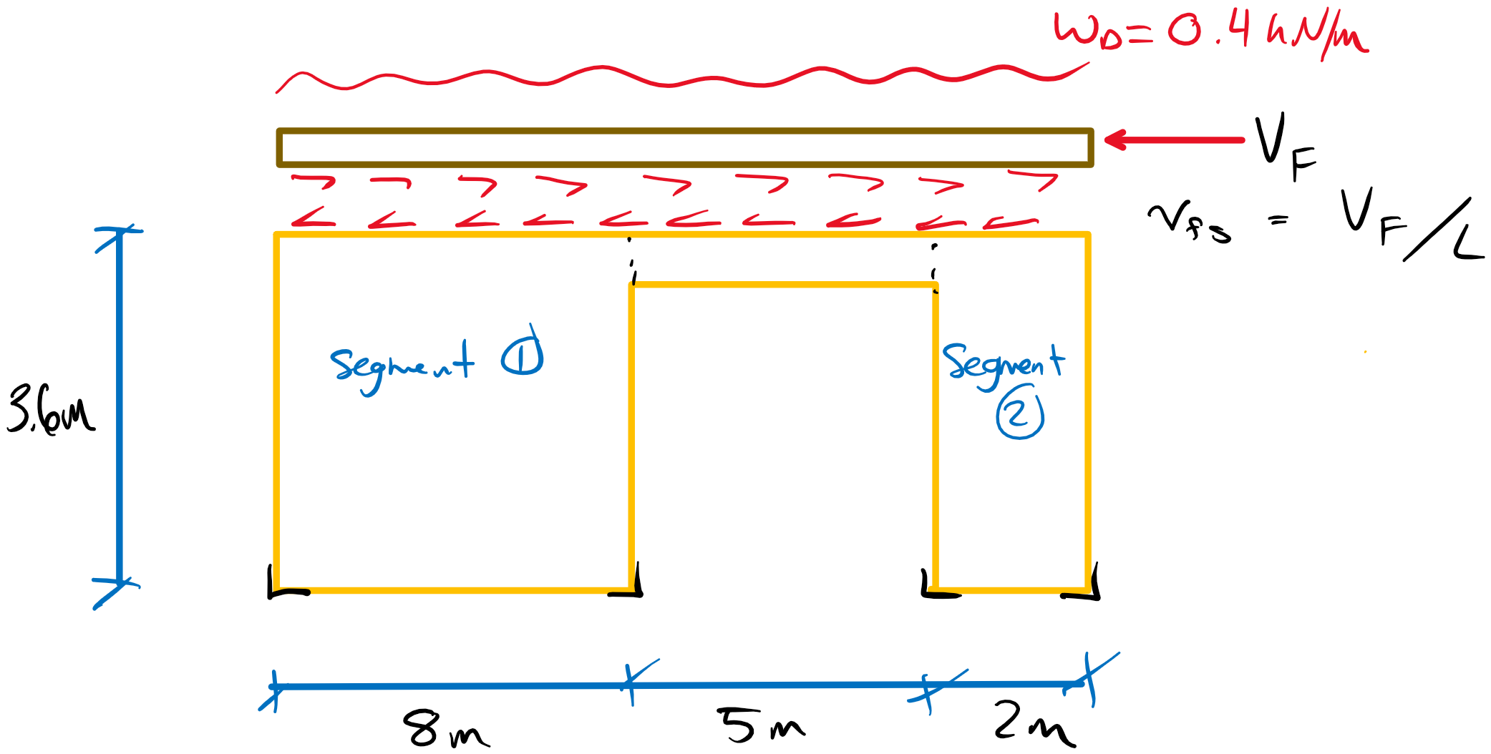

Considered only the dead loads we can determine resistance to uplift at the hold downs:

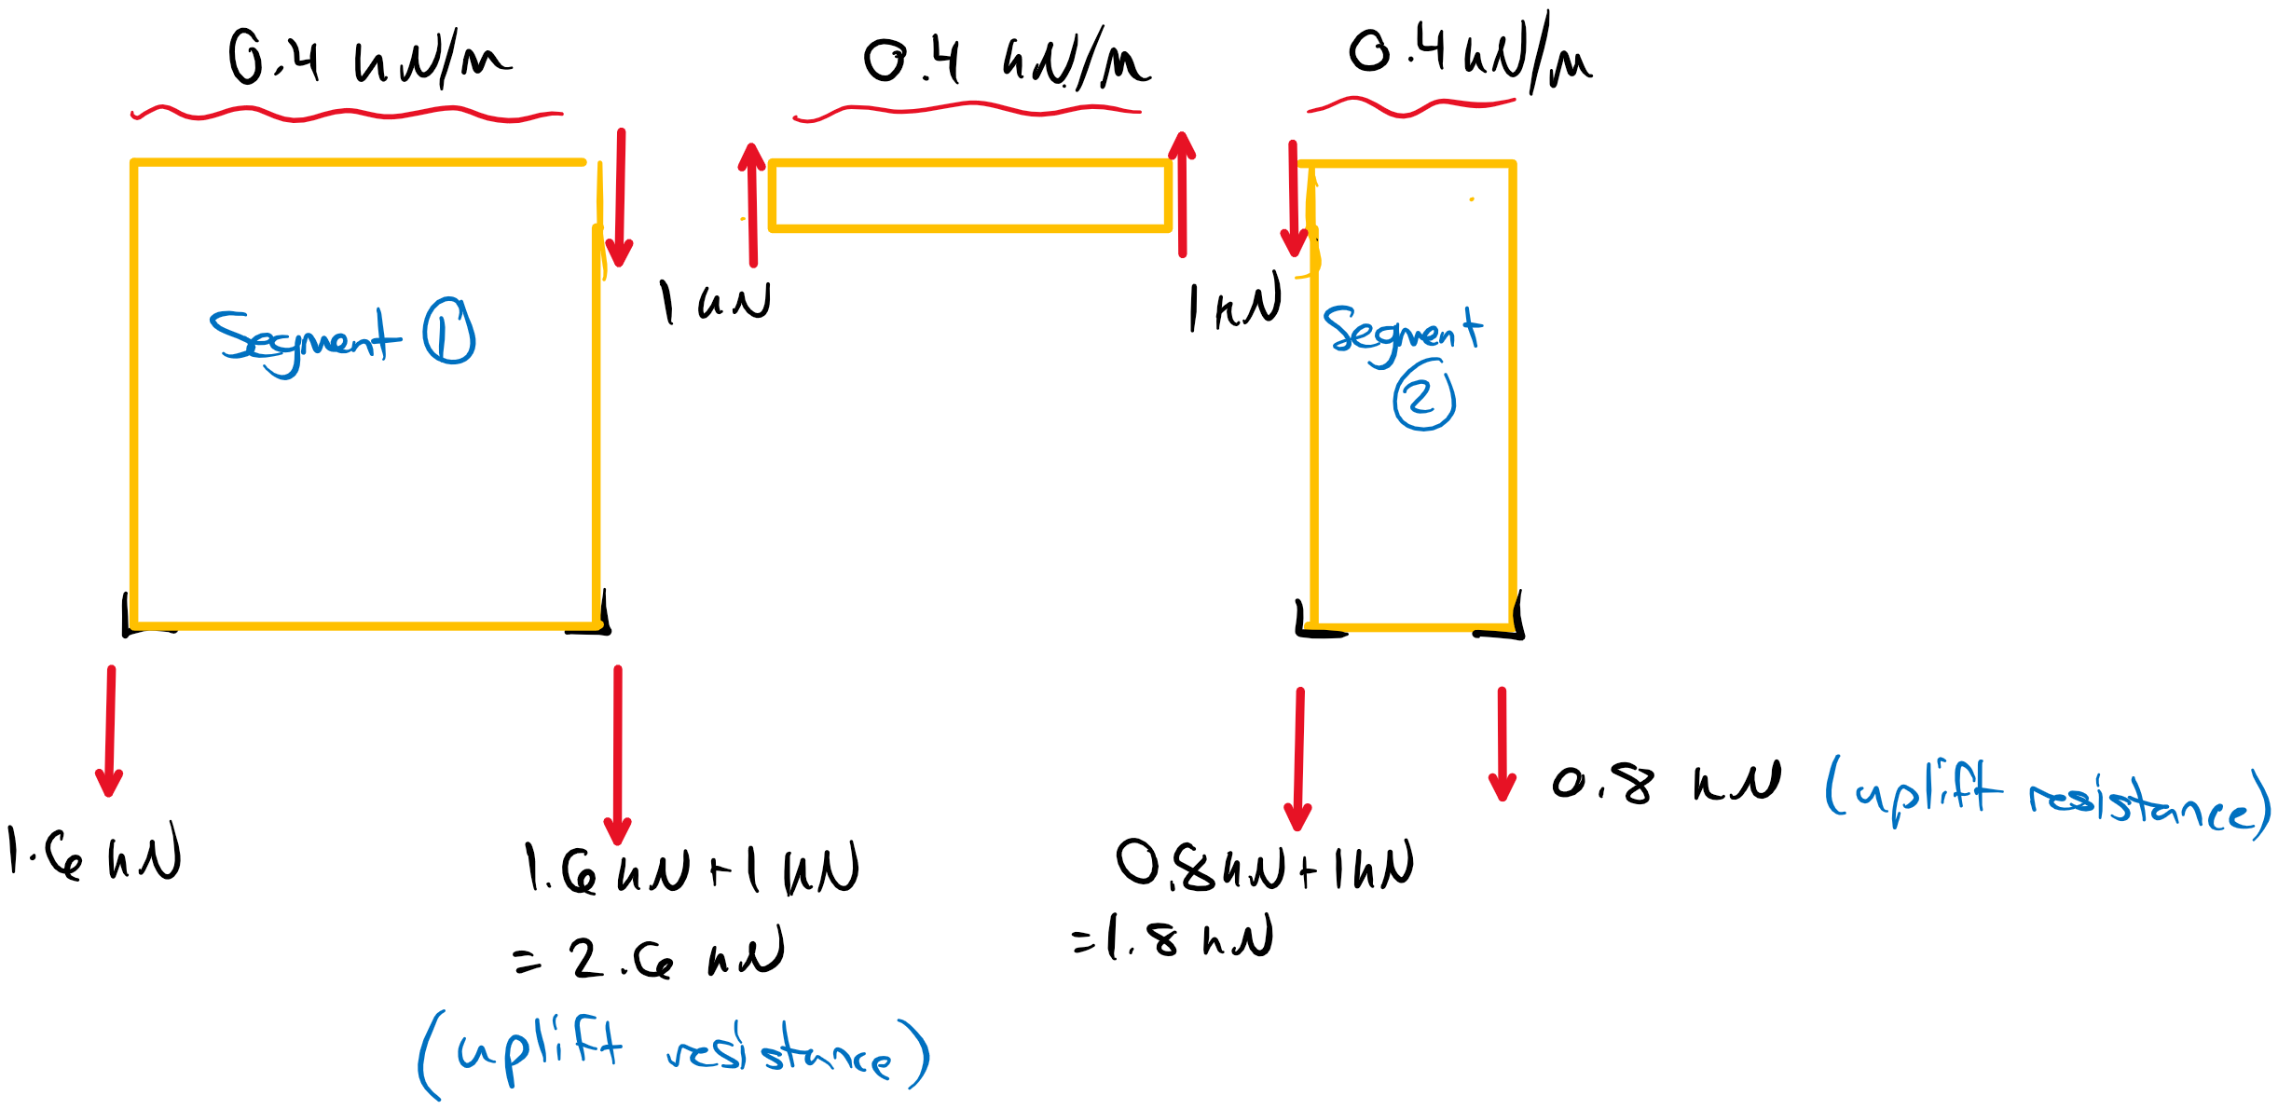

Sheathing to Framing Connection (**11.5.1.2 a**):

Vrs = φvdJDnsJ­usJsJhdLs

vd = Nu /s

Nu = nu­KDKsfKT **(per clause 12.9.4 for nailed connections)**

For a two-member nailed connection with the side member as 1F20 SPF OSB and the main member as SPF studs with 3.5” common wire nails.

For the steel side member (member 1):

df = 4.06 mm

t1 = 15 mm

t2 = 73.9 mm **(nail penetration into stud)**

G1 = 0.42 **(Table A.12.1 for OSB)**

G2 = 0.42 **(Table A.12.1 for SPF visual grade)**

Jx = 1.0

f1 = 104G1(1-0.1df) = 43.3 MPa

f2 = 50G2(1-0.01df)Jx= 20.1 MPa

f3 = 110G21.8(1-0.01df)Jx = 24.2 MPa

fy =50(16-df) = 597 MPa

**12.9.4.2 a)** nu = 2.64 kN

**b)** nu = 6.03 kN

**d)** nu = 1.16 kN **(governs)**

**e)** nu = 3.23 kN

**f)** nu = 1.73 kN

**g)** nu = 1.26 kN

Nu = (1.16 kN)(1.15)(1)(1) = 1.33 kN

vd = 1.33 kN/ 100 mm spacing = 0.013 kN/mm

JD = 1.3 **(12.9.4.1 for shear walls)**

Jus = 1.0 **(11.4.4 for blocked shear walls)**

Js = 1 – (150 – 100 / 150)4.2 = 0.99 **(11.4.1 for 100 mm spacing)**

Jhd = 1.0 **(11.4.5.3 – Jhd­ will vary per wall segment but is first taken as 1.0)**

Wall Segment 1:

Vrs = (0.80)(0.013 kN/mm)(1.3)(1)(1)(0.99)(1)(8000 mm)

Vrs = Vhd = 107 kN

Updating Jhd per **11.4.5.3**

Jhd = (Vhd + P) / Vhd = (107 + 2.6 kN)/(107 kN) = 1.02 ~~<~~ 1.0

P = 2.6 kN **(Uplift restraint force from dead load)**

Jhd = 1.0

Therefore the original Jhd was valid and the shear resistance of the first wall segment is:

Vrs = 107 kN **(GOVERNS segment 1 shear resistance)**

Wall Segment 2:

Vrs = (0.80)(0.013 kN/mm)(1.3)(1)(1)(0.99)(1)(2000 mm)

Vrs = Vhd = 26.75 kN

Updating Jhd per **11.4.5.3**

Jhd = (Vhd + P) / Vhd = (26.75 + 0.8 kN)/(26.75 kN) = 1.03 ~~<~~ 1.0

P = 0.8 kN **(Uplift restraint force from dead load)**

Jhd = 1.0

Therefore the original Jhd was valid and the shear resistance of the second wall segment is:

Vrs = 26.75 kN **(GOVERNS segment 2 shear resistance)**

Panel Buckling (**11.5.1.2 b**):

Vrs = φvpbKDKSKTLs

Vpb = Kpbπ2t2/(3000b) x (Ba, 0 Ba, 903)1/4

a = 2400 mm (Assumed panel length)

b = 1200 mm (Assume panel width)

Ba, 0 = 56000 N/mm (**Table 9.3C** – axial stiffness of panel at 0°)

Ba, 90 = 38000 N/mm (**Table 9.3C** – axial stiffness of panel at 90°)

Bv = 11000 N/mm (**Table 9.3C** – shear through thickness rigidity)

t = 15 mm

α = a/b x (Ba, 90/Ba, 0)1/4 = 1.82

η = 2Bv / (Ba, 0 + Ba, 90)1/2 = 0.48

K­pb = 1.7(η + 1) e( -α / (0.05 η + 0.75) ) + (0.5η + 0.8) = 1.28

Vpb = (1.74)π2(15 mm)2/(3000 (1200 mm) ) x ( (56000 N/mm) (38000 N/mm)3 )1/4

Vpb = 44.9 N/mm

Wall Segment 1:

Vrs = (0.80)(44.9 N/mm)(1.15)(1)(1)(8000 mm) = 330 kN **(doesn’t govern over 11.5.1.2 a)**

Wall Segment 2:

Vrs = (0.80)(44.9 N/mm)(1.15)(1)(1)(2000 mm) = 83 kN **(doesn’t govern over 11.5.1.2 a)**

Per clause **11.3.4.2**, the contribution of the gypsum wall panels on the interior face can be added to each segment’s shear resistance per **11.5.1.3**.

Gypsum Panel Contribution (**11.5.1.3**):

Vrs = φvdJhdLs

vd = 2.1 kN/m **(Table 11.5.4** – 12.5 mm gypsum, 100 mm fastener spacing, blocked)

Wall Segment 1:

Vrs = (0.7)(2.1 kN/m)(1.0)(8 m) = 11.8 kN **(contribution of gypsum panel)**

Vrs, 1 = 11.8 kN + 107 kN = 119 kN **(Wall Segment 1 Total Shear Resistance)**

Wall Segment 2:

Vrs = (0.7)(2.1 kN/m)(1.0)(2 m) = 2.9 kN

Vrs, 2 = 2.9 kN + 26.75 kN = 30 kN **(Wall Segment 2 Total Shear Resistance)**

Therefore, the total resistance of the shear wall (for both sides of the building) is:

Vrs, total = 2 x ( Vrs, 1 + Vrs, 2) = 298 kN > Vf

Vf, max = 298 kN **(Max applied lateral load)**

The maximum applied lateral load for this shear wall system is 298 kN.

# Question 3

This question requires two components: 1) designing the glulam beam for the applied loads and 2) designing the 3-member bolted connection based on the reaction loads supporting the beam. The critical load cases must be considered. The load duration factor will be 1.0 for all cases.

D = 5 kN/m

L = 12 kN/m

Load Case 2a: 1.25D + 1.5L KD = 1.0

wf = 6.25 + 18 kN/m = 24.25 kN/m (over full beam length)

P = 237.65 kN; Ax = 206 kN; Ay =51 kN

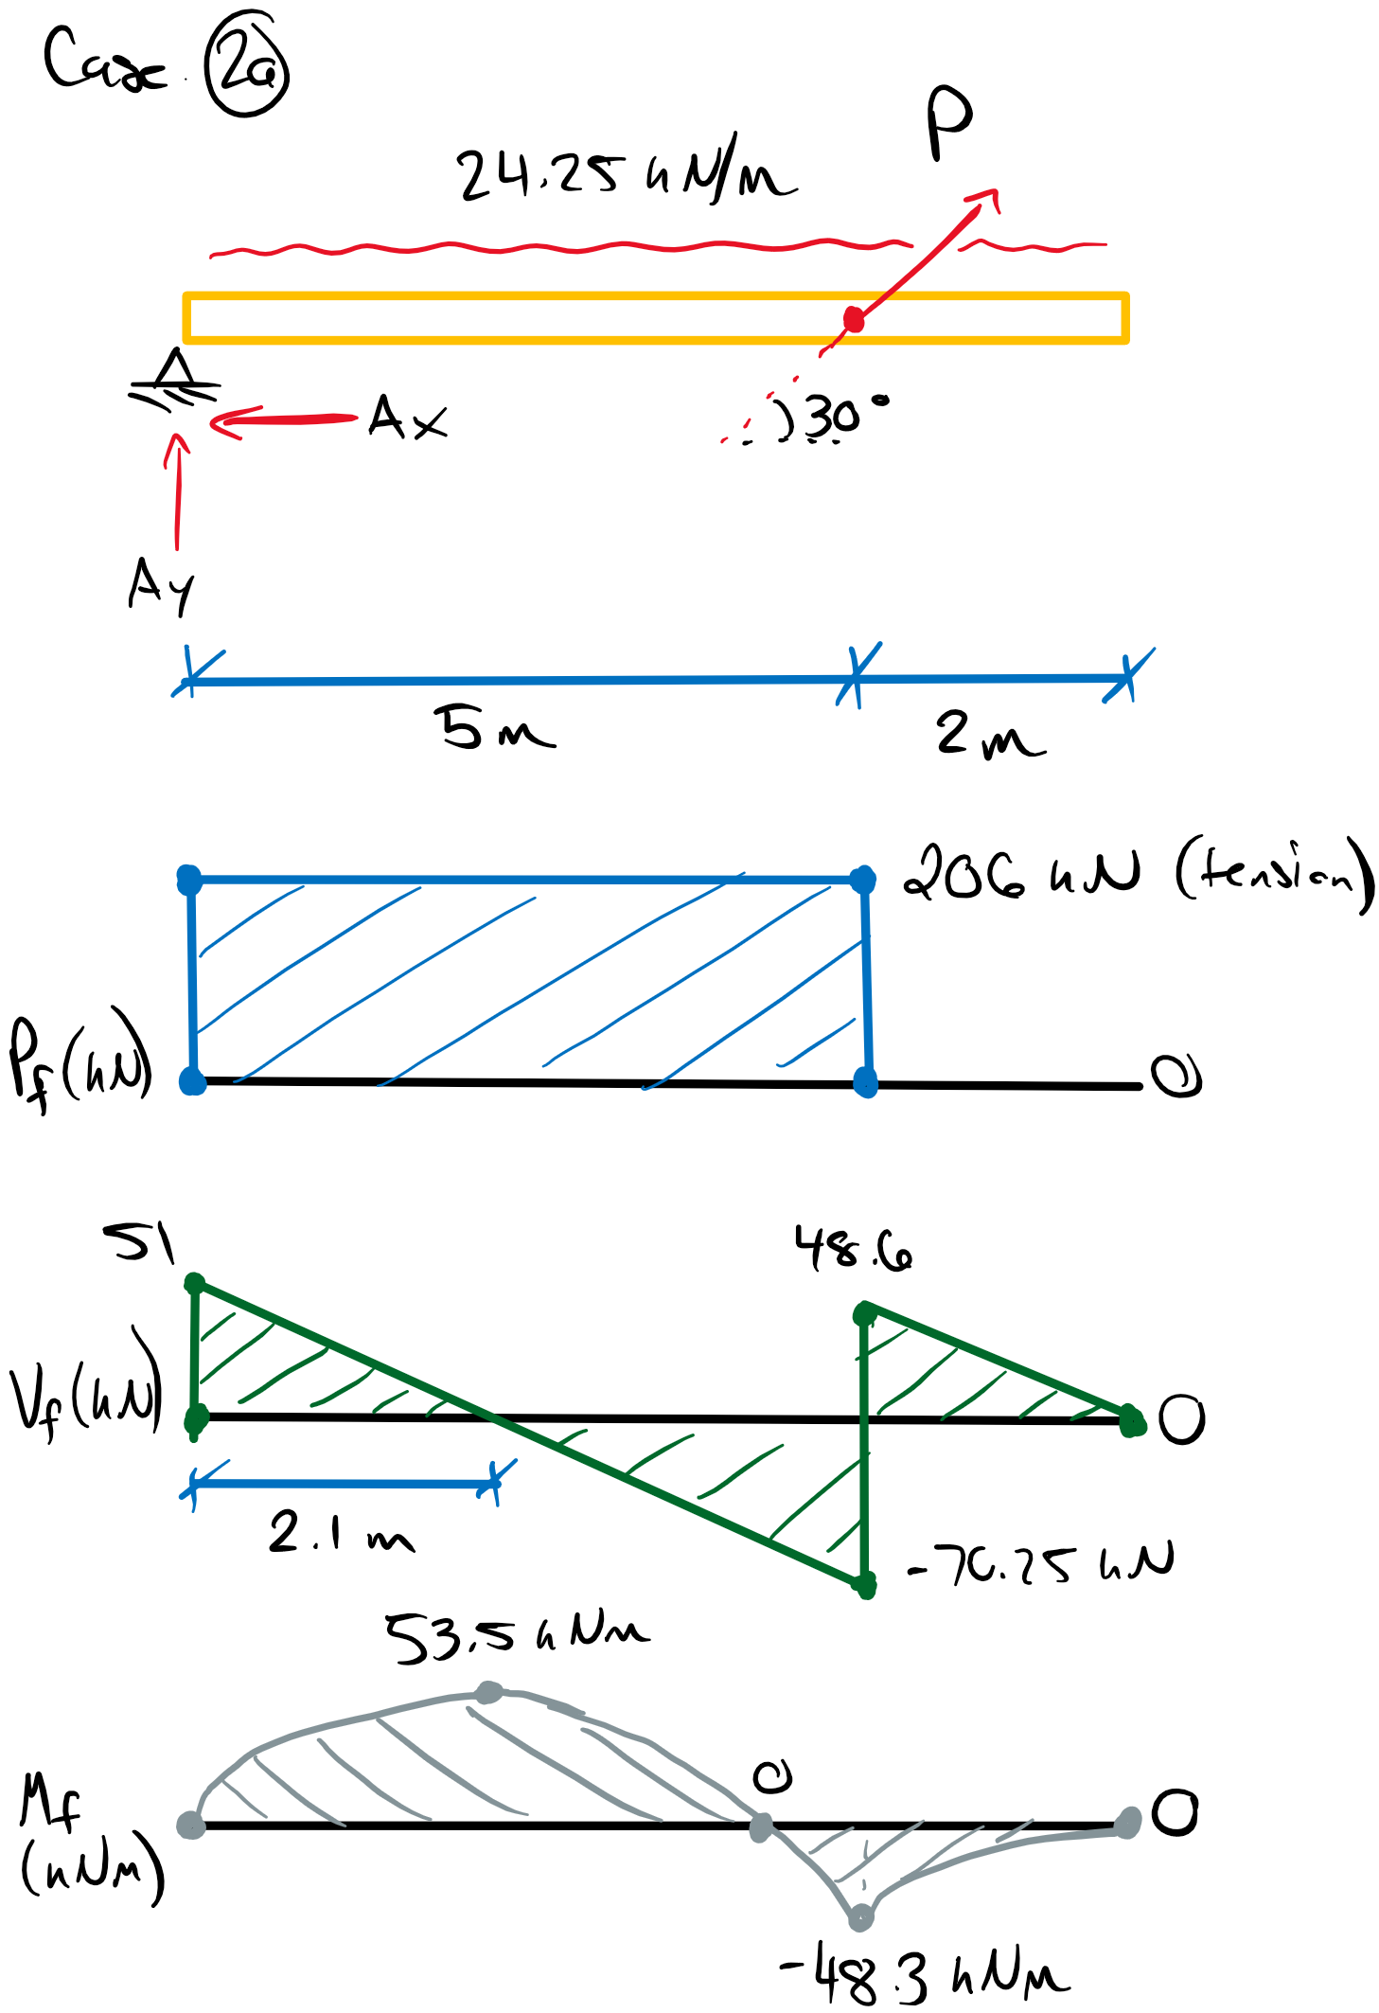

Pf = 206 kN (tension) **(Governs Axial)**

Vf = 70 kN **(Governs Shear)**

Mf+ = 53.5 kNm **(Governs Positive Mf)**

Mf- = 48.3 kNm **(Governs Negative Mf)**

Load Case 2b: 1.25D + 1.5L KD = 1.0

No live load applied to cantilever.

wf, D = 6.25 kN/m wf, L = 18 kN/m

P = 151.25 kN; Ax = 131 kN; Ay = 58.1 kN

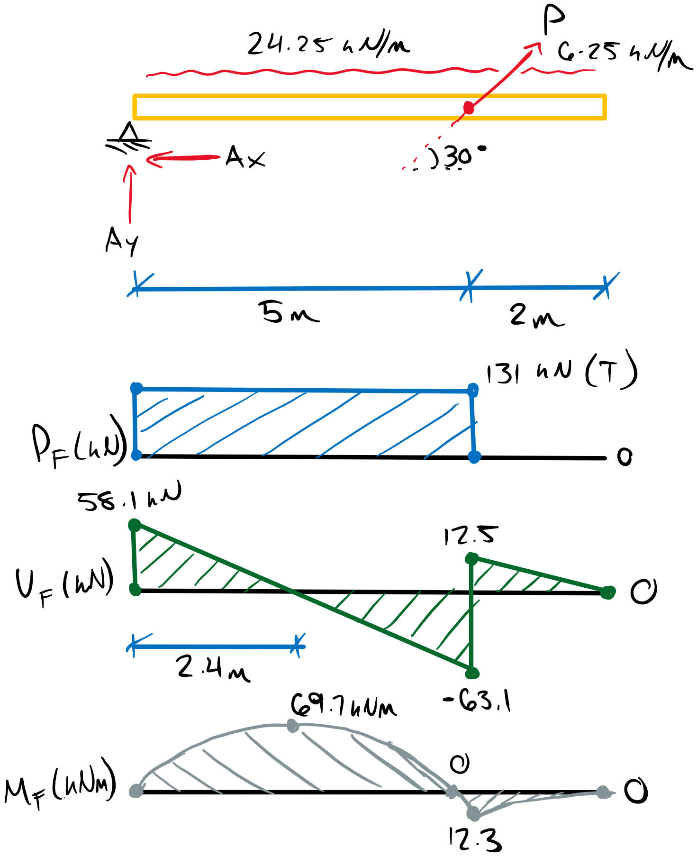

Pf = 131 kN (tension)

Vf = 63 kN

Mf+ = 70 kNm **(Governs Positive Mf)**

Mf- = 12.3 kNm

Load Case 2c: 0.9D + 1.5L KD = 1.0

Max load on cantilever

wf, D = 4.5 kN/m wf, L = 18 kN/m

P = 130.5 kN; Ax = 113 kN; Ay = 2.25 kN

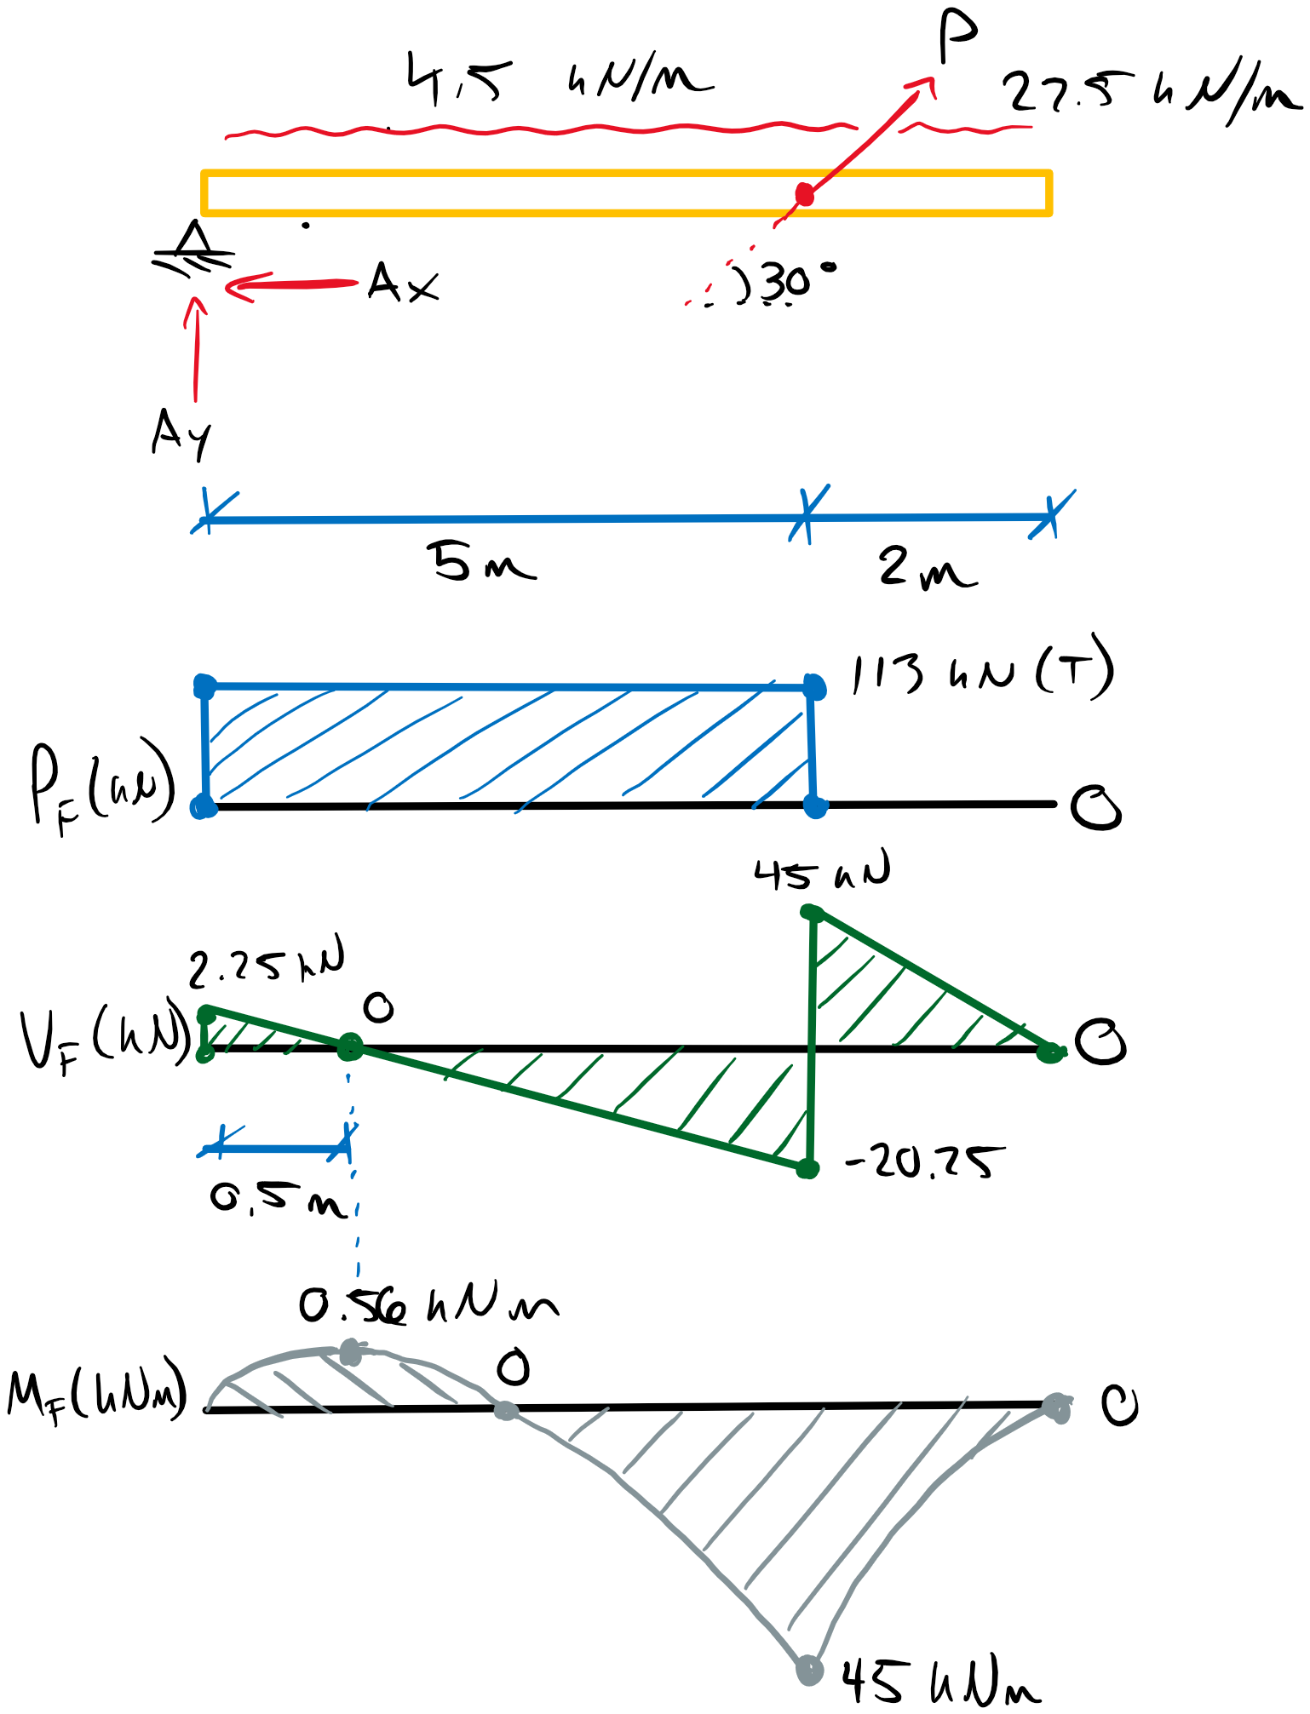

Pf = 113 kN (tension)

Vf = 45 kN

Mf+ = 0.56 kNm

Mf- = 45 kNm

Critical Factored Load Summary:

Pf = 206 kN (tension)

Vf = 70 kN

Mf+ = 70 kNm

Mf- = 48 kNm

Case 2a (Axial + Bending):

Pf = 206 kN (tension)**;** Mf = 53.5 kNm

Case 2b (Axial + Bending):

Pf = 131 kN (tension)**;** Mf = 70 kNm

Critical Reaction Loads:

Designing the connection at A must account for the reactions Ax and Ay in supporting the beam, and their resultant force A. Per **12.4.4.2 d**, for loading at angle to the grain, as the resultant A is applied, the angle θ, must be account for which implies load cases with different θ values must be compared individually. Therefore, two critical cases can be observed.

Case 2a:

Ay = Qf = 51 kN (factored splitting load perpendicular to grain)

**Ax = Pf = 206 kN** (factored load parallel to grain) **(GOVERNS Pf)**

**A = Nf = 212 kN**  (factored fastener yielding load) **(GOVERNS Nf)**

θ = tan(Ay/Ax) = 13.9° (angle of resultant force A relative to grain)

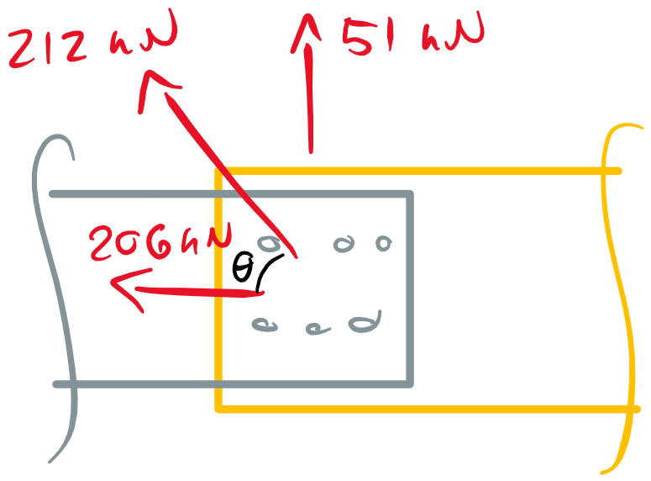

Case 2b:

**Ay = Qf = 58 kN** (factored splitting load perpendicular to grain) **(GOVERNS Qf)**

Ax = Pf = 131 kN (factored load parallel to grain)

A = Nf = 143 kN (factored fastener yielding load)

θ = tan(Ay/Ax) = 23.9° (angle of resultant force A relative to grain)

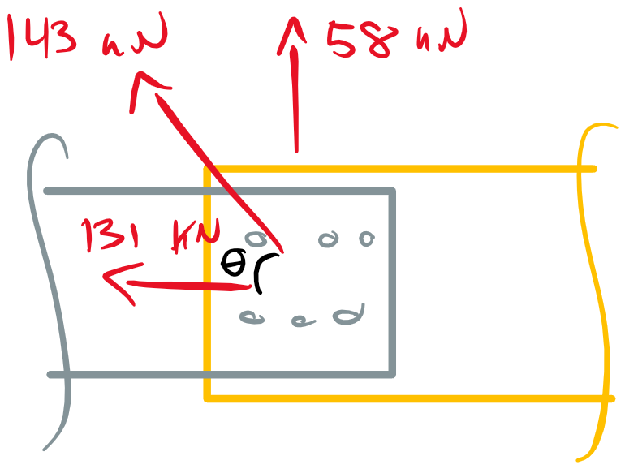

Therefore, the connection must be design for the governing individual loads above as well as both interactions for different θ values (see **12.4.4.2 a-d**).

Beam Design (Using Selection Tables):

The beam must be design for the factored tension, shear, and bending loads as well as the axial + bending interaction. Depending on the following connection design, the net section of the beam must be accounted for. At this stage, let’s assume the maximum gross section reduction is required for the connection which will be a conservative estimate:

An = 0.75Ag (maximum reduction per **12.4.4.6.2**)

Try **215x342 20f-EX SPF glulam**

Trg = Trn = 840 kN > Tf = 206 kN **(Tensile resistance OK** – see note below)

Note that the tabulated tensile resistance values provide the gross area tensile resistance which applies the full member section and the gross section tensile strength, ftg. This must also be compared to the net section tensile resistance per **7.5.11** for glulam which applies the net section tensile strength, ftn. For the case of 25% gross section reduction, the net section tensile resistance is equivalent to the gross section tensile resistance since the tabulated value of ftg is 0.75 of ftn. Therefore, although the net area is reduced by 0.75 per our assumption, the net section strength is increased by 1/0.75, making both resistances equivalent for this case. Thus the tabulated tensile resistance is accurate for our assumption.

Mr = 96.6 kNm > Mf =70 kNm **(Moment Resistance OK** – see note below)

Per **7.5.6.5.1**, the size factor for bending must be calculated between points of inflection in the applied moment which is not done in the tabulated values. However, it is conservative to omit this since Kzbg for the full member will always be greater than that for a member’s segment (assuming a constant cross-section). Further, the tabulated values assume KL is 1.0 which per **6.5.4.2.1** for d/b = 1.6 is accurate.

Vr = 77.2 kN > Vf = 70 kN **(Shear Resistance OK** – must account for de)

Vr, e = Vr/d x de = 70 kNm

de > 70 kN/77.2 kN x 342 mm

**de > 310 mm** (de based on the connection must be greater than 310 mm for adequate Vr)

Tf/Tr + Mf/Mr ≤ 1.0

1.0 ≥ 206/840 + 70/96.6

1.0 ≥ 0.97 **(Axial-Moment Interaction OK)**

Therefore, 215x342 should be adequate for An up to 0.75A­g and for de > 310 mm.

Connection Design:

tplate = 6 mm

Try 3/4" hex bolts. See **Table 11.4** in *Introduction to Wood Design* book for bolt varieties. Also note that the holes required for bolts must be a maximum of 2 mm greater than the diameter of the bolt (see **11.4** in the *Introduction to Wood Design* book).

dbolt = 25.4 x 3/4 = 19.05 mm

dhole = 25.4 x 3/4 + 2.0 mm = 21.05 mm

Therefore, based on the net section requirements, the maximum number of bolt rows is:

# rows = 0.25d/dhole = 0.25(342 mm)/21.05 mm = 4.06 = 4 rows

Spacing Requirements (**12.4.3**):

Since we are designing for both parallel and perpendicular to grain load components, we must satisfy both **12.4.3.1** and **12.4.3.2**. The parallel to grain “row spacing” is the same as the perpendicular to grain “bolt spacing” and vice versa.

Min. Spacing Parallel to Grain (**12.4.3.1**): Min. Spacing Perpendicular to Grain (**12.4.3.2**):

Sr = 4dbolt = 76.2 mm **(Governs)** Sr = 3dbolt = 57.15 mm (bolt spacing)

Sc = 3dbolt = 57.15 mm **(Governs)** Sc = 3dbolt = 57.15 mm (row spacing)

a = max (50, 4dbolt) = 76.2 mm a = max (50, 4dbolt) = 76.2 mm (unloaded end dist.)

aL = max (50, 5dbolt) = 95.25 mm **(Governs)** (loaded end dist.)

eQ = 4dbolt = 76.2 mm **(Governs)** (loaded edge dist.)

ep = max (Sr, perp./2, 1.5dbolt) = **TBD** ep = 1.5dbolt = 28.6 mm (unloaded edge dist.)

Try:

Sr = 80 mm

Sc = 60 mm

aL = 100 mm

We should aim for a design such that ep = eQ and the connection is symmetric across the cross-section. This will avoid inducing eccentricities in the connection forces. Therefore:

ep = eQ = 80 mm

Let’s ensure we can still achieve de > 310 mm.

de = d – ep + dhole/2 = 342 – 80 + 21.05/2 = 251 < 310 mm **(section too small)**

We cannot achieve our required de with this configuration so we must consider new fastener sizes or provide a deeper member. For our desired connection spacing we can calculated a required depth.

dreq = de + ep – dhole/2 = 310 mm + 80 mm - 21.05/2 = 379.5 mm = 380 mm.

Therefore, try a **215x380 mm** member:

de = 380 – 80 + 21.05/2 = 310.5 mm > 310 mm

215x380 mm 20f-EX SPF glulam:

Tr = 934 > Tf = 206 kN **(tension OK)**

Mr = 119 kNm > Mf = 70 kNm **(moment OK)**

Vre = Vr/d x de = 85.8 kN/380 x 310.5 = 70.1 kN > 70 kN **(shear OK –** can check Wr also)

Tf/Tr + Mf/Mr ≤ 1.0

0.81 ≤ 1.0 **(axial-moment interaction OK)**

Continuing with connection design…

The requirements of **12.4.4.2** must be met for the connection. We can begin by using **12.4.4.2 a**, the fastener yielding resistance, to determine the minimum number of bolts required.

Bolt Yielding (**12.4.4.3.2**):

Nr = φynunfns

Similarly to nails, bolt yielding is calculated for all relevant cases in **12.4.4.3.2**. For the three-member connection herein we only need to considered **a, c, d, g**.

t1 = 6 mm (steel plate thickness)

t2 = 215 mm (wood member thickness)

f1 = Ksp fu φsteel/φwood = (3.0)(450 MPa)(0.80)/(0.80) = 1350 MPa

fy = 310 MPa (assumed bolt yield strength)

f2 = fipfiQ/(fipsin2θ + fiQcos2θ)

fip = 50G(1-0.01df)Jx = 17.8 MPa (G = 0.44 **Table A.12.1**)

fiQ = 22G(1-0.01df) = 7.8 MPa

Case 2a (θ = 13.9°):

f2 = 16.6 MPa

Case 2b (θ = 23.9°):

f2 = 14.7 MPa

Find the governing case using Case 2a then calculate Case 2b:

**12.4.4.3.2 a)** nu = 154 kN

**c)** nu = 34 kN

**d)** nu = 41.4 kN

**g)** nu = 21.1 kN **(GOVERNS** – Case 2a)

nu = 19.9 kN **(GOVERNS** – Case 2b)

Nr = (0.80)(21.1 kN)(2)nf ≥ Nf = 212 kN

nf ≥ 6.3 bolts

nf ≥ 7 bolts **(GOVERNS)**

Nr = (0.80)(19.9 kN)(2)nf ≥ Nf = 143 kN

nf ≥ 4.5 bolts

Therefore a minimum of 7 bolts are required to resist fastener yielding.

Row Shear (**12.4.4.4**):

The row shear resistance is the sum of the row shear strength of all individual members required for the failure. In this case, the central wood member is the only member resisting the row shear (similarly the steel plates are as well, but only the single wood member must fail for row shear to occur – and the steel plate design is not covered in **O86**).

PRrT = ΣPRri = PRr, glulam beam

PRr = φw PRij, minnR

PRij, min = 1.2fv KDKsvKTKls t nc acr, I (min. row shear resistance of all rows)

fv = 1.75 MPa

Kls = 1.0 (for an internal member in a 3 member connection)

acr, I = min(aL , Sr) = 80 mm (for 80 mm row spacing)

For now, let’s assume there are 8 bolts in 2 rows at 80 mm bolt spacing (meets An and # bolt requirements)

nc = 4 bolts/row

PRij, min = 1.2(1.75 MPa)(1)(1)(1)(1)­(215 mm)(4 bolts/row)(80 mm)

PRij, min = 144 kN/row

PRrT = PRr = (0.70)(144 kN/row)(2 rows) = 202 kN ≤ PF = 206 kN **(Insufficient for row shear Pf)**

Try 9 bolts in three rows with 80 mm bolt spacing

nc = 3 bolts/row

PRij, min = 108 kN/row

PRrT = PRr = 227 kN ≥ PF = 206 kN **(OK for row shear resistance)**

For three rows of bolts placed symmetrically about the glulam beam:

Sc = (d – ep – eQ)/2 = (380 – 80 – 80)/2 = 110 mm (bolt row spacing for 3 rows)

ep, min = Sc/2 = 55 mm < 80 mm (unloaded edge spacing OK)

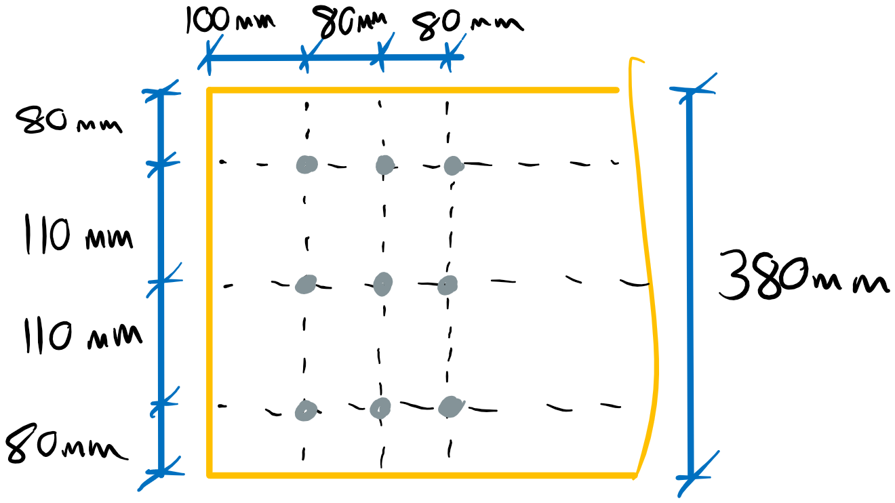

Group Tear-Out (**12.4.4.5**):

Similarly to row shear, the total group tear-out resistance is the sum of the contributing members’ resistances.

PGrT = ΣPGri = PGr, glulam

PGri = φw[ (PRi, 1 + PRi,nR)/2 + ftK­DKstKTApGi ]

PRi, 1 = PRi, nR = 1.2fv KDKsvKTKlsAPG

fv = 1.75 MPa

ft = ftn = 17.0 MPa

Kls = 1.0

nc = 3 bolts/row

acr­ = 80 mm

t = 215 mm

APG = t[ (Sc x 2) – 2 x dhole/2 – dhole] (Net section area between fastener group)

APG­ = (215 mm) [(110 mm x 2) – (2 x 21.05 mm /2) – 21.05 mm] = 38248 mm2

PRi, 1 = PRi, nR = 1.2(1.75 MPa)(1)(1)(1)(1)(215 mm)(3)(80 mm) = 108 kN

PGrT = PGri = (0.70) [ 2 x (108 kN)/2 + (17.0 MPa)(1)(1)(1)(1)(38248 mm2) ]

PGrT = 531 kN ≥ Pf = 206 kN **(OK for group tear-out)**

Perpendicular to Grain Splitting (**12.4.4.7**):

QSrT = ΣQSri = QSr, glulam

QSri = φwQSiKDKsfKT

QSi = 14t(de / (1-de/d) )1/2 = 14(215 mm)( (310.5 mm) / (1 – (310.5 mm)/(380 mm))1/2

QSi = 124 kN

QRrT = QSri = (0.7)(124 kN)(1)(1)(1)

QRrT = 87 kN > Qf = 58 kN **(OK for Perp. Splitting Resistance)**

Net Tension (**12.4.4.6 – 7.5.11**):

Although the beam has been designed for net tension, the specific resistance value must be known to determine the governing resistance to axial load.

TNrT = ΣTNri = TNr, glulam

TNri = φFtnAn

An = (215x380 mm2) – 3 x (21.05 mm x 215 mm) = 68123 mm2

Ftn = (17.0 MPa)(1)(1)(1)(1) = 17.0 MPa

TNri = (0.90)(17.0 MPa)(68123 mm2)

TNri = 1042 kN > Tf = 206 kN **(OK for Net Tension)**

Summary:

We have completed the necessary resistance checks per **12.4.4.2**, however we must recalculate the fastener yielding resistance since the configuration change after the initial calculation.

For fastener yielding with 9 bolts:

Nr = (0.80)(21.1 kN)(2)(9 bolts) = 304 kN ≥ Nf = 212 kN **(OK for Fastener Yielding – Case 2a)**

Nr = (0.80)(19.9 kN)(2)(9 bolts) = 287 kN ≥ Nf = 143 kN **(OK for Fastener Yielding – Case 2a)**

Therefore the relevant resistances for the current configuration area:

Fastener Yielding:

Nr = 304 kN > Nf = 212 kN (Case 2a)

Nr = 287 kN > Nf = 143 kN (Case 2b)

Row Shear:

PRr = 227 kN > Pf = 206 kN **(GOVERNS Pr per 12.4.4.2b)**

Group Tear-Out:

PGrT =531 kN > Pf = 206 kN

Perp. to Grain Splitting:

QRrT = 87 kN > Qf =58 kN **(GOVERNS Qr per 12.4.4.2c)**

Net Tension:

TNri = 1042 kN > Tf = 206 kN

Based on the governing resistances, we must now check **12.4.4.2d** for loading at angle to grain:

Case 2a: θ = 13.9°

Nr = PrQr/(Prsin2θ + Qrcos2θ) = (227 kN)(87 kN)/[(227 kN)sin213.9 + (87 kN)cos213.9]

Nr = 208 kN < Nf = 212 kN **(Design FAILS check for loading at angle to grain)**

We must provide some extra strength to the connection. Perhaps the simplest approach would be to increase the bolt spacing from 80 mm to 100 mm while maintaining 3 rows of 3 bolts. This will only increase the row shear and group tear-out resistance which may provide enough additional capacity. We know the group tear-out resistance is much greater than the row shear resistance, so we will assume it will not govern the updated design.

Update Row Shear for 3 rows of 3 bolts at 100 mm spacing:

PRij, min = 1.2(1.75 MPa)(1)(1)(1)(1)­(215 mm)(3 bolts/row)(100 mm)

PRij, min = 135 kN/row

PRrT = PRr = (0.70)(135 kN/row)(3 rows)

PRr = 283.5 kN ≤ PF = 206 kN **(OK for row shear – still governs Pr)**

Now check for loading at an angle to grain:

Case 2a: θ = 13.9°

Nr = PrQr/(Prsin2θ + Qrcos2θ) = (283.5 kN)(87 kN)/[(283.5 kN)sin213.9 + (87 kN)cos213.9]

Nr = 251 kN < Nf = 212 kN **(OK for loading at angle to grain)**

Case 2b: θ = 23.9°

Nr = PrQr/(Prsin2θ + Qrcos2θ) = (283.5 kN)(87 kN)/[(283.5 kN)sin223.9 + (87 kN)cos223.9]

Nr = 207 kN < Nf = 143 kN **(OK for loading at angle to grain)**

Therefore, the final design uses a **215x380 mm SPF 20f-EX glulam beam** with the following bolted connection detail:

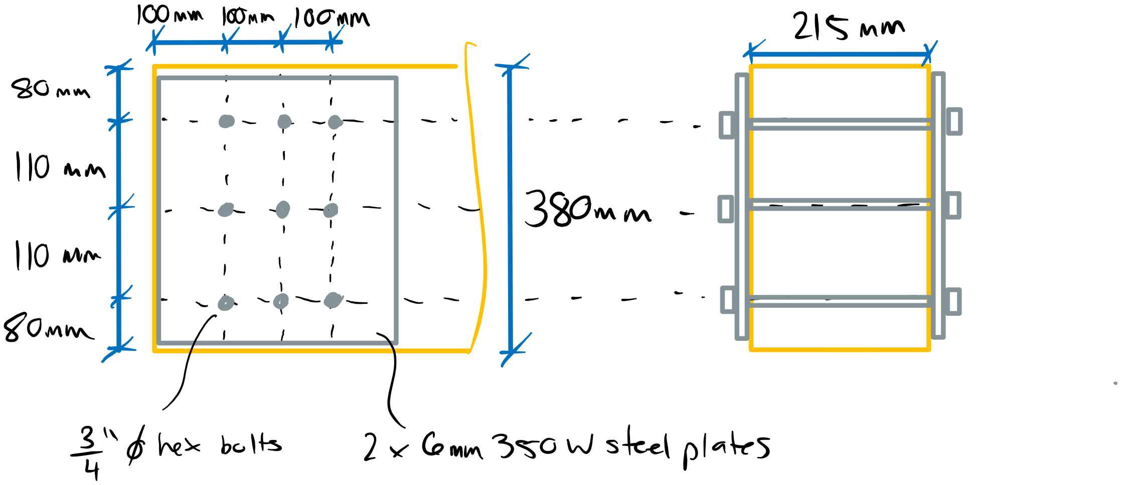

# Question 4

Per **Annex B**, the Fire Resistance Rating (FRR) can be determined based on the time required to reduce the cross-section through charring such that failure occurs. In this problem we can assume the requirements for applying **Annex B** in **O86-14 B.2.2** are met.

To proceed, we must calculate the critical depth of charring required to induce failure through the following modes. The 500 mm support bearing length is assumed to be fire protected and will not experience a reduction in size.

-shear

-flexure

-bearing at a joist load

-critical bearing near support

Fire Safety Requirements:

**Annex B** outlines procedures for determine the capacity of timber member exposed to fire. Per clause **B.4**, the charring rate per timber element is provided in **Table B.4.2**. In this example, since charring will occur on more than one exposed face, the notional charring rate of 0.70 mm/min is used. In addition to the production of char, clause **B.5.1** stipulates that an additional heated wood depth beyond the char is considered to have no strength. This value is taken as 7 mm for heating times greater than 20 minutes. Finally, the role of modification factors are discussed in clause **B.3** including the factor Kfi which adjusted the specified member strength to mean member strength and is taken as 1.35 for glulam. Finally, a short term load duration factor is adopted for fire scenarios (**B.3.3**). Therefore, the char plus zero-strength depth as a function of time is:

dx = xc,n + xt

dx = βnt + 7

Therefore, the width and depth of a beam with all sides exposed as a function of time is:

do = d – 2dx = d - 2βnt – 14 = d – 1.4t – 14 = 936 – 1.4t

bo = b – 2dx = b - 2βnt – 14 = b – 1.4t – 14 = 201 – 1.4t

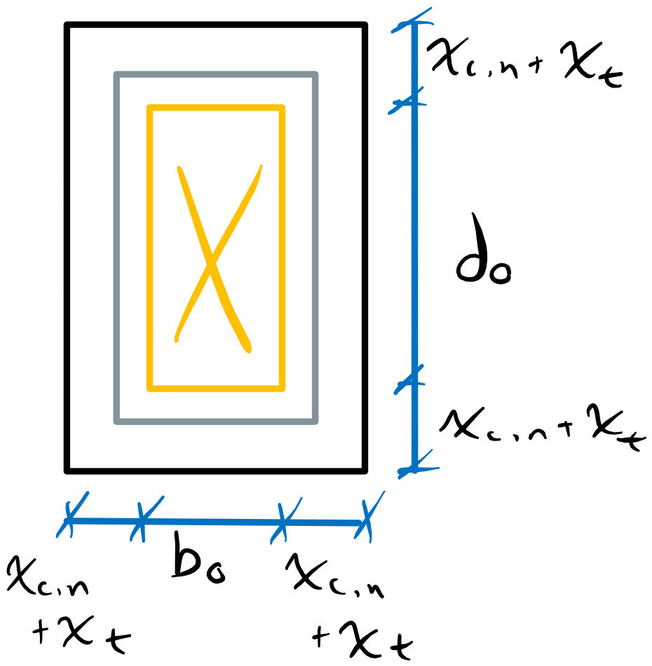

Girder Loading:

Per **B.1.4**, the gravity loading combination for fire scenarios is 1.0D + 1.0L. Therefore, the beam diagrams for D = 20 kN, L = 10 kN are:

Pf = 1.0D + 1.0L = 30 kN

KD = 1.0 - 0.5log(20/10) = 0.85

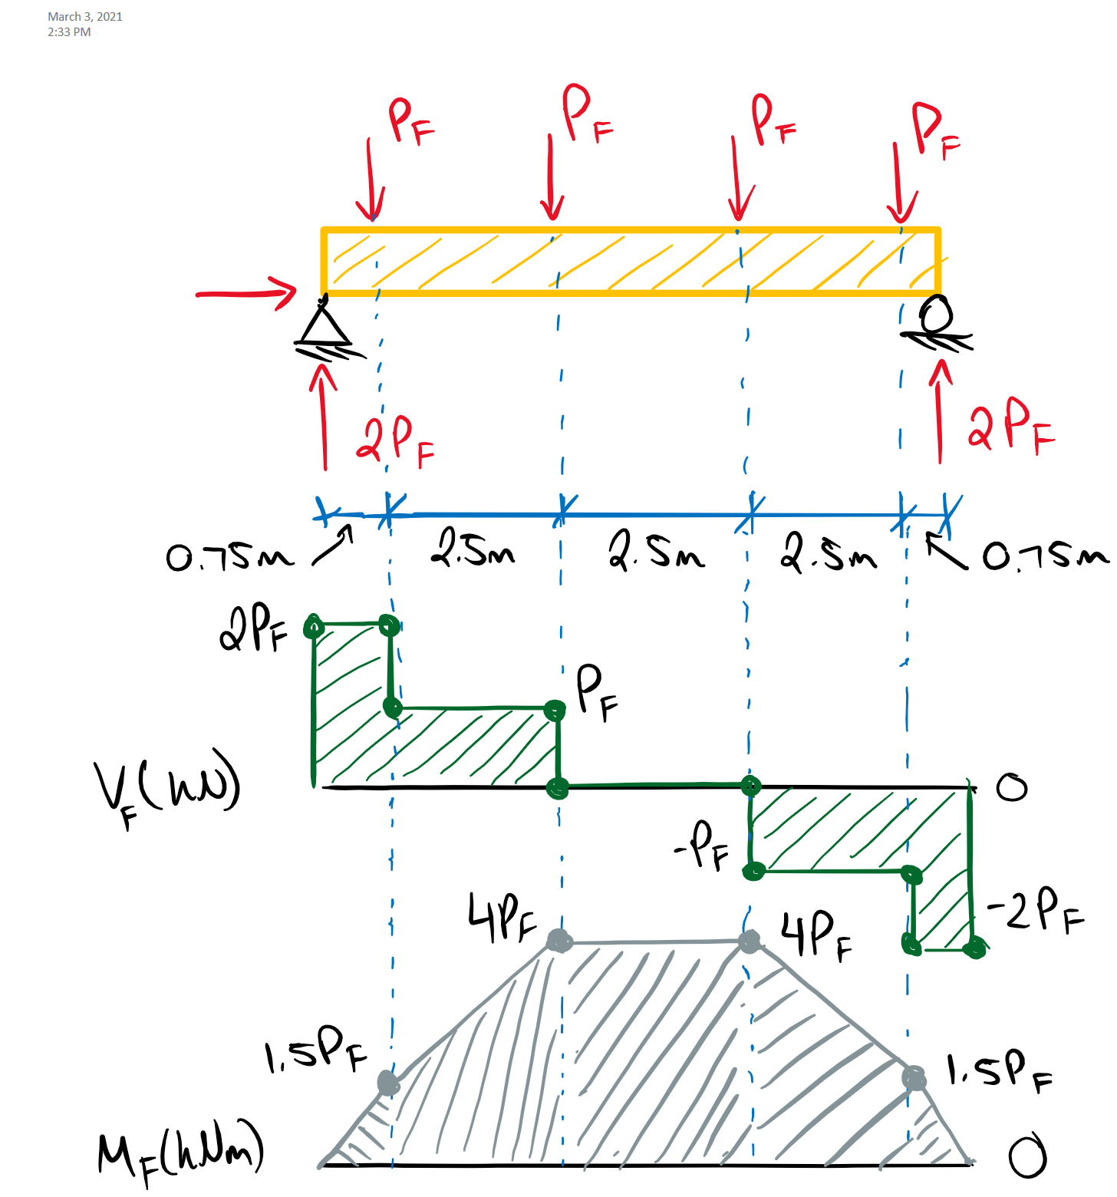

Vf = 2Pf = 60 kN

Mf = 4Pf = 120 kNm

Qf = Pf = 30 kN

Qf’ = = Pf = 30 kN

Girder Shear Resistance (**7.5.7.2**):

We can find the critical reduced area to determine the time-to-failure in shear.

Z = 0.125 x 0.950 x 9000 m3 = 1.84 m3 < 2.0 m3

Vr =φFvA 2/3 Kls

Per **B.3.2**, the resistance factor, φ, for fire load cases is taken as 1.0.

Fv = fvKDKHKSKT = (1.75 MPa)(1.15)(1)(1)(1) = 2.01 MPa

Vr = (1)(2.01 MPa) 2/3 (1.35)A ≥ Vf = 60 kN

A ≥ 33167 mm2 **(Critical reduced area for shear failure)**

We can express the area in terms of the reduced section sizes bo and do to determine the charring time required.

A = bo x do = (b – 1.4t – 14) x (d – 1.4t – 14) = (201 – 1.4t)(936 – 1.4t)

33167 mm2 = 1.96t2 -1591.8t + 188136

0 = 1.96t2 -1591.8t + 154969

Solving for the roots of the equation give:

+root: t = 699 min

-root: t = 113 min **(GOVERNS FRR for shear)**

Therefore, after 113 minutes of fire exposure, enough section will be lost to cause shear failure.

Girder Moment Resistance (**7.5.6.5**):

Per **Annex B**, the size factor for bending must be determined using the originally member size, while the lateral stability factor is determined with the reduced member size. This will complicate the determination of the FRR.

Kzbg = (130/107.5 x 610/950 x 9100/9000)1/10 = 0.98 ≤ 1.3 (recall the laminate width is 107.5 mm)

Fb = fbKDKHKsKT = (25.6 MPa)(1.15) = 29.4 MPa

In addition to exceeding the moment resistance, the beam may become too slender after a significant reduction in cross-section.

CB = (Ledo/bo)1/2 ≤ 50

Le = 1.92a = 1.92(2.5 m) = 4.8 m (2.5 m is the maximum joist spacing)

CB (t) = [ (4800 mm)(936 – 1.4t)/(201 – 1.4t) ]1/2

The slenderness ratio CB must be calculated for each point of interest to determine the factor KL per **7.5.6.4.4**, which is then used to determine the moment resistance Mr.

For CB ≤ 10 KL = 1.0

For 10 < CB ≤ CK = 21.4 KL = 1 – 1/3 (CB/CK)4(see **7.5.6.4.4b**)

For CK < CB ≤ 50 KL = 0.65EKSEKT/CB2FbKx (see **7.5.6.4.4c**)

S(t) = bodo2/6 = (201-1.4t) (936-1.4t)2/6

Mr(t) = φFbS(t)Kls x min(Kzbg, KL)

We can apply the “Goal Seek” functionality in Excel to determine the critical times to failure for the girder in flexure based on the above equations. First, we can determine that the t required for CB = 50 is 116 min. This is the absolute maximum FRR. We must determine if flexural failure will occur prior to this time. For a range of t values, the given Mr and Cb values are given in the Table and Figure below. Keep in mind, the depth of the zero-strength layer is a function of time when t < 20 minutes (clause **B.5.1**) (not likely to affect the results herein but this detail is reflected in the figures below).

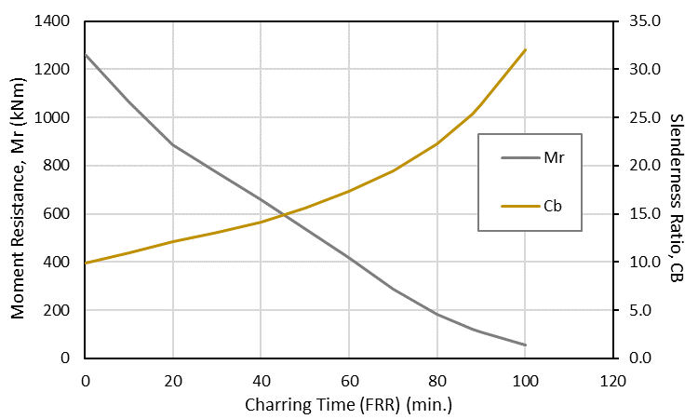

|  |  |  |
| --- | --- | --- |
| **t (min.)** | **Mr (kNm)** | **Cb** |
| 0 | 1260 | 9.9 |
| 10 | 1064 | 10.9 |
| 20 | 887 | 12.1 |
| 30 | 772 | 13.0 |
| 40 | 657 | 14.2 |
| 50 | 540 | 15.6 |
| 60 | 417 | 17.3 |
| 70 | 287 | 19.5 |
| 80 | 182 | 22.3 |
| **88** | **120** | **25.4** |
| 90 | 107 | 26.3 |
| 100 | 57 | 32.0 |

Here we can see that the critical FRR is around 88 minutes where the factored moment equals the remaining moment resistance. The slenderness ratio, Cb does not exceed the limit of 50 within this period and therefore does not govern the failure.

Girder Bearing:

The bearing resistance must be checked at two locations to determine the critical FRR: 1) bearing at joist away from the support (**7.5.9.2**) and 2) bearing at a joist within d from the support (**7.5.9.3**). In both cases, the girder and joist will have reduced cross-sections due to charring per below.

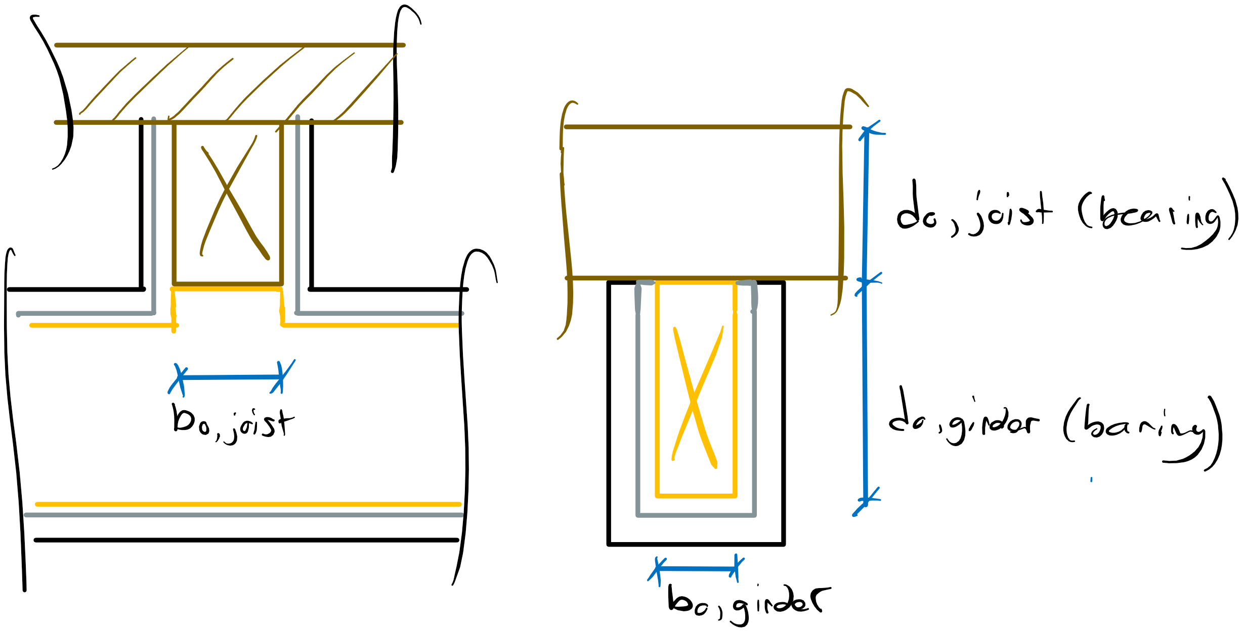

Away from Support (**7.5.9.2**):

Qr = φFcpAbKBKzcpKls

Kzcp = 1.0 (**6.5.7.4** for b/d < 1.0)

KB = 1.0 (**6.5.7.5** for area of high bending stress)

Fcb = fcbKDKHKsKT = (5.8 MPa)(1.15)(1)(1)(1) = 6.7 MPa

Ab = bo, joist x bo, girder = (bjoist – 14 – 1.4t)(bgirder – 14 – 1.4t) = (177 – 1.4t)(201 – 1.4t)

Qr = (1.0)(6.7 MPa)Ab(1)(1)(1.35) ≥ Qf = 30 kN

Ab ≥ 3317 mm2 (Critical minimum bearing area)

Ab = (177 – 1.4t)(201 – 1.4t) = 3317 mm2

0 = 1.96t2 - 529.2t + 32260

Solving for the roots of the equation give:

+root: t = 177 min

-root: t = 93 min **(GOVERNS FRR for bearing away from support)**

Critical Bearing Near Support (**7.5.9.3**):

Qr’ = 2/3φFcpKBKzcpKlsAb’

The inclusion of Ab’ for unequal bearing areas (**7.5.9.3.2**) adds more complexity to this analysis since there is an upper limit on the size of Ab’. The two bearing areas to consider is the constant 500 mm x 215 mm area at the girder support and the non-constant bearing area at the joist-girder location.

Ab’ = baverageLbearing, average­ ≤ 1.5baverageLbearing, min

baverage = (215 mm + bo, girder)/2 = 107.5 mm + (201 – 1.4t)/2 = 208 – 0.7t

Lbearing, avg = (500 mm + bo, joist)/2 = 250 mm + (177 – 1.4t)/2 = 338.5 – 0.7t

Lbearing, min = bo, joist = 177 – 1.4t

Ab’ = (208 – 0.7t)(338.5 – 0.7t) ≤ 1.5(208 – 0.7t)(177 – 1.4t)

We must determine which area calculation governs for the values of t we are interested in. We can manipulate the inequality as follows and plot the function to determine the applicable range of t values (alternatively, plug in t-values from 0 to 100 min. and determine the relevant formula).

(208 – 0.7t)(338.5 – 0.7t) ≤ 1.5(208 – 0.7t)(177 – 1.4t)

(208 – 0.7t)(338.5 – 0.7t) - 1.5(208 – 0.7t)(177 – 1.4t) ≤ 0 (when satisfied, upper Ab’ limit applies)

From this, we can see this inequality is satisfied for 0 ≤ t ≤ ~200 min. which is within the relevant range for the FRR values calculated previously. Therefore, we must use the upper limit of the Ab’ calculation for the bearing resistance.

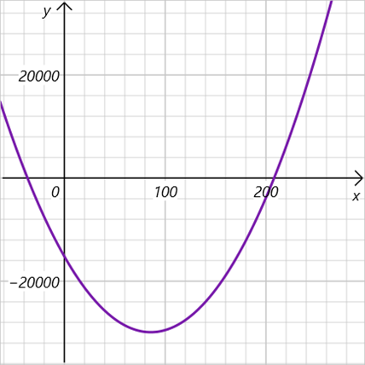

t (min.)

Inequality value

Qr’ = 2/3(1)(6.7 MPa)(1)(1)(1.35)Ab’ ≥ Qf’ = 30 kN

Ab’ ≥ 4975 mm2

Ab’ = 1.5(208 – 0.7t)(177 – 1.4t) = 4975 mm2

0 = 1.47t2 - 622.65t + 50249

Solving for the roots of the equation give:

+root: t = 315 min

-root: t = 108 min **(GOVERNS FRR for bearing away from support)**

Summary:

Shear: FRR = 113 min

Moment: FRR = 88 min **(GOVERNS Girder FRR)**

Bearing: FRR = 93 min

Critical Bearing: FRR = 108 min

Therefore, the FRR of the girder for this loading configuration is 88 minutes based on the flexural resistance.

# Question 5

This question requires the selection of a column depth such that a FRR of 30 minutes is met. We can calculate the required section sizes for each relevant ULS then add char and zero-strength depth to determine the required full member size. For 30 minutes of fire exposure:

dx = xc,n + xt = βnt + 7 mm = (0.7 mm/min)(30 min) + 7 mm = 28 mm (**B.4.4/B.5.1**)

Therefore, the width and depth of a column with all sides exposed is:

do = d – 2dx = d – 2(28 mm) = d – 56 mm

bo = b – 2dx = 265 mm – 56 mm = 209 mm

Load Case 1: 1.4D KD = 0.65

Pf = 210 kN

Load Case 2: 1.25D + 1.5L + 1.0S KD = 1.0

Pf = 387.5 kN

Fire Load Case: 1.0D + 1.0L + 1.0S KD = 1.15

Pf = 300 kN

Kfl = 1.35 (**B.3.9** and **B.6.3**)

Axial Compression Resistance (**7.5.8**):

Let’s use the fire load case to select an initial size and assume d > b and do > bo. The slenderness ratio will then always be governed by:

Ccy = Le/bo = (8000 mm)/(209 mm) = 38.3 < 50 (Slenderness OK)

Fc = fcKDKHKSKT = (30.2 MPa)(1.15)(1)(1)(1) = 34.7 MPa

Ao = bo x do = (209 mm)(d – 56 mm)

From the selection tables, a member size of 265x266 mm D. Fir L. 16c-e is not sufficient for load case 2 (KD = 1.0). Therefore let’s try the next biggest size of 265x304 mm.

Ao = (209 mm)(304 – 56 mm) = 51832 mm2

Kzcg = 0.68(0.265 x 0.304 x 8 m3)-0.13 = 0.72 ≤ 1.0 (Size factor uses *original* dimensions – **B.3.5**)

Kc = [1.0 + FcKzcgCc3/35EKSEKT]-1 = [1.0 + (34.7 MPa)(0.72)(38.3)3/35(12400 MPa)(1)(1)]-1

Kc = 0.23

Note: Per **B.6.4**, the specified mean value of the modulus of elasticity is used in **Annex B** calculations instead of E05.

Pr = φFcAoKzcgKcKls = (1)(34.7 MPa)(51832 mm2)(0.72)(0.23)(1.35)

Pr = 402 kN > Pf = 300 kN (**Section OK for 30 min. FRR**)

Check standard load cases:

Case 1:

Ccy = 8000 mm/265 mm = 30.2

F­c = (30.2 MPa)(0.65) = 19.63 MPa

Kc = [1.0 + (19.63 MPa)(0.72)(30.2)3/35(0.87 x 12400 MPa)(1)(1)]-1­ = 0.49

Pr = (0.80)(19.63 MPa)(265x304 mm2)(0.72)(0.49)

Pr = 446 kN > Pf = 210 kN (**Section OK for Case 1**)

Case 2:

F­c = 30.2 MPa

Kc = [1.0 + (30.2 MPa)(0.72)(30.2)3/35(0.87 x 12400 MPa)(1)(1)]-1­ = 0.39

Pr = (0.80)(30.2 MPa)(265x304 mm2)(0.72)(0.39)

Pr = 546 kN > Pf = 387.5 kN (**Section OK for Case 2**)

Therefore, a 265x304 mm D.Fir-L 16c-e is the smallest section with a width of 265 mm that can provide a 30 min. FRR for this loading case (265x266 mm was insufficient for load case 2 per the tabulated value).

# Question 6

**Part A:**

This question asks for the application of two assumptions to determine the loading envelope for the shear walls in the direction of the applied lateral load Vf. Note that the following methods are approximate and are generally used for estimation however they are recommended in the CWC commentary of **O86-14**.

Assumption A:

If the diaphragm is rigid and the shear walls are flexible, shear wall loads will be distributed based on their relative stiffness, which are assumed proportional to their length.

Vf, i = Vf Ki/ΣKi

**Vf, 1 = Vf, 4 = Vf (6 m)/(6 m + 4 m + 4 m + 6 m) = 3Vf/10** **(Governs Vf for walls 1 and 4)**

Vf, 2 = Vf, 3 = Vf (4 m)/(6 m + 4 m + 4 m + 6 m) = 2Vf/10

Assumption B:

If the shear walls are rigid and the diaphragm is flexible, the loads to the shear walls will be governed by tributary area. The applied load Vf can be assumed to be distributed across the length of the building.

Vf, 1 = Vf, 4 = 8.5 m/2 x Vf/20 m = 0.2125Vf

**Vf, 2 = Vf, 3 = (8.5 m/2 + 3m/2) x Vf/20 m = 0.2875Vf** **(Governs Vf for walls 2 and 3)**

**Part B:**

The chord forces of the diaphragm refers to the tension and compression induced in the extreme diaphragm fiber due to bending. To approximate the chord forces, we can treat the diaphragm like a deep beam supported by the four shear walls, with reaction loads equal to the maximum design shear values calculated in Part A. This is an approximation and requires the analogous distributed load to be non-uniform across the length of the diaphragm. Constructing the assumed beam diagram gives:

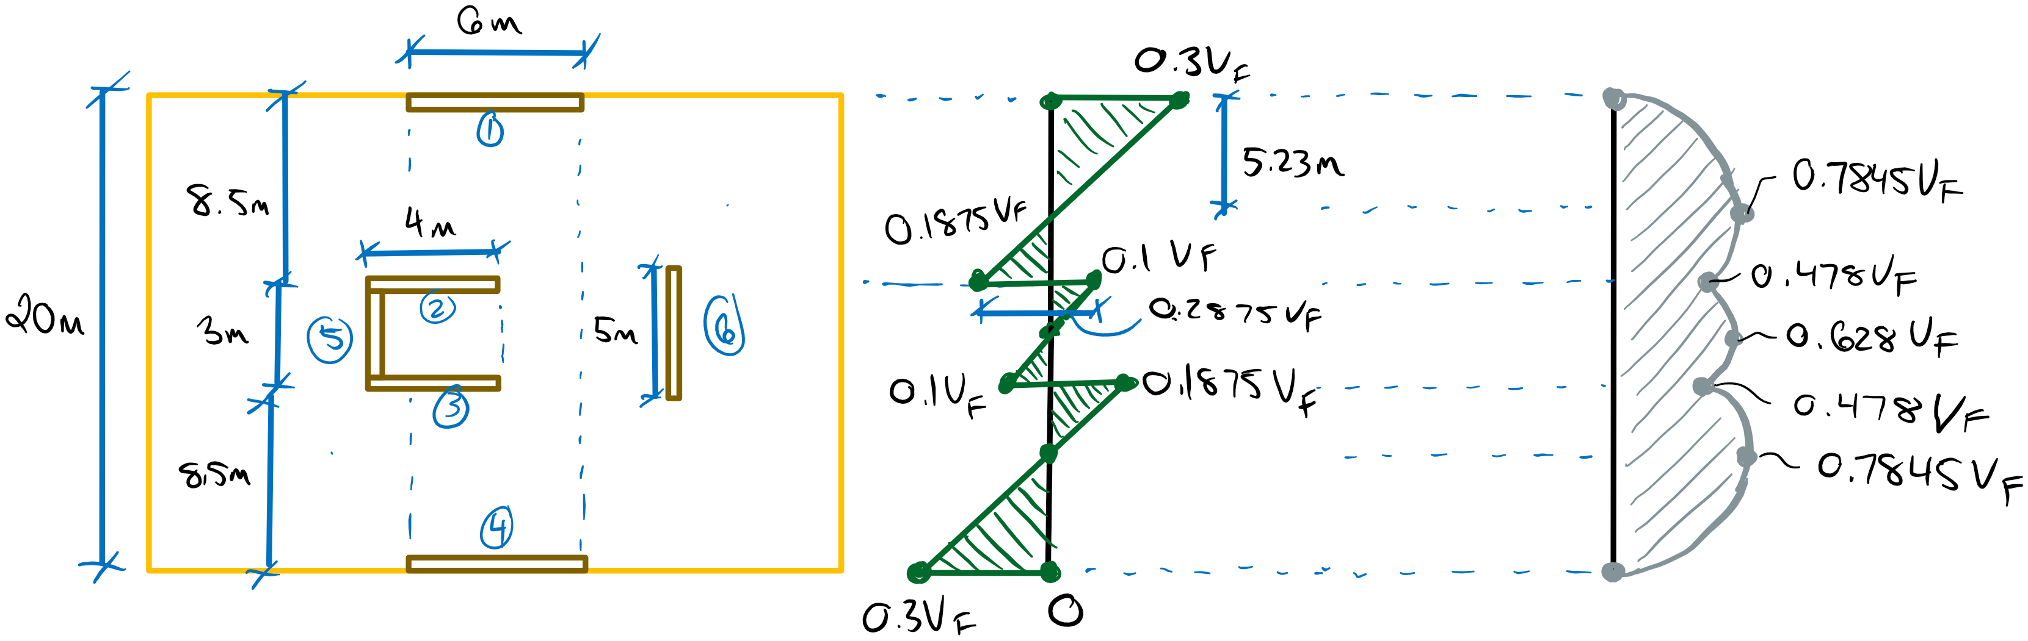

Therefore, the maximum moment in the diaphragm as a deep beam is:

Mf = 0.7845Vf

The chord forces can be estimated by taking the sum of internal moments in the diaphragm.

ΣM = 0 = 0.7845Vf – Tchord d

Tchord = 0.7845Vf/d

Tchord = 0.7845Vf/(35 m)

**Tchord = 1569/70000 Vf (Tension Chord Force in the Diaphragm)**

**Cchord = Tchord = 1569/70000 Vf** **(Compression Chord Force in the Diaphragm)**