CWC Wood Engineering

Final Exam Solutions

# Question 1

The column to be replaced supported the truss in bearing. We can take the global equilibrium of the truss to determine the axial load on the column from the distributed dead and snow loads. We are assuming there is no eccentricity in the axial column load.

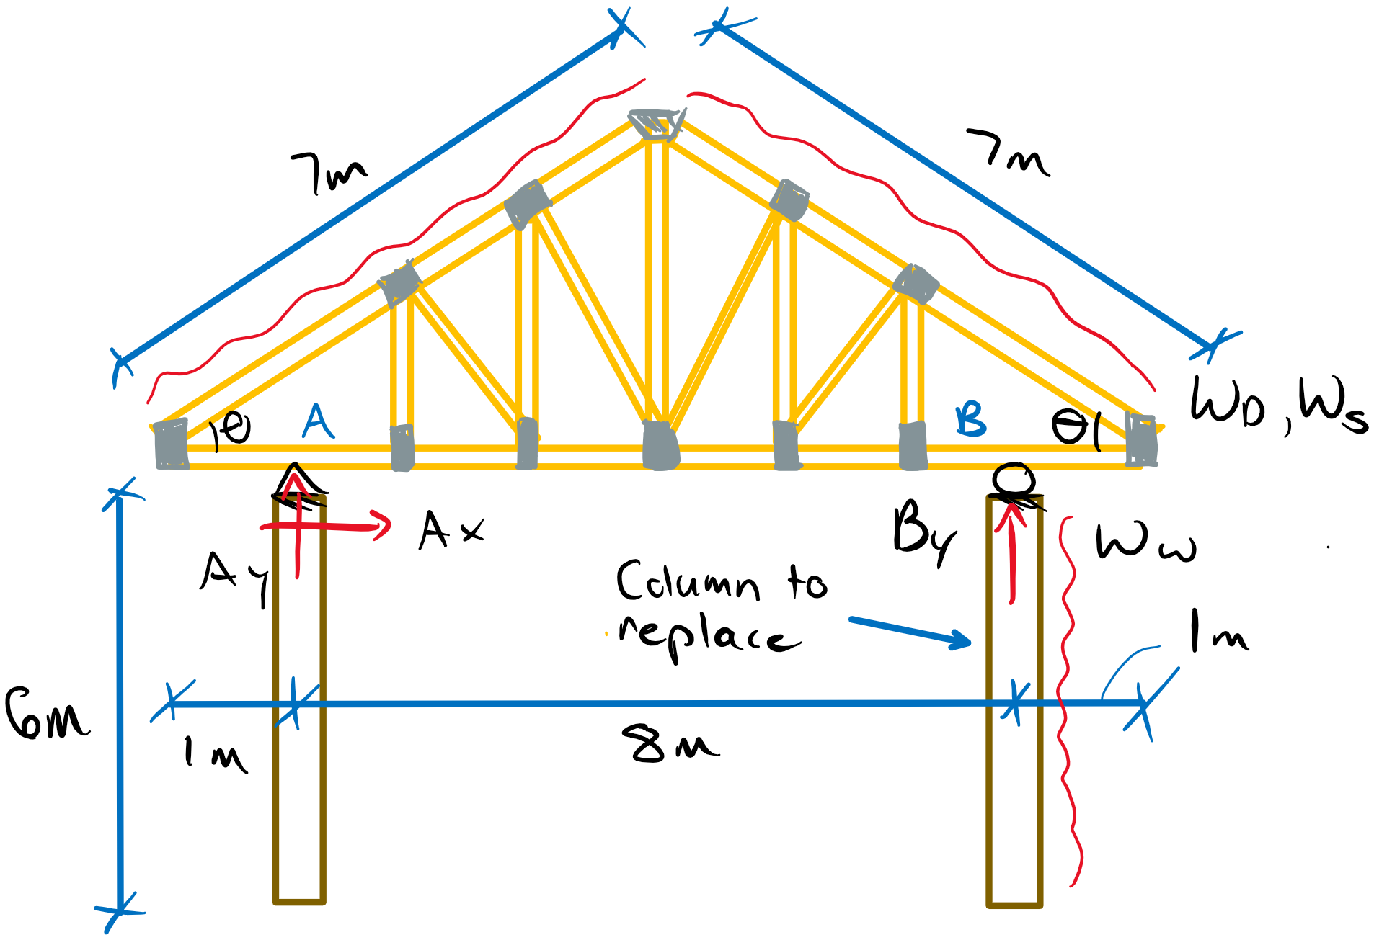

wD = 68.2 kN/m ws = 28.4 kN/m ww = 25 kN/m

cosθ = 5/7

θ = 44.4°

ΣMA = 0 = -w(7 m)(3.5 – 1 x 7/5 m) – w(7 m)(4 + 5/2 m)5/7 + w(7 m)(7/2 x sin44.4 m)sin44.4 + 8By

By = 4.4w

By = 4.4ws + 4.4wD­

PD = 4.4(68.2 kN/m) = 300 kN

Ps = 4.4(28.4 kN/m) = 125 kN

The column is in combined compression + bending, therefore we must identify the possible governing load cases.

Load Case 1: 1.4D KD = 0.65

Pf = 1.4PD = 420 kN

Vf = 0

Mf = 0

Load Case 3: 1.25D+1.5S+0.4W KD = 1.15

Pf = 1.25PD + 1.5Ps = 562.5 kN

ww,f = 0.4ww = 10 kN/m

Vf = wL/2 = 30 kN Vf/KD = 26 kN

Mf = wL2/8 = 112.5 kNm Mf/KD = 98 kNm

Load Case 4: 1.25D+1.4W+0.5S KD = 1.15

Pf = 1.25PD + 0.5Ps = 437.5 kN

ww,f = 1.4ww = 35 kN/m

Vf = wL/2 = 105 kN Vf/KD = 91 kN **(Governs factored shear)**

Mf = wL2/8 = 157.5 kNm Mf/KD = 137 kNm **(Governs factored moment)**

All cases must be checked for axial compression resistance as well as axial + moment interaction. Additionally, we are specified a deflection limit requirement of L/180. We can determine the minimum bending stiffness to meet this requirement:

Serviceability Case 4: 1.0D + 1.0W + 0.5S (only W contributes to bending)

Δ ≤ L/180 = 5/384 wL4/EI

EI ≤ wL4/2560

EI ≤ (25 N/mm)(6000 mm)4/2560

EI ≤ 12660 x 109 Nmm2 **(Minimum EI required for deflection limit)**

Trial Section: 365x380 SPF 20f-EX

From Tables:

Mr = 291 kNm

Vr = 175 kN

Pr = 1840 kN

EI = 17200 x 109 Nmm2 > EIreq **(Deflection OK – 74% utility)**

Shear Capacity (**7.5.7.2**):

Z = 0.365 x 0.380 x 6 m3 = 0.83 m3 < 2.0 m3

Vr = φFv2/3Ag

Fv = fvKDKHKsvKT = (1.75 MPa)(1.15)(1)(1)(1) = 2.01 MPa

Vr = (0.90)(2.01 MPa)2/3(365x380 mm2)

Vr = 167 kN ≥ Vf = 105 kN **(OK for shear requirement – 63% utility)**

Moment Capacity (**7.5.6.5**):

Kzbg = (130x610x9100/ 182.5x380x6000)0.1 = 1.06 ≤ 1.3

CB = (Led/b2)1/2 = 4.1 ≤ 10 KL = 1.0 (**7.5.6.4**)

Since Kzbg > KL, Mr2 will be more critical.

Case 1: KD = 0.65

Mr2 = φF­BSKXKL = (0.90)(25.6 MPa x 0.65 x 1 x 1 x1)(365x3802/6 mm3)(1)(1)

Mr2 = 132 kNm ≥ Mf = 0 **(Moment OK for Case 1)**

Case 3/4: KD = 1.15

Mr2 = (0.90)(25.6 MPa x 1.15 x 1 x 1 x1)(365x3802/6 mm3)(1)(1)

Mr2 = 233 kNm ≥ Mf = 157.5 **(Moment OK for Cases 3/4 – 68% utility)**

Axial Compression (**7.5.8**):

For no intermediate bracing, the weak axis will govern the compression resistance:

Ccy = Le/b = 6000/365 = 16.4 ≤ 50 (slenderness OK)

Kzcg = 0.68(0.83 m3)-0.13 = 0.70 ≤ 1.0

Fc = fcKDKHKscKT = (25.2 MPa)KD(1)(1)(1) = 25.2KD

Case 1: KD = 0.65

Fc = 16.4 MPa

Kc = (1.0 + (16.4 MPa)(0.70)(16.4)3/35(10300x0.87 MPa)(1)(1) )-1

Kc = 0.86

Pr = φFCAKzcgKC = (0.80)(16.4 MPa)(365x380 mm2)(0.70)(0.86)

Pr = 1095 kN ≥ Pf = 420 kN **(Axial OK for Case 1)**

Case 3/4: KD = 1.15

Fc = 29.0 MPa

Kc = (1.0 + (29.0 MPa)(0.70)(16.4)3/35(10300x0.87 MPa)(1)(1) )-1

Kc = 0.78

Pr = (0.80)(29.0 MPa)(365x380 mm2)(0.70)(0.78)

Pr = 1757 kN ≥ Pf = 565.2 kN **(Axial OK for Cases 3/4)**

Combined Axial + Bending (**7.5.12**):

PE = π2E05KSEKTI/Le2 = π2(0.87x10300 MPa)(1)(1)(365x4563/12 mm4)/(6000 mm)2

PE = 7085 kN

Case 1: KD = 0.65

No interaction

Case 3: KD = 1.15

(Pf/Pr)2 + (Mf/Mr)(1/1-Pf/PE) ≤ 1.0

(562.5/1757)2 + (112.5/233)(1/1-(562.5/7085) ≤ 1.0

0.63 ≤ 1.0 **(Section OK for Case 3 Interaction)**

Case 4: KD = 1.15

(437.5/1757)2 + (157.5/233)(1/1-(437.5/7085) ≤ 1.0

0.78 ≤ 1.0 **(Section OK for Case 3 Interaction – utility > 75%)**

Therefore, a 365x380 mm SPF 20f-EX member is suitable and achieved a utility greater than 75%.

# Question 2

a) This question requires the determination of the critical distributed load for the 365x1254 mm D. Fir-L 24f-E member, given that the live load is 80% the dead load and that the beam is required to have 30 minute FRR. Constructing a beam diagram gives:

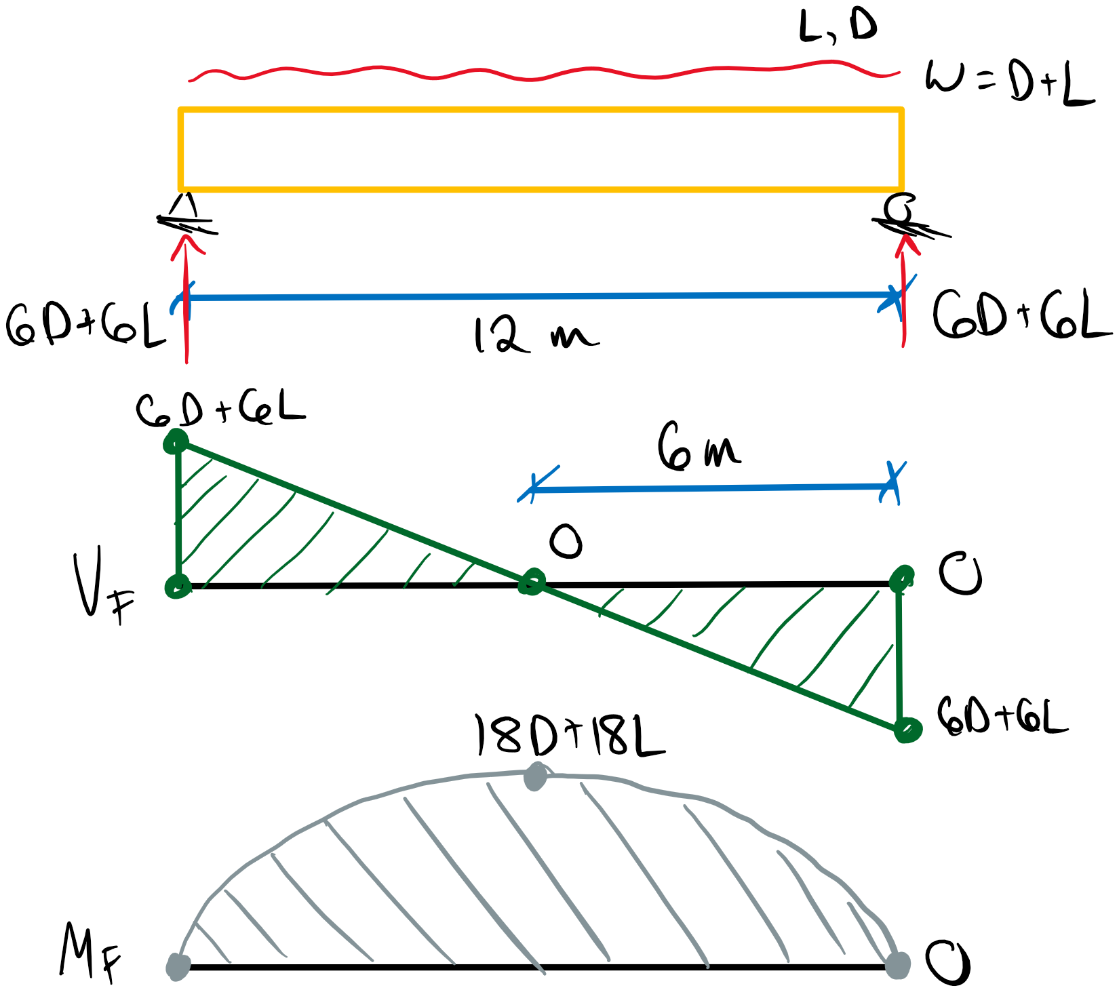

Vf = 6D + 6L

Wf = 12D + 12L

Mf = 18D + 18L

L = 0.8D

Load Case 1: 1.4D KD = 0.65

Wf = 1.4(12D) = 16.8D Wf/KD = 25.8D

Mf = 1.4(18D) = 25.2D Mf/KD = 38.8D

Load Case 2: 1.25D +1.5L KD = 1 – 0.5log(D/0.8D) = 0.95

Wf = 29.4D Wf/KD = 30.9D **(Governs Factored Shear)**

Mf = 44.1D Mf/KD = 46.4D **(Governs Factored Moment)**

Fire Load Case: 1.0D + 1.0L KD = 1.15 (per **B.3.3**)

Assuming **B.2.2** is met.

Wf = 21.6D  **(Must check independently of cases above)**

Mf = 32.4D  **(Must check independently of cases above)**

Kfi = 1.35 (**B.3.9** for glulam)

For charring and zero-strength layer determination:

Βn = 0.7 mm/min (**B.4.2** for multiple exposed sides)

xt = 7 mm (**B.5.1** for FRR > 20 min)

xn = βnt + xt = (0.7 mm/min)(30 min) + 7 mm = 28 mm (**B.4.4**)

The reduced cross-section will have the following dimensions (assuming the top of beam is protected from fire).

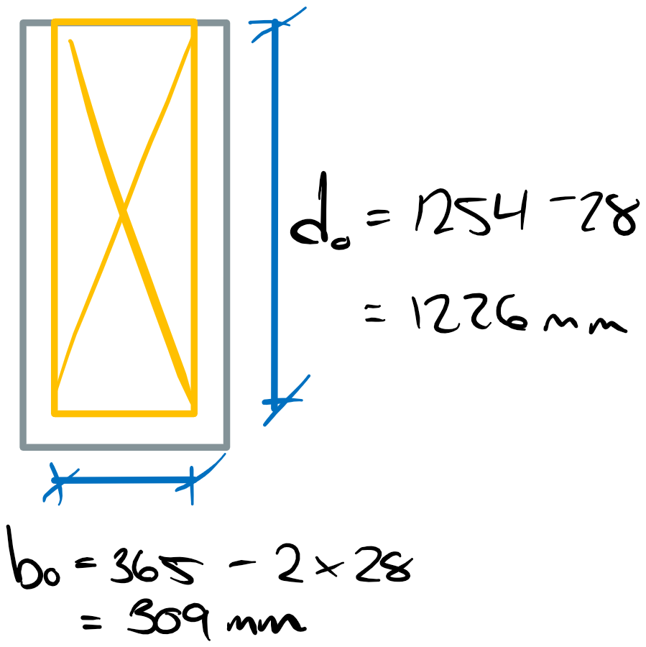

Shear Resistance (**7.5.7**):

Z = 0.365 x 1.254 x 12 = 5.5 m3 ≥ 2.0 m3

Zo = 0.309 x 1.226 x 12 = 4.5 m3 ≥ 2.0 m3

Must apply **7.5.7.2a** for all cases.

Fv = fvKDKHKsvKT = 2.0 MPa x KD(1)(1)(1) = 2KD

Calculating Cv (**7.5.7.5**):

r*= 0 Cv = 3.69 (**Table 7.5.7.5**)

Case 2:

Wr = φFv0.48AgCvZ-0.18 = (0.90)(2 MPa x 0.95)0.48(365x1254 mm2)(3.69)(5.5 m3)-0.18

Wr = 1020 kN ≥ Wf = 29.4D

**D ≤ 34.7 kN/m** **(GOVERNS Critical deadload for beam shear)**

Fire:

Wr = φFv0.48AgCvZ-0.18Kfi = (1.0)(2 MPa x 1.15)0.48(309x1226 mm2)(3.69)(4.5 m3)-0.18(1.35)

Wr = 1589 kN ≥ Wf = 21.6D

D ≤ 73.6 kN/m **(Critical deadload for beam shear in fire)**

Moment Resistance (**7.5.6.5**):

The size factor is calculated with the original beam dimensions for all cases.

Kzbg = (130x610x9100/182.5x1254x12000)0.1 = 0.87 ≤ 1.3

Case 2:

CB = ( (12000 mm)(1254 mm)/(365 mm)2)1/2 = 10.6 > 10 (**7.5.6.4**)

Fb = (30.6 MPa)KDKHKsbKT = 30.6 MPa x (0.95)(1)(1)(1) = 29.1 MPa

Ck = (0.97EKSEKT/Fb)1/2 = ( (0.97)(12800)(1)(1)/(29.1) )1/2 = 20.6

KL = 1 – 1/3(CB/Ck)4 = 1 – 1/3(10.6/20.6)4 = 0.98

Since Kzbg < KL, Mr1 will be more critical.

Mr1 = φFbSKxKzbg = (0.90)(29.1 MPa)(365x12542/6 mm3)(1)(0.87)

Mr1 = 2180 kNm ≥ Mf = 44.1D

D ≤ 49.4 kN/m **(Critical deadload for beam moment resistance)**

Fire:

CB = ( (12000 mm)(1226 mm)/(309 mm)2)1/2 = 12.4 > 10 (**7.5.6.4**)

Fb = (30.6 MPa)KDKHKsbKT = 30.6 MPa x (1.15)(1)(1)(1) = 35.2 MPa

Ck = (0.97EKSEKT/Fb)1/2 = ( (0.97)(12800)(1)(1)/(35.2) )1/2 = 18.8

KL = 1 – 1/3(CB/Ck)4 = 1 – 1/3(12.4/18.8)4 = 0.94

Since Kzbg < KL, Mr1 will be more critical.

Mr1 = φFbSKxKzbgKfi = (1)(35.2 MPa)(309x12262/6 mm3)(1)(0.87)(1.35)

Mr1 = 3200 kNm ≥ Mf = 32.4D

D ≤ 98.8 kN/m **(Critical deadload for beam moment resistance during fire)**

Therefore, based on the moment and shear capacity of the beam and the 30 minute FRR, the maximum specified dead load that can be applied is 34.7 kN/m.

b) The goal of Annex B is to predict the results of the standard fire resistance test CAN/ULC-S101 for a timber member. Therefore, the use of a specified loading and mean strength values (instead of specified strengths) is done to predict the actual performance of a member in the standard fire test which results in apparent strengths greater than those calculated through the methods in main body of O86-14.

c) This part of the question requires the determination of the maximum notch depth required to support a factored load of 55 kN/m assuming a 500 mm long support and a notch length of 500 mm for the same beam referred to in part A (now ignoring fire resistance considerations). Assume KD = 1.0.

Vf = wfL/2 = (55 kN/m)(12 m)/2

Vf = 330 kN

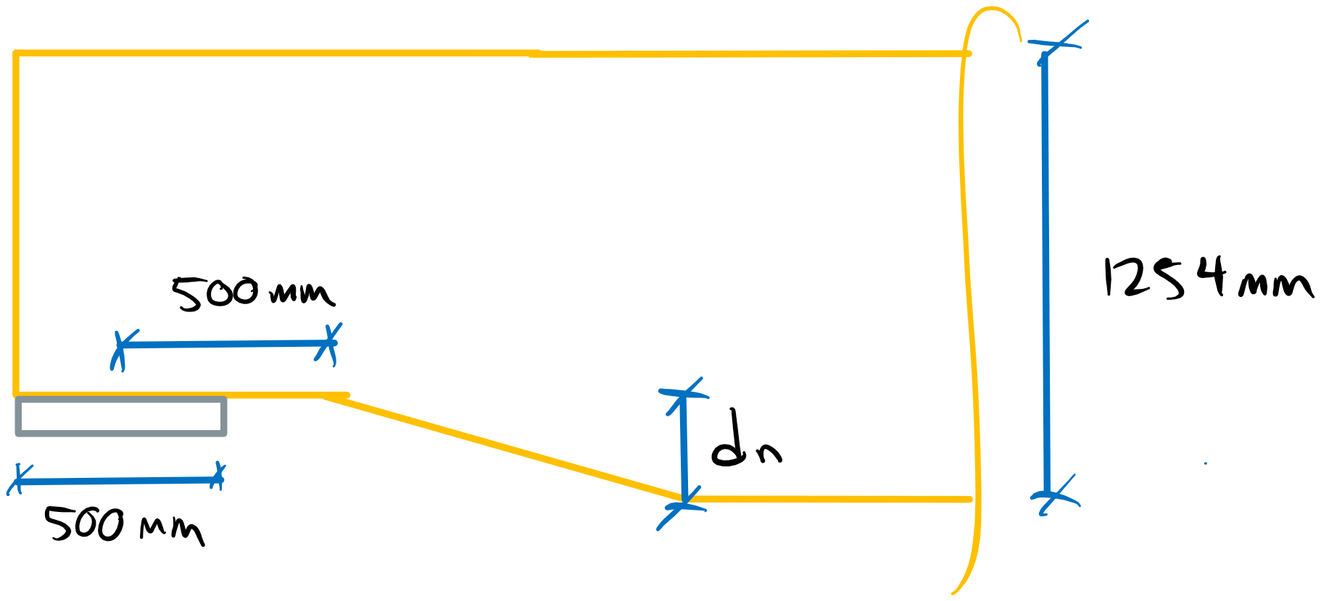

Tension Side Notch Shear Resistance (**7.5.7.4.2**):

Fr = φFfAgKN

ff = 2.5(365/2 mm)-0.2 = 0.88 ~~≤~~ 0.90

ff = 0.90 MPa

Ff = ffKDKHKsKT = 0.90 MPa x 1 x 1 x 1 x 1 = 0.90 MPa

We must solve for the notch depth, dn, by determining the critical KN for e = 500 mm.

Fr = (0.90)(0.90 MPa)(1254x365 mm2)KN ≥ Vf = 330 kN

KN ≥ 0.89

The equation given in **7.5.7.4.2** is complicated, so let’s interpolate with **Table 6.5.5.3.2:**

Interpolating with:

KNd1/2 = 31.5 (this is the minimum acceptable value of KNd1/2)

η = e/d = 0.40

α – 0.95 / 0.90 – 0.95 = 31.5 – 38.8 / 26.5 – 38.8

α = 0.92 (Since α and KN are directly proportional, this is the minimum acceptable α)

α ≥ 0.92

1 – dn/d ≥ 0.92

dn ≤ 0.08(1254 mm)

dn ≤ 100 mm **(Maximum allowable notch depth)**

Therefore, the maximum allowable notch depth for a notch length of 500 mm is 100 mm based on the applied load.

# Question 3

This question requires the design of a bolt connection to a 5 m long, simply supported 265x608 SPF 20f-E beam under wet service conditions. The beam and connection were fabricated when the timber was dry. The question specifies the use of 1/2" ASTM A307 bolts and two 3 mm 350W steel plates to create a 3 member connection. The beam also supports a 30 kN/m distributed load. The load duration factor is assumed to be 1.0. The factored shear force can be calculated as follows:

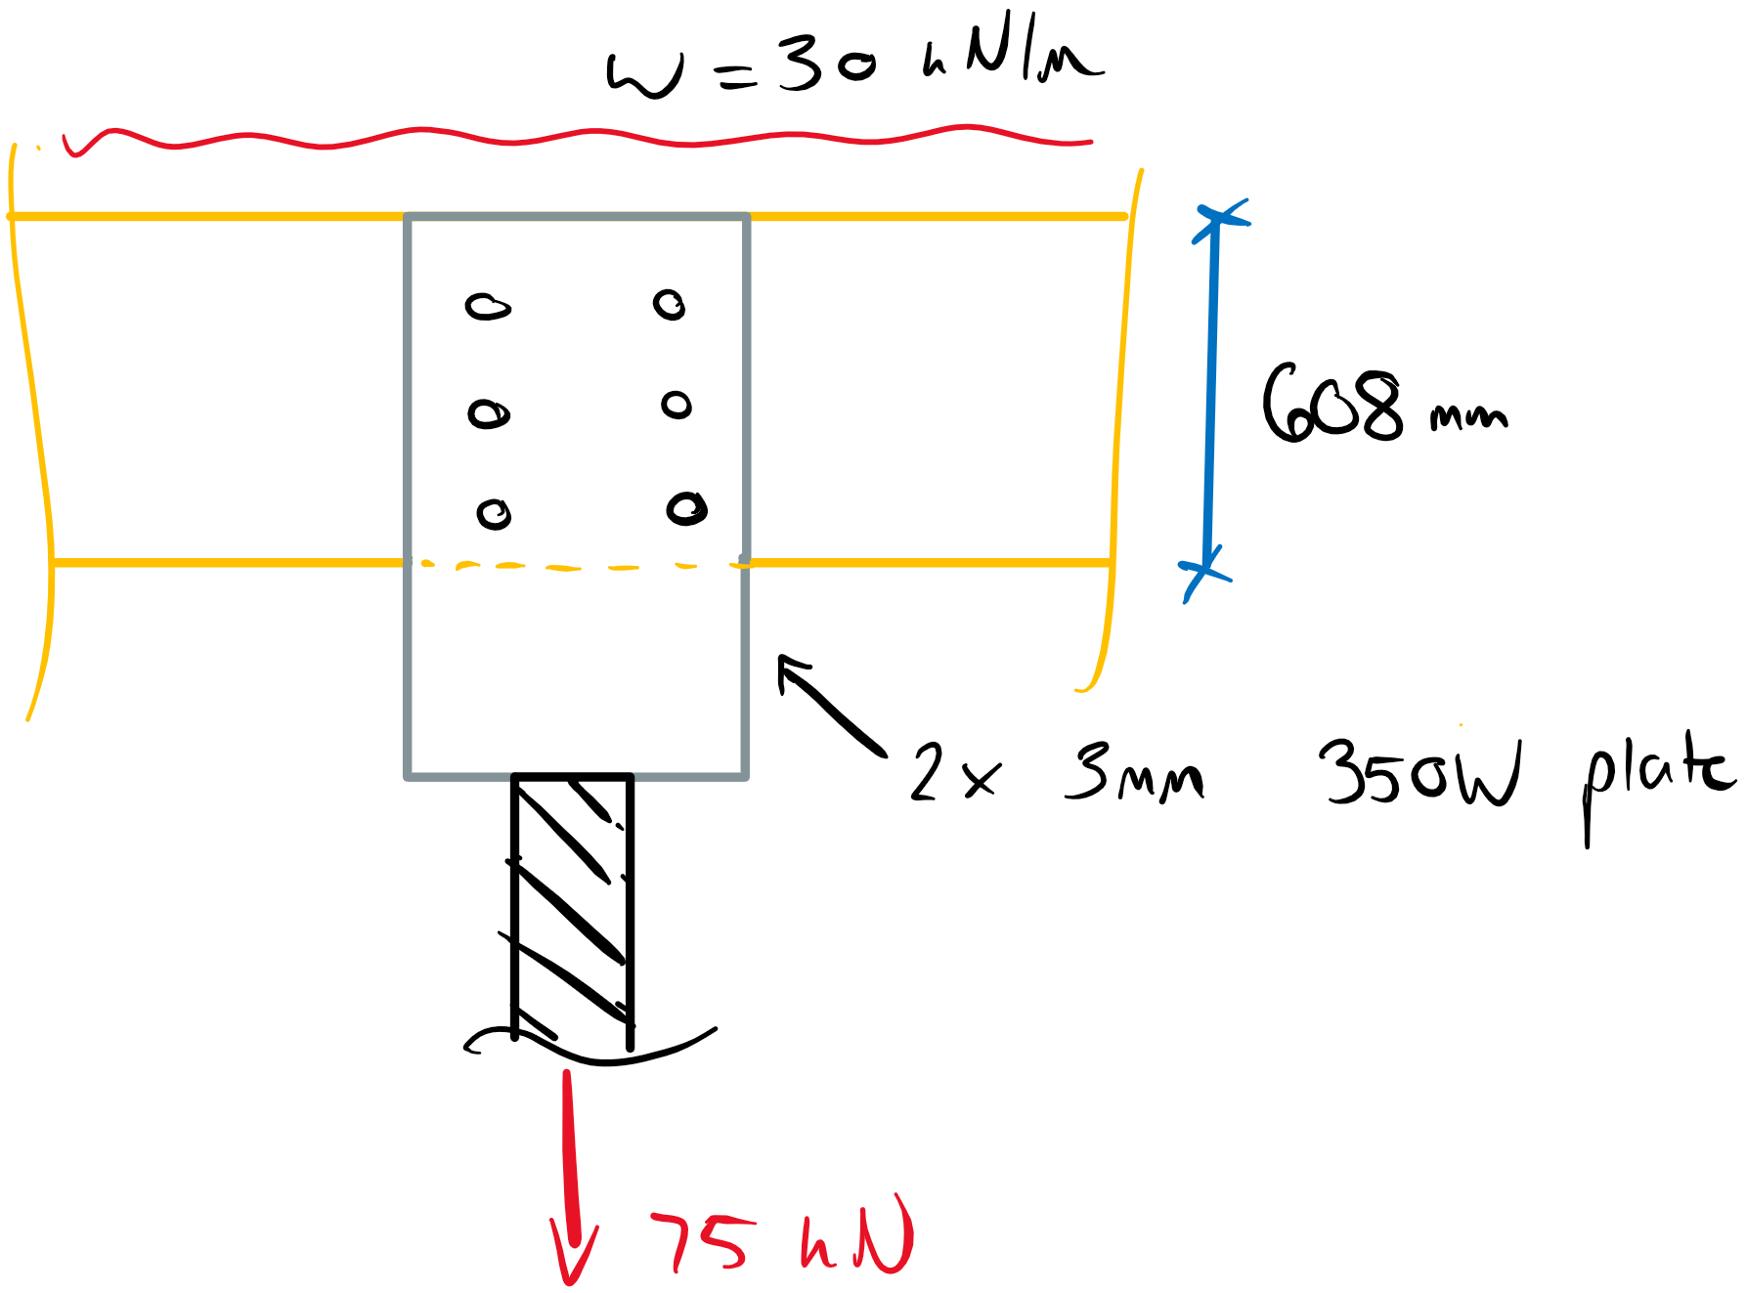

Vf = wL/2 + Pf/2 = (30 kN/m)(5 m)/2 + (75 kN)/2 = 112.5 kN

From the beam selection tables, the beam shear resistance is:

Vr = 169 kN

We can determine the critical loaded edge distance based on the reduction of shear capacity:

Vre = Vr x Ksv x de/d ≥ 112.5 kN

de ≤ (112.5 kN)(608 mm)/(169 kN)(0.85)

de ≤ 476 mm

de ~ 480 mm (Required effective shear depth)

dbolt = 0.5 x 25.4 mm = 12.7 mm (bolt diameter)

dhole = dbolt + 2 mm = 14.7 mm (bolt hole diameter)

Therefore, the loaded edge distance can be:

ep = 608 – 480 + 14.7/2 = 135 mm

Perpendicular to Grain Fastener Spacing Requirements (**12.4.3.2**):

a) Sr ≥ 3dbolt = 38.1 mm

b) Sc ≥ 3dbolt = 38.1 mm

c) eQ ≥ 4dbolt = 50.8 mm

d) ep ≥ 1.5dbolt = 19.05 mm

Bolt Yielding (**12.4.4.3**):

We can determine the minimum number of bolts required to resist fastener yielding as a starting point.

Nr = φynunsnf

Ksf = 0.67 (**Table 12.2.1.6**)

f1 = Kspφsteel/φyfu = (3.0)(0.80/0.80)(450 MPa) = 1350 MPa (350W steel plates)

t1 = 3 mm

f2 = fiQ = 22G(1-0.01df)Ksf = 22(0.42)(1-0.01(12.7))(0.67) = 5.4 MPa (G = 0.42 for SPF)

t2 = 265 mm

fy = 310 MPa (ASTM A307 bolts)

a) nu =51.4 kN

c) nu =9.1 kN

d) nu =13.0 kN

g) nu =5.4 kN **(GOVERNS)**

Nr = (0.80)(5.4 kN)(2 shear planes)nf ≥ Nf =75 kN

nf ≤ 8.7 bolts (Min. number of bolts to resist yielding)

Let’s try 9 bolts with the following spacing:

ep = 135 mm eQ = 75 mm Sc = 75 mm SR = (608 – 135 – 75)/2 = 199 mm

de = 480 mm

Splitting Perpendicular to Grain (**12.4.4.7**)

QSr = φwQsiKDKsfKT

QSi = 1.4t(de/1-de/d))1/2 = 1.4(265)(480/(1-480/608))1/2 = 177 kN

QSr = (0.70)(177 kN)(1)(0.67)(1)

QSr = 83 kN ≥ QSf = 75 kN **(Connection splitting resistance OK)**

Therefore, the following bolt layout for the 3-member connection satisfies fastener yielding, perpendicular to grain splitting, and beam shear.

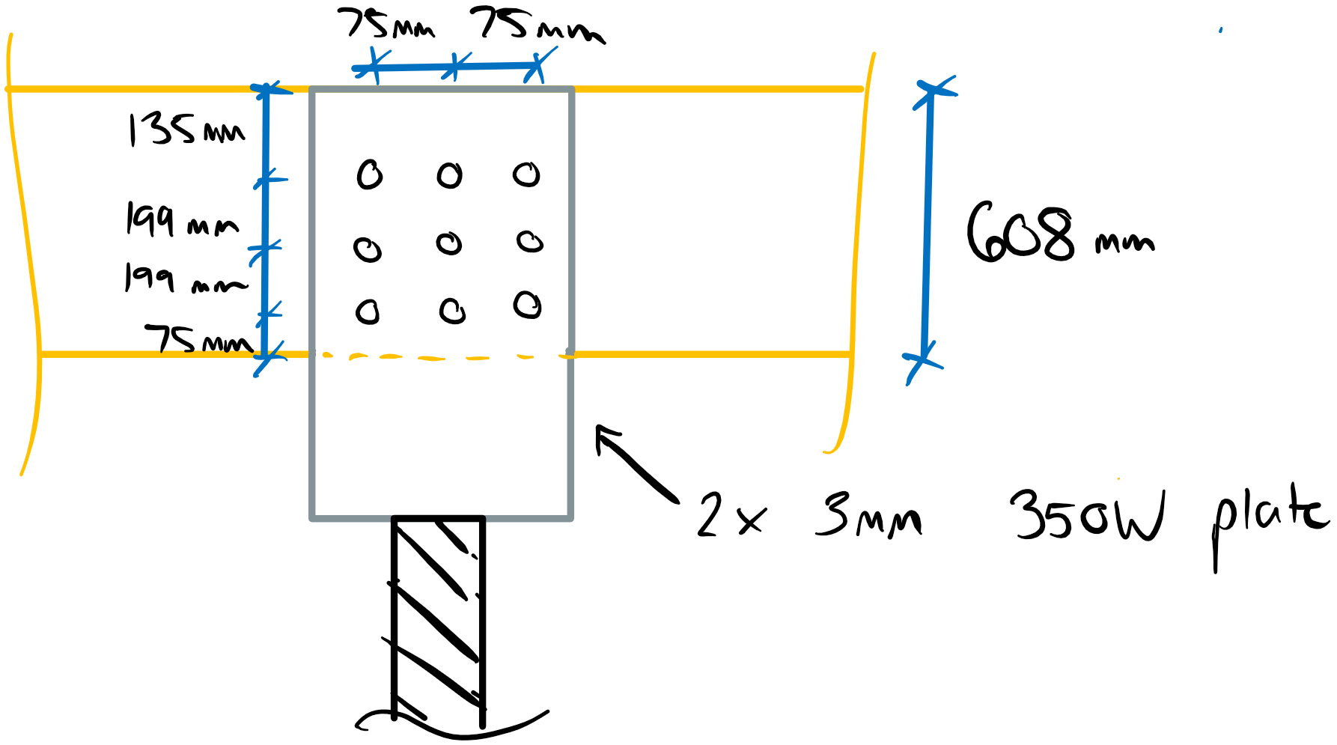

# Question 4

In order to determine the tension chord force, we must first distribute the overall building shear to the two shear wall segments.

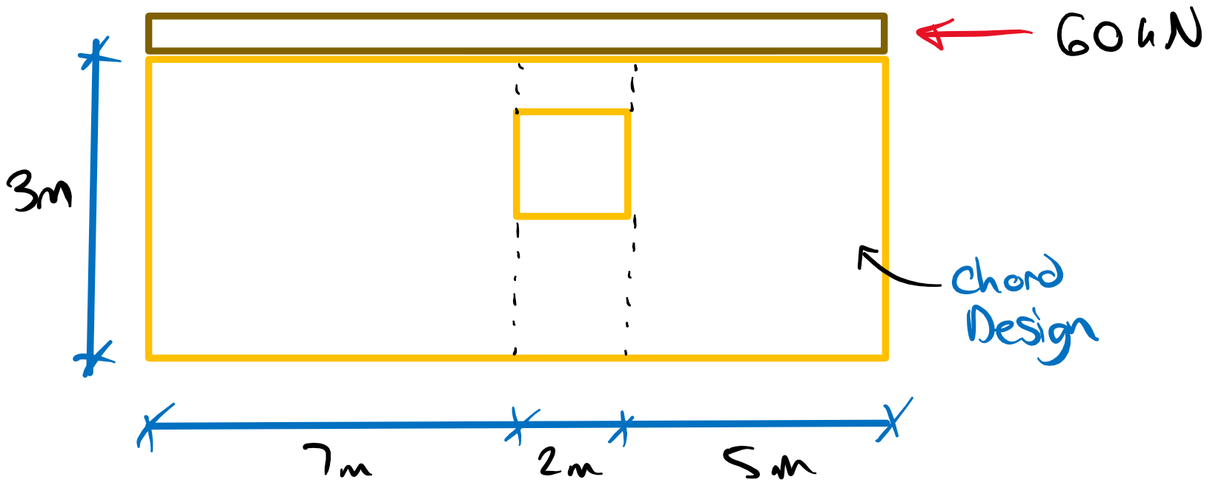

Assuming the wall stiffness is proportional to length we get the following factored shear force for the 5 m long wall.

Vf = 5 m/(5 m + 7m) x 60 kN = 25 kN

The chord forces can be determined by taking the equilibrium of the 5 m wall.

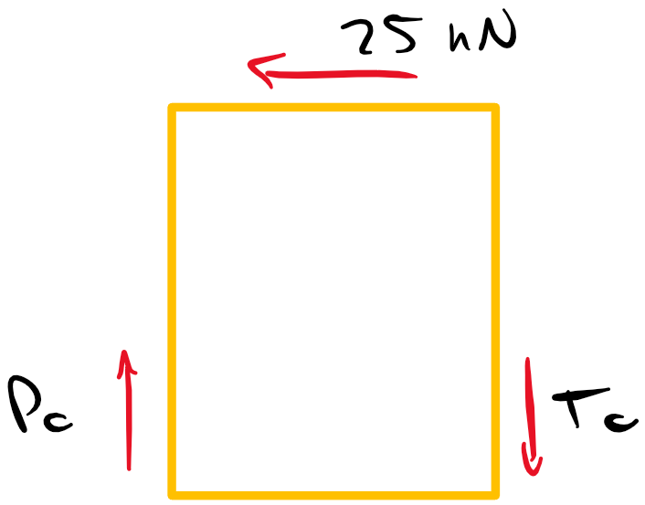

ΣMp = 0 = -Tc(5 m) + (25 kN)(3 m)

Tc = 15 kN

Therefore, we must design the tension chord for 15 kN. The chord is specified to use SPF No.3/Stud. We can use the selection tables to find a suitable member. The load duration factor is taken as 1.15. Note there is no reduction in net section area for nailed members.

Try 38x89 mm SPF No. 3:

Tr = 14.6 kN x 1.15 = 16.8 kN > Tf = 15 kN

Therefore, use 38x89 SPF No.3 members for the tension chord.

Design of Splice:

Assuming a max chord member length of 1.5 m, we now need to design a nail splice connection to transmit the chord force. We will use another 38x89 SPF No.3 member for the splice. The nail penetration requirements from **12.9.2.2** must be met:

Try 2” common wire nails: df =2.84 mm **(Table A.12.9.5.2)**

t1 ≥ 3df = 8.56 mm < 38 mm (Member 1 Penetration OK)

t2 ≥ 5df = 14.2 mm

Lf = 2” x 25.4 = 50.8 mm ≤ 38 + 14.2 = 52.2 mm (Nail is too short to meet member 2 penetration)

Try 2.5” common wire nails: df =3.25 mm **(Table A.12.9.5.2)**

t1 ≥ 3df = 9.75 mm < 38 mm (Member 1 Penetration OK)

t2 ≥ 5df = 16.25 mm

Lf = 2.5” x 25.4 = 63.5 mm ≥ 38 + 16.25 = 54.25 mm (Nail is long enough)

t2 = 63.5 – 38 = 25.5 mm

Check Nail Spacing Requirements (**12.9.2.1**):

a = 16df = 52 mm (Spacing para. to grain)

b = 12df = 39 mm (End dist. para. to grain)

c = 8df = 26 mm (Spacing perp. to grain)

d = 4df = 13 mm (Edge dist. perp. to grain)

Nail Yielding (**12.9.4**):

Nr = φNunfnsJF

Jf = JEJAJBJ­D = (1)(1)(1)(1.3) = 1.3 (for shearwall construction)

t1 = 38 mm

f1 = 50(0.42)(1-0.01(3.25)) = 20.3 MPa

t2 = 25.5 mm

f2 = 20.3 MPa

f3 = 110(0.42)1.8(1-0.01(3.25)) = 22.3 MPa

fy = 50(16-3.25) = 637.5 MPa

a) nu = 2.51 kN

b) nu = 1.68 kN

d) nu = 0.86 kN

e) nu = 0.69 kN **(GOVERNS)**

f) nu = 0.84 kN

g) nu = 0.71 kN

Nu­ =nuKDKsfKT = 0.69 kN(1.15)(1)(1) = 0.79 kN

Nr = (0.80)(0.79 kN)nf(1)(1.3) ≥ Nf = 15 kN

nf ≥ 18.3 nails (Min. nails for fastener yielding)

Therefore, let’s try 12 nails in two rows of 6, with 8 nails staggered on the diagonals per **12.9.2.1**. The spacings are taken as follows. Remember that all member edges in this splice are loaded edges.

a = 55 mm (fastener spacing)

b = 40 mm (end distance)

c = 46 mm (row spacing)

d = 20 mm (edge distance)

Based on these spacing values, the splice member must be at least 560 mm long and is also a 38x89 SPF No. 3 member.

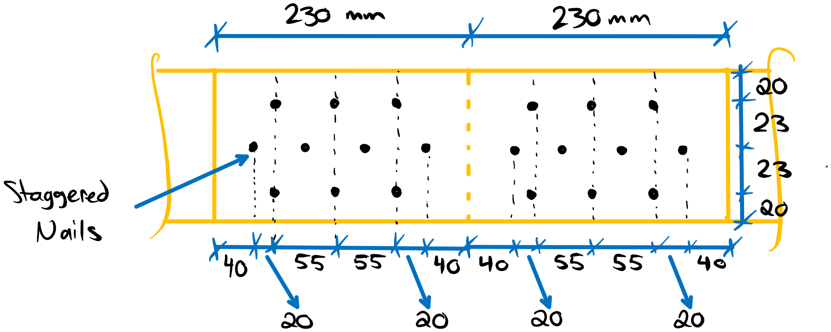

# Question 5

This question requires the determination of the critical moisture content such that the glulam swelling will induce a critical bearing failure in the 175x418 SPF 20f-E joist. A perpendicular to grain compression stiffness is given as 114 kN/mm and we are told to assume the critical bearing near the support (**7.5.9.3**) will govern. First, let’s assess the critical bearing capacity of the configuration for wet conditions under short duration loading.

Critical Bearing Resistance (Bearing Near Support – **7.5.9.3**):

Qr’=2/3 φFcpAb’KBKzcp­

Fcp = fcpKDKscpKT = (5.8 MPa)(1.15)(0.67)(1) = 4.5 MPa

b1 = b2 = 175 mm

L1 = 265 mm

L2 >> L1 (therefore, the upper limit on Ab’ will be reached per **7.5.9.3.2**)

Ab’ = 1.5bL1 = 1.5(175 mm)(265 mm) = 69562.5 mm2

KB = 1.0 (near end of member per **6.5.7.5**)

Kzcp = 1.0 (b/d < 1.0 per **6.5.7.5**)

Qr’ = 2/3 (0.80)(4.5 MPa)(69562.5 mm2)(1)(1)

Qr’ = 167 kN

Therefore, for a critical load of 167 kN, the required amount of restrained swelling can be determined.

Δreq = Δgap + Qr’/k = 20 mm + 167 kN/(114 kN/m) = 20 mm + 1.5 mm = 21.5 mm

For an original moisture content of 5%, the required final moisture content to yield the critical swelling can be calculated.

Δreq = S = d(M2 - M1)c (**A.5.4.6**)

M2 = Δreq/cd + M1 (c = 0.002 for perpendicular to grain swelling – **A.5.4.6**)

M2 = (21.5 mm)/(0.002)(418 mm) + 5%

M2 = 30.7% **(Critical moisture content for critical bearing in the joist)**

Therefore, the moisture content of the wood would need to increase to over 30% to induced critical bearing in the member. However, moisture contents above 28% do not further contribute to swelling since the fiber saturation point is reached. Therefore, the potential swelling poses no risk to the critical bearing of the joist.