CWC Wood Design

Final Exam (All Modules)

# Question 1

The roof truss of a barn supports the specified dead and snow loading shown in the figure below. A column supporting the truss in bearing is in need of replacement due to termite damage. Design an SPF 20f-EX glulam column to replace the damaged member. You must achieve 75% or greater utility. Assume the laminate width is half that of the chosen member’s width. No intermediate column bracing is provided in either axis. Assume dry service conditions and no treatment. The column must also support the specified wind load as shown. Assume the column can be modelled as pin-pin supported. You may use member selection tables for initial sizing must full design calculations must be shown for the final member.

6 m

4.9 m

wD = 68.2 kN/m

wS = 28.4 kN/m

1 m

1 m

8 m

ww = 25 kN/m

(column wind load)

Column to be replaced

# Question 2

a) For the 365x1254 D.Fir-L 24f-E beam shown below, determine the largest specified deadload, wD, that can be supported if a fire resistance rating (FRR) of 30 minutes is required and the distributed live load, wL, is known to be 80% of the deadload value. Be sure to consider standard ULS load cases as well. You may assume the conditions of **O86-14 B.2.2** are met. Assume dry service conditions and no treatment. Assume the glulam laminate width is half the total width of the beam. Ignore deflection and serviceability requirements. Show all work including all relevant resistance calculations.

12 m

**wD + wL**

wL = 0.8wD

365x1254 D. Fir-L 24f-E

b) Why does the apparent strength of the beam increase for the fire load case despite a reduction in cross-section? Briefly explain within the context of Annex B of O86-14.

c) An architect decides to include a tension side notch in the beam described in part A. If the total factored distributed load is taken as 55 kN/m and the required notch length, e, is 500 mm, what is the maximum allowable notch depth, dn? Assume dry service conditions, no treatment, and a standard load duration factor. Ignore the fire resistance specifications of part A.

# Question 3

A 5 meter long, simply supported 265x608 SPF 20f-E beam is subjected to a 75 kN factored point load at midspan and a 30 kN/m factored distrusted load along its length. The 75 kN load is to be transmitted through a 3-member, bolted connection using two 3 mm 350W steel side plates and ASTM A307 bolts. Design the bolted connection required to transmit the point load to the beam. Assume wet service conditions and a standard duration load factor.

5 m

30 kN/m

365x608 SPF 20f-E

75 kN

2 x 350W steel plates + ASTM A307 bolts

(to be designed)

# Question 4

A building is supported by two light-frame shear wall segments. For an applied lateral load of 60 kN at the diaphragm of the structure, design the tension chord of the 5 m shear wall segment. You may assume the shear force can be distributed proportionally by the length of the shear wall segments. You may also use selection tables for the design of the chord members if necessary. Assuming the chord members are available in max lengths of 1.5 m, design a 2-member nailed connection splice for the tension chord. Use SPF No.3 lumber for both the chord and splice members. Assume a short term load duration factor.

60 kN

7 m

2 m

5 m

3 m

Hold Downs

# Question 5

For the configuration below, determine the moisture content required to induce a critical bearing failure (governed by clause **O86-14 7.5.9.3** – you need not consider other bearing resistances) in the 175x418 SPF 20f-E joist. Assume an initial moisture content of 5% and a fibre saturation point of 28%. Assume wet conditions and a short term load duration factor. All other members in the system shown are detailed against shrinkage/expansion (only the joist expands). You may assume the joist has a perpendicular-to-grain elastic stiffness of k = 114 kN/mm when its expansion is restrained. Clearly state any assumptions used in solving the problem.

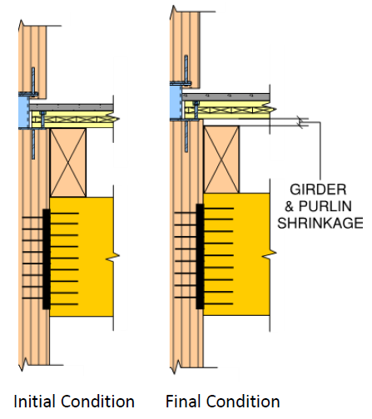

265x798mm SPF 20f-E girder

(no swelling)

175x418 SPF 20f-E joist

105 mm CLT Floor

(no swelling)

25 mm clearance

20 mm clearance