**Lab: Flexural Timber**

**Objective:**

The aim of the laboratory is to determine the flexural strength of wood. The lab will provide experience measuring strength properties and links to these associated graduate attributes. Testing the specimens in bending allows the students to observe both tension and compression effects. Bending and shear are also available. A separate tension and compression test may also complement this lab should you have the resources available and capacity of your laboratory frame. A bending test will likely be under the compressive peak load.

# Course Learning Outcomes:

# Prepare a professional laboratory report including engineering charts, tables and graphs to present results effectively [CLO 10]

# Interpret laboratory data to generate load-displacement plots, shear force and bending moment diagrams corresponding to the peak load [CLO 11]

# Interpret laboratory data to assist calculations in determining the proportional limit and modulus of rupture for the timber specimens tested [CLO 11]

# Conduct experimental testing to understand mechanical behaviour of timber specimens and provide experience measuring strength properties [CLO 12]

# Procedure:

Each lab session will test five (5) wood sizes to determine the loads and displacements at failure due to the three‐point bending test. The laboratory work involves the following:

# Specimen Measurements

**NOTE: The following should be completed prior to testing.**

1. Measure the length of the wood samples to be tested.
2. Measure the actual height and width of the cross section of each wood sample to be tested.
3. Measure the distance between the centre‐to‐centre of the roller supports of the test setup placed within the Universal Testing Machine. This is the clear span that will be used to determine the shear force and bending moment diagrams.
4. Measure the distance from the centre of the point load to the centre of each end support.

Table 1: Wood Samples for Testing

|  |  |
| --- | --- |
| **Type of Wood** | **Nominal Dimensions* Length x height (in x in)** |
| S‐P‐F | 2 x 2 |
| S‐P‐F | 2 x 3 |
| S‐P‐F | 2 x 4 |
| Cedar | 2 x 4 |
| S‐P‐F | 4 x 2 |

# All Specimens to be cut to be sized to at least 8 inches long.

# These are the nominal dimensions. The actual dimensions will differ and must be measured.

# Three‐Point Bending Test

1. Place the wood sample over the roller support system located within the Universal Testing Machine. Ensure that the height as provided in the Table is placed vertically in the testing machine.
2. Lower the bearing block connected to the Universal Testing Machine such that it just touches against the top surface of the wood sample.
3. During testing, the load imposed by the bearing block shall be applied at a continuous rate of 2.5mm/mm to failure.
4. Record the applied load and the displacement of the bearing block throughout testing using the built‐in load cell and displacement reading of the Universal Testing Machine.
5. Record the mode of failure using the figure below.
6. Repeat the same procedure for all wood samples.

**Types of Wood Failure in Static Bending (ASTM D143):**

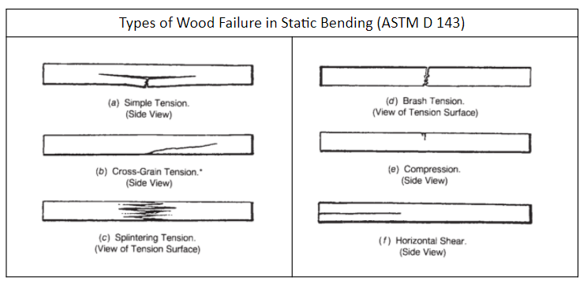

Figure 1: Types of Wood Failure

# Results:

Report the following information:

* 1. Actual measurements of each wood sample tested.
  2. Actual measurements of the clear span between supports and location of the point load.
  3. Load‐displacement plots for each wood sample tested.
  4. Identify the maximum load and corresponding displacement for each wood sample tested.
  5. Identify the force that corresponds to the proportional limit (PL) for each wood sample on the load‐displacement plot.
  6. Identify the type of failure experienced by each wood sample.
  7. Draw the shear force and bending moment diagrams that correspond to the peak recorded force for each wood sample. Note that you will need to determine the reaction forces for this task.
  8. Calculate the MOR (modulus of rupture) for each wood sample.
  9. Summarize the maximum force and corresponding displacement, maximum shear force and bending moment, proportional limit, modulus of rupture, and type of failure in the table. Discuss the relationship between the height of the samples and the ultimate strength for the SPF specimens.

