CWC Wood Engineering

Midterm Solution

# Question 1

a) First, we must use equilibrium to determine the relevant specified forces in truss member CE. To do this, we can create a section through members CD, CE, and AE.

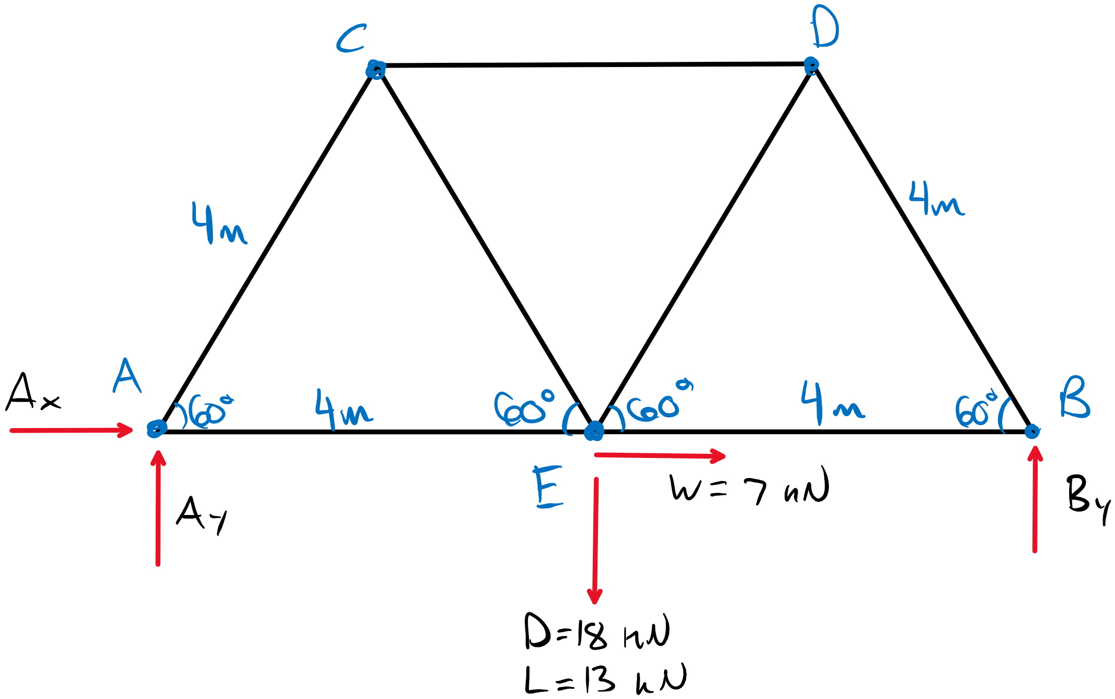

Using equilibrium, we can determine the reaction forces as follows:

ΣFx = 0 = Ax + W Ax = -W

ΣMA = 0 = -4D - 4L + 8By By = (D+L)/2

ΣFy = 0 = AY + By – D – L Ay = D + L – (D+L)/2 = (D+L)/2

Now, taking a section:

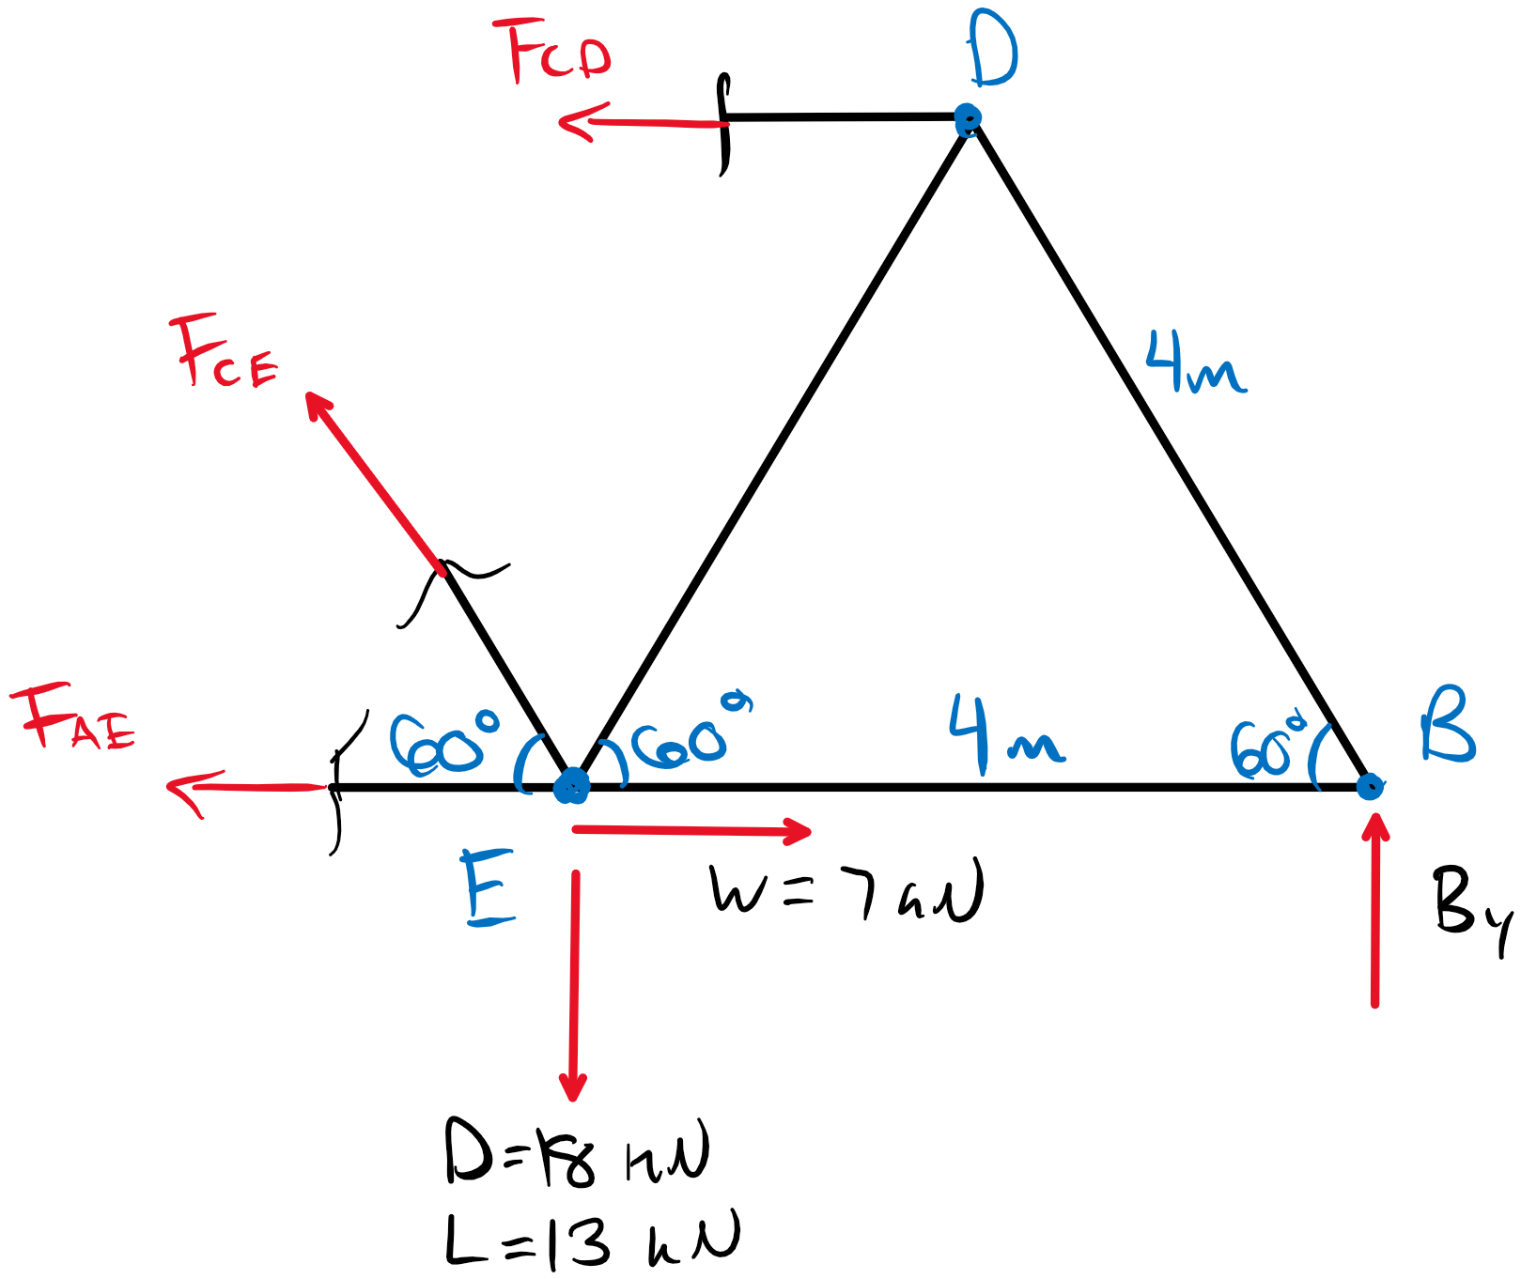

Taking the sum of forces in the y-direction now gives:

ΣFy = 0 = Fcesin60 – D – L + By Fce =(D+L-By)/sin60 = (D+L)/2sin60

Member CE is in tension, so we can determine the governing load case by considering KD:

Load Case 1: 1.4D KD = 0.65

Pf, ce = 14.5 kN Pf/KD = 22.4 kN

Load Case 2: 1.25D + 1.5L KD = 1 – 0.5log(18/13) = 0.93

Pf, ce = 24.2 kN Pf/KD = 26.1 kN **(GOVERNS tensions in member CE)**

b) We must design a Nothern No. 1 tension member to resist a factored load of 24.2 kN with KD = 0.93. The net tension requirement can be approximated as follows by also accounting for the 25% gross section reduction:

Pf/0.75KD = 34.7 kN

From the selection tables, try Nothern No.1 38x235 (Pr = 35.4 kN). Now perform the design check.

For structural joists and planks (**Table 6.2.2.1**)

ft = 4.0 MPa

Ft = ftKDKHKsKt = (4.0 MPa)(0.93)(1)(1)(1) = 3.72 MPa

Kzt = 1.1 (**Table 6.4.5**)

For lumber in tension:

Tr = φFtAnKzt = (0.90)(3.72 MPa)(0.75 x 38x325 mm2)(1.1)

Tr = 24.7 kN > Tf = 24.2 kN **(Section Passes Tension Check)**

Therefore, a Nothern No.1 38x325 mm member is suitable and achieves a utilization of 98% (Tf/Tr).

b) By inspection, member BD is in compression. Per **6.5.6.2.2**, the slenderness ratio must be below 50.

Ccx = Le/d = 4000/325 = 12.3 < 50

Ccy = 4000/38 = 105 > 50 **(Section too slender for compression – cannot be used)**

Therefore, the member used for CE is too slender for BD and cannot be used.

# Question 2

The question requires the calculation of the critical factored load on a cantilevered SPF 20f-E 315x760 mm member in wet service conditions. Creating the beam diagrams gives the following factored loads:

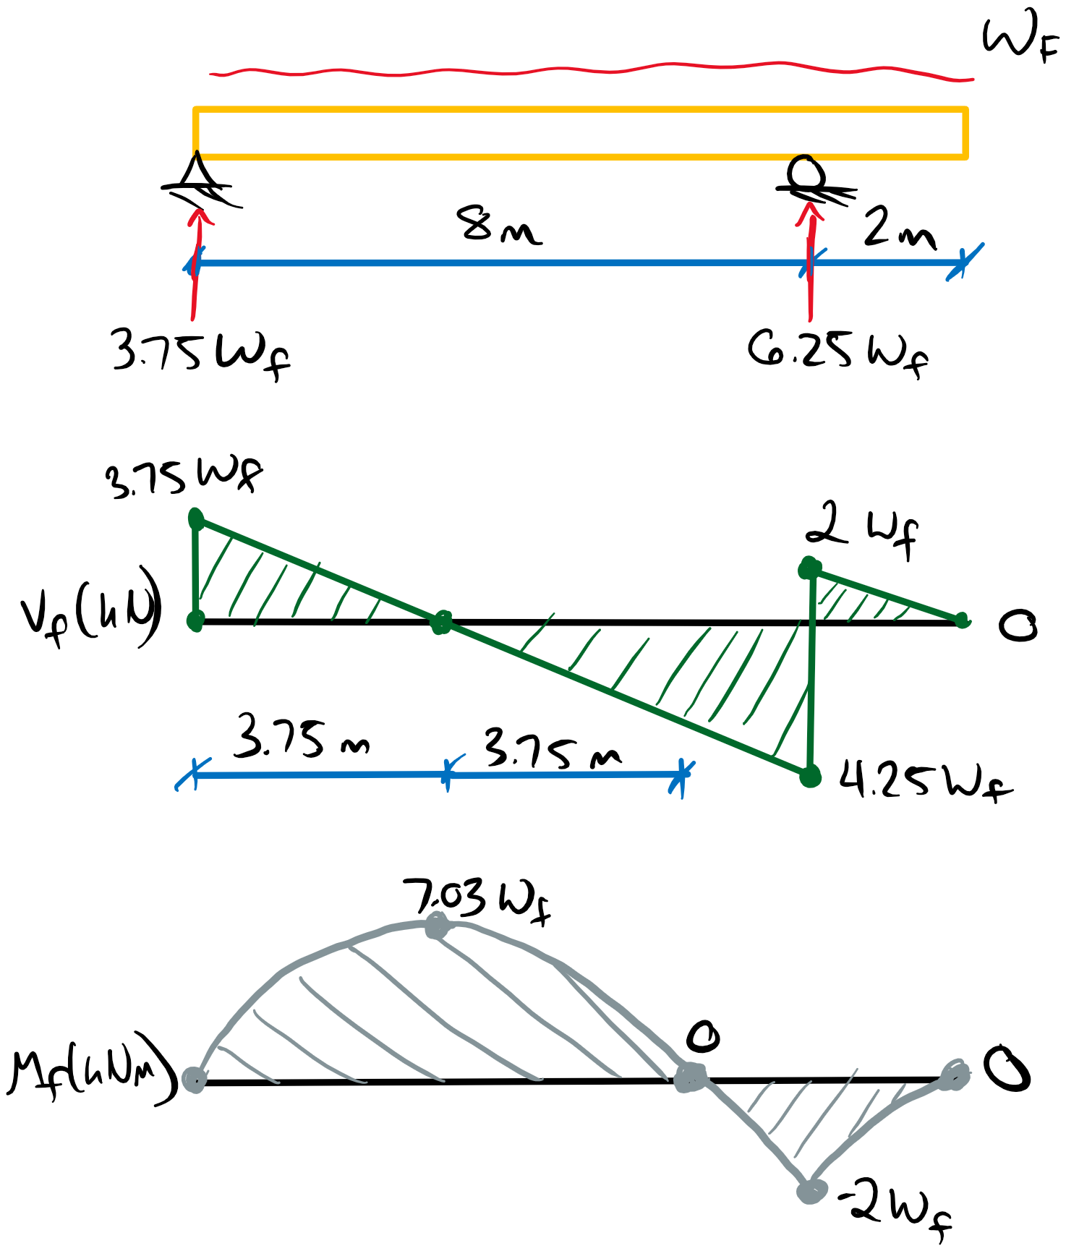

Vf = 4.25wf

Wf = 10wf

Mf, + = 7.03wf

Mf, - = -2wf

For SPF 20f-E

fb, + = 25.6 MPa

fb, - = 19.2 MPa

fv = 1.75 MPa

E = 10300 MPa

Shear Resistance (**7.5.7**):

Z = bxdxL = (0.315 x 0.760 x 10 m3) = 2.39 m3 > 2.0 m3

Therefore, **7.5.7.2a** applies. From the shear force diagram, we can establish three segments per **7.5.7.5**.

Segment 1: G1 = (3.75m)( (3.75wf)5+0+4(1.875wf)5) = 3128.5wf5

Segment 2: G2 = (4.25m)( 0+(4.25wf)5+4(2.125wf)5) = 6629.6wf5

Segment 3: G3 = (2m)( (2wf)5+0+4(1wf)5) = 72wf5

Cv =1.825(10wf) ( 10 / 9830.1wf5)1/5 = 4.6

Alternatively, we can interpolate Cv from **Table 7.5.7.5C** with:

r*= 0/wf = 0 L1/L2 = 2/8 = 0.25

Cv = (4.55+4.88)/2 = 4.71 (relatively close to 4.6 determined above).

Wr = φFv0.48AgCvZ-0.18

Fv = fvKDKHKsvKT = (1.75 MPa)(1)(1)(0.87)(1) = 1.52 MPa

Wr = (0.90)0.48(760x315 mm2)(4.71)(2.39 m3)-0.18

Wr =416 kN ≥ Wf = 10wf

wf ≤ 41.6 kNm **(GOVERNS - Critical factored load for shear resistance)**

Moment Resistance (**7.5.6.5**):

There is a point of inflection in the applied moment at the roller support which must be treated per the note in **7.5.6.5**.

Kzbg, 1 = (130 x 610 x 9100/ 157.5 x 760 x 7500)1/10 = 0.98 ≤ 1.3

Kzbg, 2 = 1.1 ≤ 1.3

Assuming the beam is supported continuously:

KL = 1.0

S = bd2/6 = 30.32 x 106 mm3

Fb, + = fb,+KDKHKsbKt = (25.6 MPa)(1)(1)(0.80)(1) = 20.5 MPa

Fb, - = (19.2 MPa)(1)(1)(0.80)(1) = 15.4 MPa

The relevant Mr is calculated for the factored moment in that segment.

Mr1, 1 =φFb,+ SKxKzbg, 1 = (0.90)(20.5 MPa)(30.32 x 106 mm3)(1)(0.98)

Mr1, 1 = 548 kNm ≥ Mf, 1 =7.03wf

wf ≤ 78 kNm **(Critical factored load for moment resistance in segment 1)**

Mr1, 2 =φFb,- SKxKzbg, 2 = (0.90)(15.4 MPa)(30.32 x 106 mm3)(1)(1.1)

Mr1, 2 =462 kNm ≥ Mf, 2 = 2wf

wf ≤ 231 kNm **(Critical factored load for moment resistance in segment 2)**

The moment resistance based on KL is calculated for the full length of the beam but, by inspection, won’t govern over Mr1,1 and need not be checked.

Therefore, the critical factored load for this beam is 41.6 kNm based on the shear resistance of the member.

# Question 3

This question requires the determination of the maximum factored distributed load that can be applied based on the bearing capacity at an angle to the grain. With equilibrium, we can determine the factored bearing load relative to the distributed load.

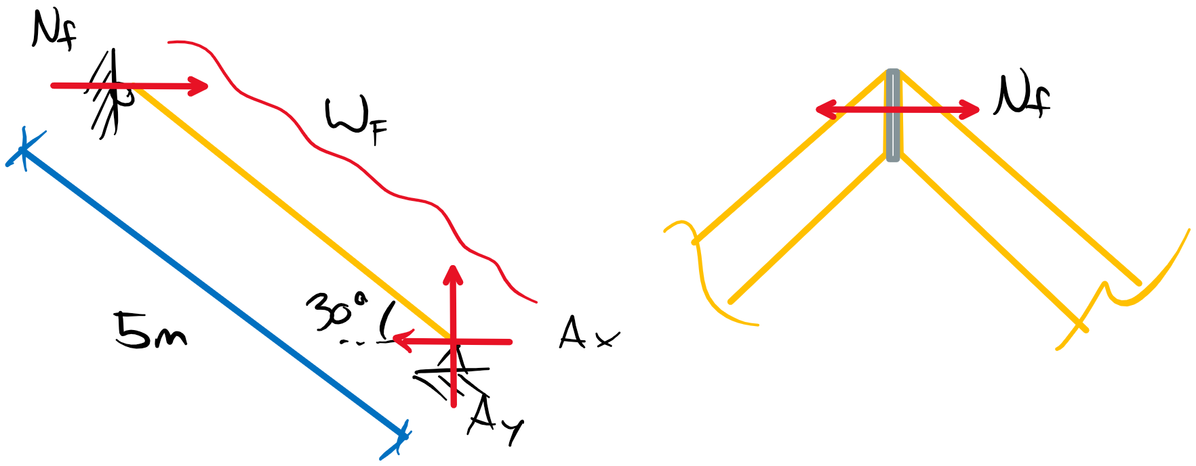

ΣMA = 0 = wf(5 m)(2.5 m) – Nf(5 m)sin30

Nf = 5wf

For D. Fir-L No.1, 143x343 mm:

fc = 11.0 MPa

fcp = 7.0 MPa

E05 = 8000 MPa

E = 12000 MPa

Bearing Capacity at an Angle to Grain (**6.5.8**):

Bearing at an angle to grain requires a summation of axial compression and bearing resistances.

Nr = PrQr/(Prsin2θ + Qrcos2θ)

Axial Compression Resistance (**6.5.6.2.3**):

Pr = φFcAKzcKc

KL = 1.0 (Per **6.5.8**)

Fc = fcKDKHKscKT = 11.0 MPa (1)(1)(1)(1) = 11.0 MPa

Kzc = 6.3(343 x 5000 mm2)-0.13 = 0.97 ≤ 1.3

Pr = (0.80)(11.0 MPa)(343x140 mm2)(0.97)(1.0)

Pr = 410 kN

Bearing Resistance (**6.5.7.2**):

Qr = φFcpAbKBKzcp

Fcp = fcpKDKHKscKT = (7.0 MPa)(1x1x1x1) = 7.0 MPa

Kzcp = 1.0 (b/d < 1.0 per **6.5.7.4**)

KB = 1.0 (near end of member **6.5.7.4**)

Qr = (0.80)(7.0 MPa)(140x343/cos30 mm2)(1)(1)

Qr = 310 kN

For an angle θ to the grain:

Nr = (410 kN)(310 kN)/( 410sin230 + 310cos230)

Nr = 379 kN ≥ Nf = 5wf

wf ≤ 75.8 kNm **(Critical factored load for bearing capacity)**

b) This critical load will likely never govern as the moment and shear capacity limit more critical factored loads. Approximating the beam as simply supported (ignoring axial + bending), the following critical loads for shear and bending are determined from the tabulated resistance values for a 140x343 No.1 D. Fir-L member.

Shear:

Vr = 43.2 kN ≥ Vf = wfL/2

wf ≤ 17.3 kN/m

Moment:

Mr = 39.0 kNm ≥ Mf = wfL2/8

wf ≤ 12.5 kN/m

Therefore, it is unlikely the bearing capacity will govern before shear or moment failure occurs.