CWC Wood Design

Question Bank

MODULES 1 to 5

True False Questions

1. The longitudinal cells in softwoods are much shorter than the cells in hardwoods. (F)
2. Cells in the cambium produce both wood and bark in living trees. (T)
3. Softwood is used more in structural application than hardwoods. (T)
4. During drying, wood shrinks the greatest in the longitudinal direction. (F)
5. Radial sawn lumber shrinks uniformly upon drying while flat sawn lumber shrinks non-uniformly (e.g. tends to warp). (T)
6. Hardwoods are widely used in structural applications. (F)
7. For sawn boards, the angle between the growth ring and the saw blade can be between 45° to 80° for rift sawn boards. (T)
8. Heartwood is located in the outer layer of a tree. (F)
9. The cambium provides structural support for a tree. (F)
10. In seasonal climates a tree’s age can be calculated based on the number of earlywood and latewood rings. (T)
11. Earlywood is also known as summerwood. (F)
12. The term bound water refers to water accumulation in the cell cavity. (F)
13. During seasoning there is no volume change in the wood until the moisture content (MC) drops below the fibre-saturation point (FSP). (T)
14. The wood preservative chromate copper arsenate (CCA) has been banned for use in residential areas since 2004. (T)
15. Glulam is referred to as engineering wood because it is made by gluing individual pieces of dimensional lumber together. (T)
16. The tensile strength of wood parallel to the longitudinal direction is 2 to 9 MPa. (F)
17. The compressive strength perpendicular to the longitudinal direction is 3 to 7 MPa. (T)
18. A tree knot is a remnant of a branch that has died. (T)
19. Wanes are produced by squirrels eating the bark of the tree. (F)
20. The final dimensions of a 2 x 4 (two-by-four) dimensional lumber bought at the local hardware store is 2 inch x 4 inch. (F)
21. Wood in the longitudinal direction exhibits the most shrinkage. (F)
22. The MSR grading method provides the modulus of elasticity and bend strength of the lumber. (T)

Short Answer Questions

1. What is the difference between sapwood and heartwood? Describe each.
2. Wood is an anisotropic material, what are the three principle axes? Describe each.
3. What is engineered wood and what are two advantage of using engineered wood? Name three types of engineered wood used in the industry.
4. A Ponderosa pine piece of lumber measuring 20 m3 has a Specific Gravity (SG) value of 0.40. What is oven-dry weight of the lumber?
5. ASTM D143 is used to specify material testing for timber. Name **seven** mechanical tests that can be used to assess the properties of timber. For each example, provide a sketch for the tests (where load is applied on the timber and showing the proper grain orientation with respect to the load).
6. The strength of timber is adjusted using modification factors. Name **five** modification factors which can be used. Also describe under what conditions each modification factor would be applied.

Technical Questions

1. A stud had dimensions of 38 mm x 89 mm x 2.438 mm and a moisture content of 150% when it was prepared. was prepared. After seasoning, the moisture content was reduced to 7%. If the tangential, radial and longitudinal directions of the grains are on the same order as the dimensions indicated above, what are the dimensions of the seasoned stud if the moisture-shrinkage relation follows Figure 1. Assume the FSP is 28%.



Figure 1. Relation between shrinkage and moisture.

1. There exists many Mill-Type constructions of heritage significance throughout Toronto. Illustrated below (Figure 1) is this construction type as would be found in Ontario. An engineer is often asked to assess the structures existing strength in order to determine its current load bearing capacity. Figure 2 illustrates the load deflections of four heritage beams taken from a Mill type building constructed in 1890 in Ontario. On the basis of the beam’s performance under applied load as per Figure 3 (four point bending, equi-distance application of load, 1m total span), and assuming that the timber was also locally harvested softwood in Ontario, estimate the estimated grade of these beams on the basis of this strength alone with proper reference. State all limitations to your grading estimate and show relevant calculations to justify your grading estimate decision**.**

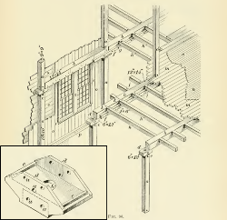

Figure 1. Mill Construction in Canada



Figure 2. Load deflection of each timber beam (load is the total from the actuator)

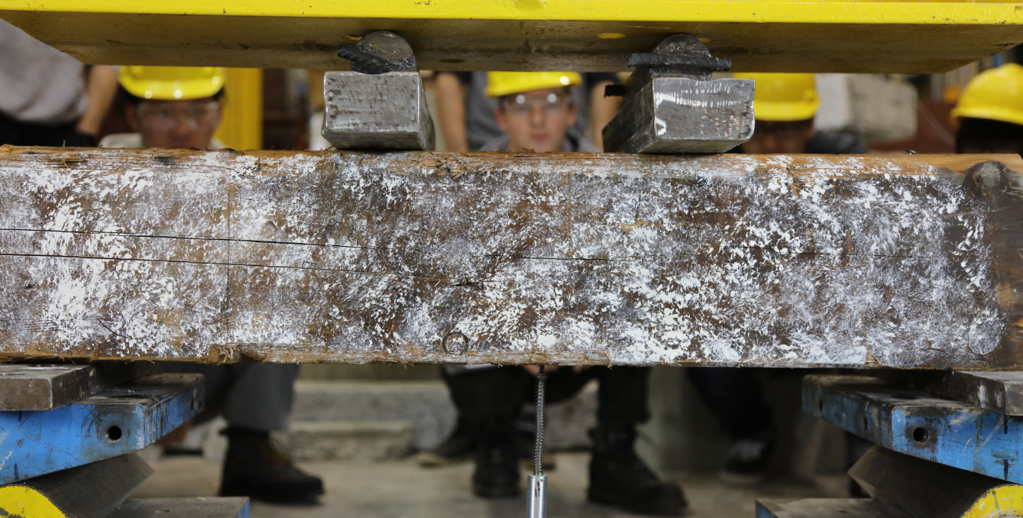

Figure 3. Test set up showing a 4 point bending test

1. In 2015 a Mills industrial heritage building was victim of localized arson attack where a SPF timber column (original dimensions 190x190mm) was exposed to a fire for 40 minutes (see Figure 1). Considering the column only, if 25 mm of charring was measured on each face of the column what was the approximate equivalent fire resistance severity in minutes? If the column were to be cleaned of char damage, estimate its remaining capacity? You may neglect buckling and slenderness effects but should consider that the column supports two stories of permanent mixed commercial and residential dwellings, that there is humidity control, and that the column is not considered to gain any enhancements from acting in a system.

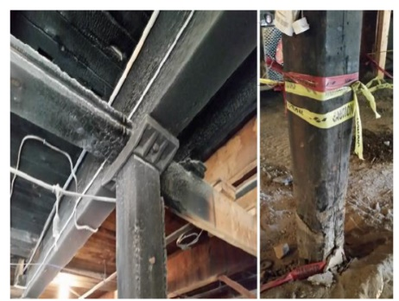

Figure 1. Fire-Damaged Column

MODULE 6

True False Questions

1. At most 30% of the cross section can be removed for connections. (F, 25%)
2. Nails and rivets do not count towards the cross-section reduction. (T)
3. The tensile strength of timber is higher when tension is applied perpendicular to the grain. (F)
4. Using the net cross-sectional area of glulam can provide a higher tensile strength than compared to the gross cross-sectional area. (T, different factors are applied for gross vs net)
5. A glulam member of grade 20f-ED is often specified for when only tensile loads are expected to be applied. (F, its more suited for tension + bending)
6. For wood columns, slenderness should be considered in only the weak axis. (F, both axis)
7. In general, shorter columns can support a greater compressive load than a longer member. (T)
8. Orientation of CLT panels can have a large impact on the panel’s axial strength. (T)
9. CLT and sawn lumber have a maximum allowable slenderness ratio of 50. (F, CLT has 43)
10. When considering axial loads, laminations in a CLT panel oriented perpendicular to the applied load are to be ignored. (T)

**Short Answer**

1. Briefly describe what requirements must be met to consider an equivalent cross-section for built up members of sawn lumber when using bolts as a fastener.
2. Describe why for a given floor plan that it is potentially economical for Column A (would be an exterior column on a plan) to be of a different grade than Column B (would be an interior column). Note that all gravity loads are uniform on all floors. (Trying to focus the question to be about selecting compression graded glulam vs bending depending on the effects of wind load as well as how the different glulam “types” have different grades of lumber in their construction).

**Long Answer**

1. For the compression member made of glulam (grade 16c-E) select an economical cross-section to resist the following unfactored loads Dead = 350 kN, Live = 150 kN, Snow = 125 kN. You can assume the column to be pinned at both ends and measures 5 m in height. The column is laterally supported at mid-height in the weak axis only. Additionally, assume dry service conditions and no system effects.

**MODULE 7**

**True False Questions**

1. For bending members where the only applied loads are perpendicular to the grain, the maximum shear stress is 2.0x that of the average shear stress. (F, 1.5 cause rectangular cross-section)
2. The “X” in glulam grading such as f-EX indicates that one face of the member has a stronger ply than the other. (F, indicates both faces are equally strong)
3. Glulam and sawn lumber account for lateral stability using different methods. (T)
4. For CLT panels, rolling shear strength is lower than longitudinal shear strength. (T)
5. For CLT panels with “large” span to depth ratios, shear accounts for a considerable portion of the deflection. (F, typically shear is a large contributor when span to depth < 30)

**Short Answer**

1. Describe 3 ways of providing lateral support to a bending member (for sawn lumber) and the impact each one has on the allowable dimensions of the cross-section.
2. Describe how a sharp notch can negatively affect the strength of a member (show photo for reference)

**Long Answer**

1. A series of 5 m long S-P-F No.1 floor joists are used to construct a floor. The joists are spaced at 500 mm on center and will be supporting a dead load of 2.5 kPa and a Live Load of 4.8 kPa. All loads are unfactored. You can assume that the subfloor will provide lateral support of the joists. You may also assume the wood is untreated and used in a dry service. Design the joist for shear, deflection, and bending. You may assume bearing will not govern and therefore does not need to be checked.

**MODULE 8**

**True False Questions**

1. The service condition factor for moisture (KSF) is only dependent on if the area around the connection is expected to be dry or wet during its service life. (F, also depends on if it was Dry or Green when the connection was fabricated)
2. For connectors such as split rings and lag screws, the load carrying capacity decreases with the number of fasteners in a row parallel to the load. (T)
3. When calculating the net area reductions for split rings, bolts, and lag screws in staggered rows, they are considered to be along the same cross-sectional plane when the center-to-center spacing along the grain is less than 8x the diameter of the connectors. (F, split rings are 2x)
4. Poorly designed connection details can lead to splitting of the timber member due to applying tension perpendicular to the grain. (T)
5. Bolts must have a pre-drilled hole no larger than 0.5 mm than the bolt diameter. (F, hole should be 1 -2mm)

**Short Answer**

1. Based on the direction of loading below, label which side is the “end”, the “edge”, and spacing between the connectors. Assume the connectors are 1” diameter bolts.

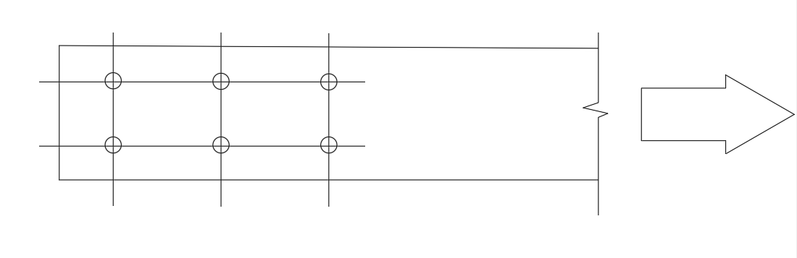

1. Describe 4 possible modes of failure for bolted connections. Provide drawings to illustrate each mode of failure.

**Long Answer**

1. Below is an angled 89 x 184 lumber member connected to a 191 x 241 lumber beam via a single 9” spike. Determine the maximum load this connection can withstand. All members are made of No. 1 S-P-F and can be assumed that they will not fail prior to the spike. You may assume that the factored load will be due to a live load.

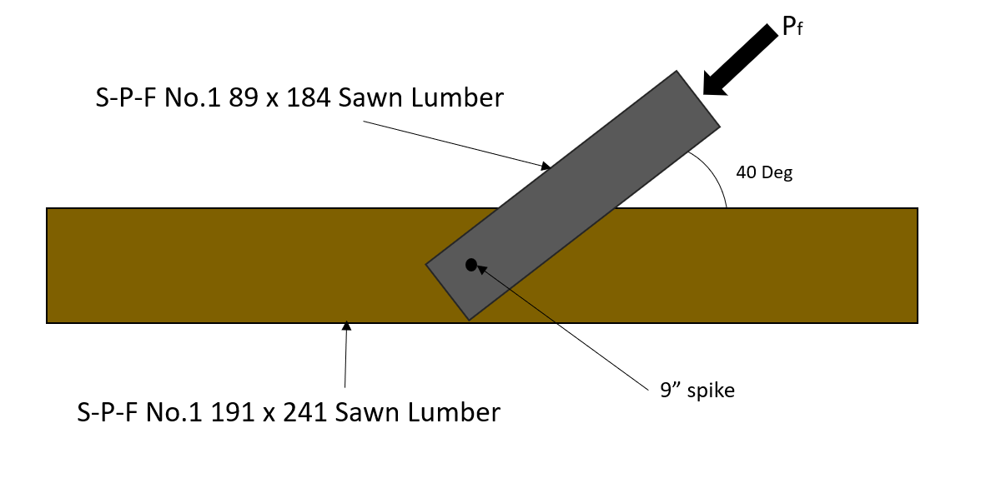

**MODULE 9**

**True False Questions**

1. Wood frame structures are naturally suited to perform in earthquakes. (T, Hight strength to weight ratio)
2. Diaphragms transfer lateral loads and conceptually behave similarly to an I-beam in bending. (T)
3. When designing shear walls and diaphragms, assuming these elements are flexible will always provide the worst-case scenario as there will be a greater deflection. (F, need to check both rigid and flexible as either could reasonably govern)
4. Shear wall and diaphragm systems require these elements to be orthogonal to each other. (F, can have sloped roofs)
5. Gypsum when combined with wood-based structural panel are capable of resisting at most 90% of the total seismic shear forces. (F, it’s 40 – 80%)

Short Answer

1. Describe the difference between assuming rigid and flexible diaphragms and shear walls. How do these assumptions affect the distribution of the lateral loads and deflection?
2. Outline the steps required to design a shear wall made from sawn lumber and OSB for a typical low-rise building with pre-determined loads. Include specific strength and serviceability checks as well as relevant code clauses required to complete the design. (Shear wall design is sort of spread throughout the code, like Chord members are clause 6.5, sheathing has a few shear checks in 11.5.1.2, connections, etc)

Long Answer

1. Below is a load plan for a roof diaphragm of a low rise building. The loads are only due to wind and have already been factored. Design both the chords and the sheathing. If your design of the chords requires multiple members built up to achieve the required strength, you do not need to design the connection of the members but can simply state an assumption about bolt size as well as spacing for calculating net area. Use S-P-F lumber for the chord design. Assume dry conditions and the wood in untreated. State any other assumptions needed to complete the design.

MODULE 10

True False Questions

1. Once a timber member begins to heat up, the entire member begins to lose strength (F)
2. In elevated temperatures, timber mainly fails due to increasing stresses in the member and not due to a decrease in material strength. (T)
3. Room fires rarely exceed 1000 0C. (F, with no suppression can reach 1000 – 13000C)
4. As per CSA O86-14. based on the char depth alone a designer can determine an effective cross-section to use in calculating the timber member’s strength post-fire. (F, also need to account for zero-strength layer)
5. Type X Gypsum board is often used for fire protection due to its ability to retain moisture. (T)

Short Answer

1. Describe the three stages that timber undergoes when heated.
2. Briefly describe what fire is.

Long Answer

1. For a 265 x 874mm glulam beam (D.Fir-L and 20f-E), determine its factored moment resistance at both ambient conditions and after being exposed to a 1-hour fire. The beam measures 5 m long and can be assumed to be simply supported. Furthermore, assume dry conditions and that only the top face is protected from fire exposure due to being pressed against the flooring system above.
2. A industrial heritage building was victim of an alleged localized arson attack where a SPF timber column (original dimensions 190x190mm) was exposed to a fire for 40 minutes (see below image). Considering the column only, if 25 mm of charring was measured on each face of the column what was the approximate equivalent fire severity in minutes? If the column were to be cleaned of char damage, estimate its remaining capacity? You may neglect buckling and slenderness effects but should consider that the column supports two stories of permanent mixed commercial and residential dwellings, that there is humidity control in the basement, and that this column is not considered to gain any enhancements from acting in a system.

